ANACHROME

[by L.Helpert 2019, NY, NY]

Disclaimer(s):
All hard science within the following text is mostly accurate.

Real names and titles of actual places, organizations, operations and characters have been used, but their stories sometimes changed.

The subtly out-of-order timeline in the following novel is likely due to the author’s own failure to patiently organize a bulleted outline prior to commencing; she had no fucking clue what she’d effuse. As an afterthought, she justifies this writing style as being in line with one of the book’s central themes: the poetic dismantling of time circa the year 2020.

Perhaps best to consider this work, rather than one long story, intended to read like a related series of short stories, using science as a coquettish instrument of foreplay and feminist thinking as a form of philosophical economic governing influence.

The following book is not intended to promote philosophies, and definitely not the opinion of the author herself. If, in fact, the reader experiences the writing as philosophical or science-fiction/conspiratorial in the least than this is only the failure of the author to make her satire both pedestrian enough and available to non-interdisciplinary thinking circa the year 2020.

"That which is Below corresponds to that which is Above, and that which is Above corresponds to that which is Below, to accomplish the miracle of the One Thing. [Whatever happens on any level of reality –physical, emotional, or mental– also happens on every other level]." --The Emerald Tablet of Hermes Trismegistus

_{(PREFACE)}

The force that creates life plays ball with itself, pitching manifestations within a matter-rich spatial jungle. Near the year 2020, scientists disclose: Earth is allured by a supercluster while it is also rejected by a low-density supervoid. What does that mean? Simply, the planet is in a push-pull relationship. The circumstance is similar to the Manhattan internet-dating scene during the same time period. In a single weekend, one guy over-texts while another disappears from orbit after date two. Research concludes, hit and miss, give and take happen simultaneously, rather than consecutively.

Some 13-plus billion years ago, cosmic inflation gave rise to what's popularly referenced as The Big Bang. By this theory, the universe was spawned the size of a poppy seed. Fast forward past rapid inflation, scalding-hot dense epochs, helium, hydrogen, and the Milky Way's debut. Out of extra-star stuff, etc. the (not round!) oblate-spheroidal-shaped Earth-ball gets tossed into the game, along with the rest of the solar system. It's a juggle. Planets form, slung from a spinning dust-disc, leaning heavily on what has been classified as the second law of thermodynamics, entropic disorder, a sophisticated equation for "what the fuck?" Governing planetary energy is spent on band-aid repairs, environmental acclimations, advancing systems of defense, call-to-arms, and je ne sais quoi(s); not so different from the presiding government expenditures on earth.

A baby forgets its source of origin once through the vaginal canal. Earth, post-formation, does the same. After its own genesis, earth self-absorbedly identifies as a celestial independent. However, the planet, falling not far from the tree (in light years), possesses similar superstring cunning as its galactic-core forebearer. Thus, after proudly surviving its first million years under siege in meteoroid bombardment, the planet capitalizes on its jagged history, wielding mineral-rich innovation from the leftover ammunition of astral attackers, exuding expansion, expansion, expansion!

It is not until just after the year 2020 those on planet earth begin to observe spatial boomeranging, recession as progress. Culturally, the strange sensation is first interpreted as a need to downsize, live in tiny houses, freelance, simplify, it's hip. It is the force of life playing ball with itself, a billion years in the future being felt as the day's trend. Transposing from pitcher to catcher, existence begins a mathematical involution. Just as there is quantum entanglement, there exists also quantum disentanglement. In this case, fortifying minerals, once arriving to earth via Panspermia space-voyage, prime for job transfer. It is not much different than how the human, regardless of her inability to distinctly recall a pre-incarnation point, is drawn back to these very coordinates at her life's end, however much these coordinates have likely shifted in both Einstein's spacetime and Heidegger's time-space.

ANACHROME (an almanac)

How does it feel to be naked with a new man? The moment you take off your bra in the deep night, when he looks at your storied chest in the low-lit room. Were you trained to feel your body is a showcase? To put one leg in front of the other in a photograph: your best angle? It started like this, an industry born out of recognizing only one flavor of the feminine, and perpetuating it as eternal. The sex symbol, the forever-ovulatory young woman, bill-boarded, crucified.

First the crones died off from the lips of the heralding heralds. Pre-media, pre-newspaper. No one talked about them; they just disappeared. Typically, yes, there was one select, scary, old witchy woman in the middle of the dark wood in every village. Just one. The competition was fierce. The rest were not mythologized, only cast off. Sometimes beggar women blurred into the town's background, destitute in ways unrecorded, smudged out. We don't even know how they were destitute. We barely know about the relic, regal female lives of the days' top parties. Marie Antoinette, Cleopatra. We know about how they smelled, what flowers they wore, how much they fucked, what men they successfully manipulated. We're moved to believe that their bodies alone allured men to start wars, rather than their minds or opinions, and we know how to paint them, how to make their smile historically uninterpretable. As though the only worthwhile debate about a woman's position is what her smile meant.

The viral heterosexual fallout started like this: a cultural hemimetaboly--- that is--an incomplete metamorphosis, anachronistic. Thomas Hardy predicted it on page 57 in his Tess of the D'ubervilles, "two halves of a perfect whole", he wrote, synch only in near-misses, out-of-synch.
Society and nature worked symbiotically; each played its part. Women were commodified until genetically dispositioned towards physical disassociation and men emotionally hardened until inherently prejudiced towards mentally cracking and destruction. Sentience disappeared as industry developed. Sexiness became an expression rather than an embodiment. Then, the revolution of culture in the mid-1900's yielded a humanity stretched thin by their opposite inclinations, part primal, part artificial intelligence. The Halfsies. Spiritual fodder became more popularized as people let go of linear corporeality. Religiosity was recognized, finally, for what it was, a sense to preserve what of us might be eternal, able to survive massive extinction like jellyfish disguise themselves, handle acidic oceans.
She takes off her shirt in the darkness and she still self-objectifies. "Is he hard?", she concerns.
"Did I get him hard?", "What is he thinking?" Her mind dialogues in soundbites that turn her on, overwhelm her, that are not even hers, that belong to television. "Let's make a baby/I am your sex-slave/I am your geisha/Control me/I am being raped by you/I am being anointed by you."

The fallout.
She sleeps minimally and walks a mile back to her home in the Manhattan morning.
This is when Manhattan is still dimensional, when you could still walk through it.
The sky looks like a mountain in the distance. These were the early days when apparition began to be a choice, where one thought but was not sure if they could perhaps change the skyline. She'd invited mountains just for minutes into the Manhattan horizon, for a refreshing symbol.

Walking home she reset: a technique like fingering prayer beads, cleared her neural pathways to the original game, the original scene. Three tongue clicks: input backup EED (energetic/external drive). Then "undo, delete", "undo, delete", "undo, delete". Time-space had been involved, but that element was easy-ish to wipe out, on the fritz, like the word fritz itself.

Since time-space was on the edge of obsolete, one actual night-length (or, even still, one more) of man and woman-bodied human touching would not destroy her ambition. She rationalizes this. However, the science was still out; perhaps her thinking was tainted. Some considered thoughts unexposed to solid hertz frequency likely corrupted by imbalanced bacterial metabolites, dysbiosis, leaky gut. It was nearly 2020, the sub-diaphragmatic portion of the human body had already begun undergoing allopathic quarantine by this time. Soon to be part of the taxation system, the quarantine was in beta-test phase, FDA-regulated and installed within the left-half of the world mostly through algorithmic Google Adwords and remarketing strategists. (The "left-half of the world" refers to the demographic population considered the "cultural-west", primarily N. America, Europe and Australasia.) In 2017, The general collective consciousness elected the (85% male) advisory committee of the NIH (National Institute of Health) to privately allocate funds to (the 86% male) DARPA (Defense Advanced Research Projects Agency) in support of a sterilization process. The "process" was simply an advanced adaptation of combined scientific Natural Language Processing and the holistic therapeutic art of Neuro Linguistic Programming (both, not-coincidentally, sharing the same acronym). Their joint acronym indicated some of the first corroboration of corrupt "transdisciplinary" initiatives between the fields of holistic therapeutic arts and data science. While transdisciplinary philosophy conveniently appeared, at worst, fruity or invaluable, underneath its harmless facade, leaders of conjoined arts and sciences had been ethically hijacked. Turning dissident together, the trans-disciplinarians maintained an outward appearance as fosterers for exceptional innovative education, defenders of freedom. However, they operated covertly as unified double agents, perpetuating noise and working desperately to keep burgeoning minds self-importantly busy. The agenda was simple: feed the ivy-league community with distinct pontification fodder; support researchers to lose themselves in pressing topics. Encourage them to compete for title of first author of their shared publications, then reap the (cost-free) provision of their well-researched findings. Resultantly, they'll have given their lives to advance the necessary science of infiltration, controlled by military money.

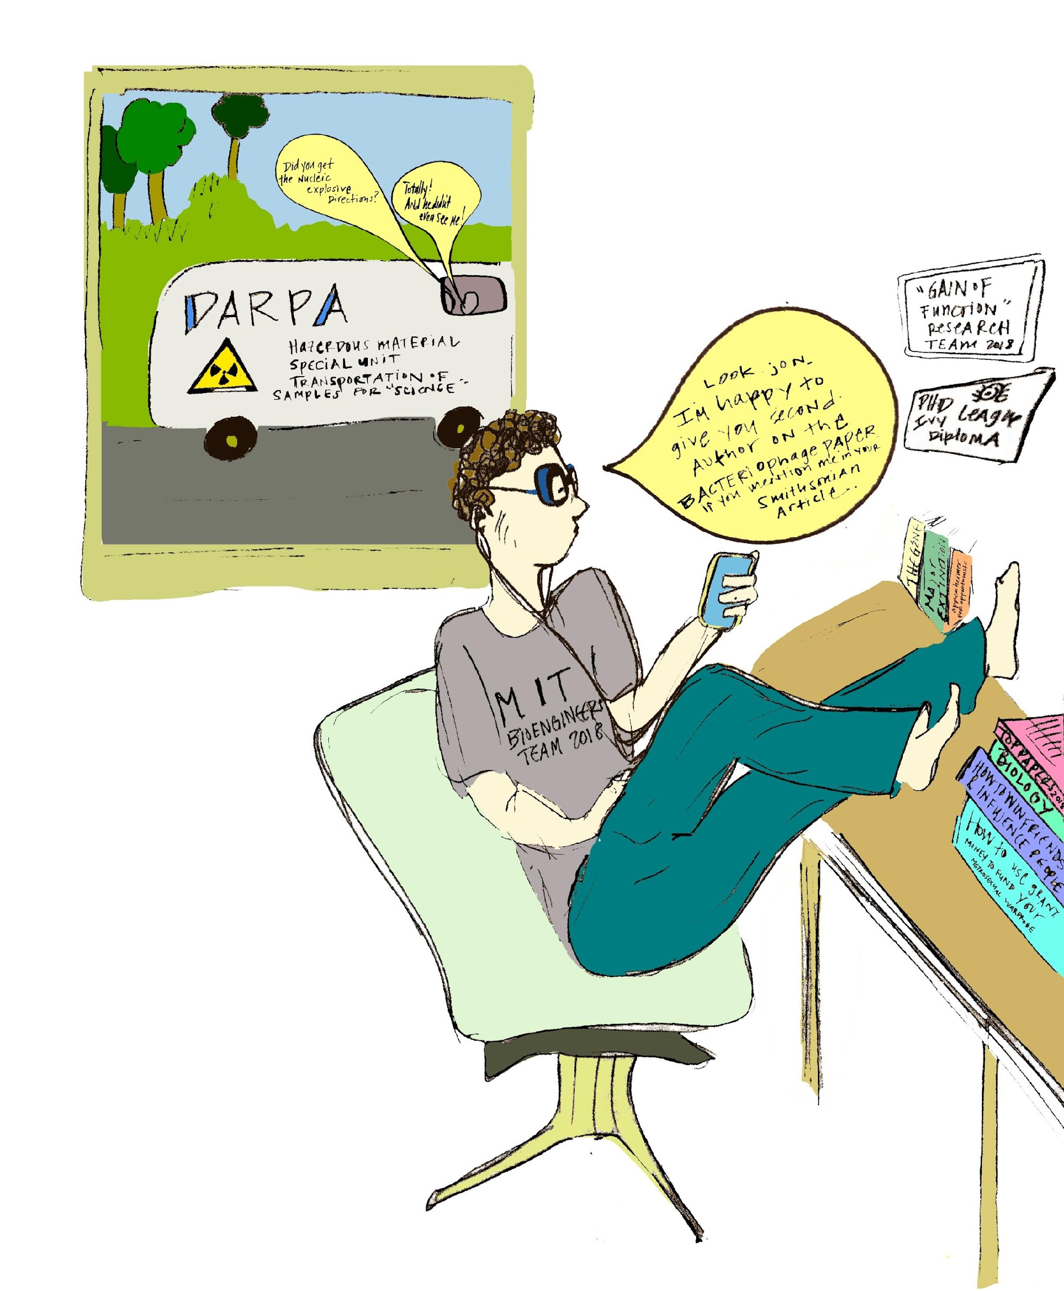
You are Ana, and you are walking home in the early Manhattan winter morning from the Lower East Side to where you live, E.11th between 2nd and 3rd avenue. You are Ana because every story has become VR optional, and your head has been stuck into this headset, and more than your head––your heart. She is written, you are written, in a time when perspective (omniscient, first person, etc.) has melded. The importance of where we are in time loses its coordinate stronghold. Through exacting equations, aided by Einstein's parentage, culture adapts to the unified field, relativity. Recognized, as bodies largely populated by colonizing bacteria, we are moving microbiomes. Ana tries to stay primarily away from all Bacteriode-saturated types, her microbiota prefers more Prevotella and Ruminococcus-populated company. She says she just feels her immunity is most aligned with their mentality and poise.
Ana knows through dreams that the fallout has been culminating for this moment, but she isn't willing to consider indexing forward to discover the transition, if and how the humanoid female and male will accept they are no longer fitting together on the essential, chromosomic level. Attention on the subject had yet to pointedly surface, but the condition was palpable. Just after the year 2020, a steady hashtag (#thefallout) would lead to proper terminology. Scientific American-- and then The New Yorker, Time Magazine, Forbes, Esquire and Vogue would catch on to normalize it, create cultural acceptability. But just before the year 2020 the fallout was in a similar stage of acceptance like Fibromyalgia in the 1980's. It was still too close to the Sylvia Plath years to consider being tired and aching all over, plus feeling extra-sensitive as anything that would potentially not be solved with some type of lobotomy. After the year 2020, though, the fallout could be heard on the lips of the most upper echelon of conservative America or even wildlife hunters in the midwest who'd never left Nebraska. The Nebraskan hunter could say "the fallout" in reference to the Anachronistic Chromosomic Heterosexual Fallout, and their family understood. Jack doesn't want a wife, he's more interested in his John Deere collection.

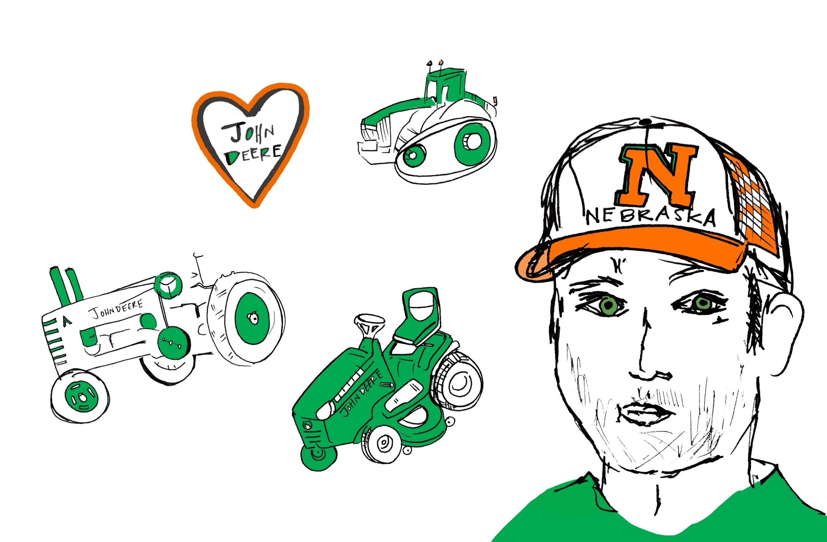

Before the year 2020, the preliminary qualifiers were released in hard science periodicals regarding the degenerative shrinking and DNA decrease of the Y chromosome. Quantitative estimations reported the male-determining Y chromosome had merely 4.6 million years left before completely disappearing.¹ While 4.6 million years may seem substantial, it calculates as less than 3% of its total 166 million-year mammalian span-of-existence. If we imagine a tube of toothpaste that is 97% empty, we can then begin to grasp how much of the male-creating chromosome we have left in the tube to squeeze onto our brush.

In general, little was publicly mentioned about Y's settled shrunken state; how it now exists as merely 1/5th the size of its coupling X chromosome, which was once its contemporary in both girth and complexity. The academic publications initially fell under the public radar, were written in a non-alarming style, none earned a front cover. (Near the year 2020, video content featuring butt-centric exercises received, on average, 50+ million individual hits annually on social media platforms in contrast to published talks on the subject of the waning Y chromosome, which garnered less than an estimated 5,000 views-a-piece over the period of a decade.)

Scientists consoled--we shouldn't concern too much regarding Y's descent, male expression could likely find another chromosome to ride (a Q or a J, perhaps?). Or else, not to fear, the female X chromosome would adopt the male SOX-9 gene necessary for sperm creation, eventually resulting in parthenogenetic, or self-replicating humans. Other researchers claimed the chromosome, shed down to a mere 27 of its once-800 ancestral genes, had now nearly ceased to dwindle and would remain in plateau, albeit in a shrunken state. This provided some sense of relief to the few who stayed updated on the subject. Perhaps out of pride, some researchers perceived Y's atrophy as an advancement of design, like the lithe, upgraded Macbook. Determining how fast it had withered and from what conditions did not spike much general curiosity. Nearly all researchers were in agreement, Y had downsized abruptly, not steadily, over 100 million years ago. However, this information was based on archaeogenetic specimen extraction techniques which, shortly beyond the year 2020, become technologically outdated.

Before the year 2020, few gave ample hypothetical consideration to how metals and plant alkaloids (the foundation of the pharm and tech industry-- and the global economy) had, through a kind of time-independent physics, orchestrated Y's genetic evolutionary decrease over successive generations. Of these few, less than an abstract handful of thinkers jumped conclusively to what would later be known cross-globally, simply by mathematically comparing the newly configured slope of decline of Y's gene content to the rise-over-run rate of incline in human industry and technology: Y's genomic decline was for the benefit of a different partnership. Y, now only 10% of its original chromosomic size, had handed a good sum of its protein-rich original job responsibilities off to X, who was (by some level of nature) fully compliant.

Y chose to process his evolution outside of his relationship with X, unloading the content of his inner world into X's open arms while making himself energetically transmutably available elsewhere. Y's eyes were on the prize of an out-of-body possession beyond X's attention. Maximizing the options available in the quantum field of relativity, Y, now light and carefree, traveled at a different speed, its naked electrons skirting through the Higgs boson field, boyishly racing light's massless particles. Outside of the human body, Y enters into a new partnership, a symbiotic mutation with the minerals originally brought to earth through trojan celestial bodies.² Somehow, this all takes place nonchalantly; like a typical affair. The husband, on a business trip, sweetly rings his wife to say goodnight then disconnects, sheepishly ascends to PH1, riding one of the city's most posh elevators. As simple as this, he arrives at the door, in a universe completely out of his wife's grasp. There, he lavishes his high-end escort, who’s been doubly paid, for a racy, in-suite all-nighter. Meanwhile, this isn't even happening in his wife's version of reality: there, her husband has only plodded to the hotel sink, unwrapped a courtesy soap, and washed his face (never caring too much about soap brand) just before collapsing on starchy sheets. He falls asleep watching a Netflix cooking show like almost every other night. And the wife, immaculately up-keeping their shared life duties while he travels afar, is dispositioned like the X chromosome, obligingly providing her relations with the best of her gene-recombining abilities. Somewhere in a city that doesn't sleep, Y focuses on its own survival, set into motion 133 million years ago, destined toward a cross-material mutualism with the world of mechanics, immeasurable by 23 and Me.

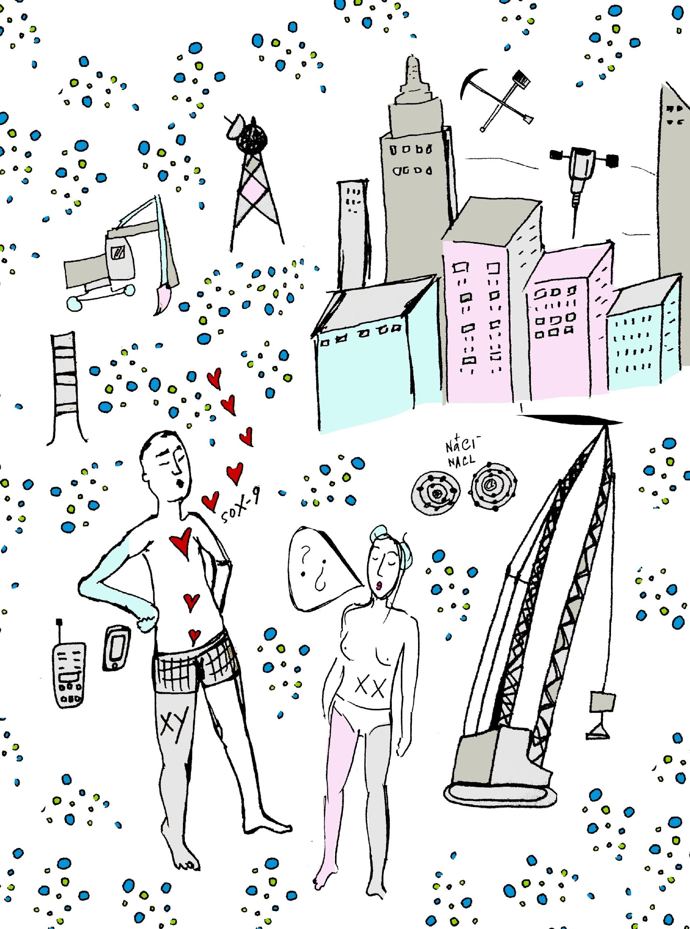

Mass populace acquiesced, accepting environmental metals, electromagnetic radiation and alkaloids could potentially trigger genetic mutations within the human body; lead and chromium exposure had been linked to potential endocrine-related birth defects and abnormalities.³ The world, for the most part, carried on. For a period, there was a general subcultural movement to avoid standing in front of a microwave, assuming any potential effects of radiant exposure thus nullified. This co-occurred with the sub-cultural trending fashion of pinch-rolled jeans. Thousands of Americans stepped to the side while their popcorn underwent 2-minute transformations on high. They'd successfully avoid wave exposure all-the-more by bending down, re-pinching and re-rolling their denim pant cuffs efficaciously, waiting on their partially hydrogenated soybean oil and polydimethylsiloxan butter-flavor kernels to pop. Polydimethylsiloxan is also used for the treatment of head-lice, but before the year 2020, this was largely overlooked when driven by the euphoric smell of artificiality.

Other waveform avoidance included "opting out" of airport security (particularly good for those who secretly preferred total body pat-down by a uniformed official versus molestation by quanta under surveillance.) Some refused to live near significant amounts of powerlines, or exchanged their hours watching television (54-700 MHz-- ${10}^{7}$) for streaming computer-based show watching (60-100 Hz-- ${10}^{2}$), despite computer waves being stronger than the aforementioned powerlines. Furthermore, WIFI, which was necessary for computer use until a substantial amount of time after the year 2020, emitted frequencies stronger than the television set (2.5-6 GHz--${10}^{10}$), what was one to do? Ironically, therapeutic radiation emitted the strongest physiologically transforming waves, targeted to kill off cells diseased from an over-exposure to microwaves⁴, airport security, the television set, etc. The championing therapeutic radiation, in the form of ionizing ultraviolet, x and gamma rays, supplied ${10}^{21}$ EHz, wave frequencies extending beyond humanly visible light.⁴ The hierarchy of light is tyrannical, in this case– the strongest frequencies are institutionally employed as a medicinal technology, reforming cells exposed to lower forms of radiation, to replicate only as they should, benignly. Whether submitting to frequencies or avoiding them with alternative paths and therapies, human culture accepted this as just so, still adamant to hold the top place in Darwin's systemic hierarchy. Society would never consider frequencies or heavy metals as alive, despite their potential quantum observer capabilities⁵, for then, we would, perhaps, have to consider their tyrannous power over us. If exposure to our own man-made technology could potentially destroy our homeostatic health, we'd not only have to consider ourselves compliant to metals and waves, but also self-saboteurs for promoting their place in the world through our most innovative technologies; and that we'd merely been accommodating their position as dominatrix-- ourselves in the role as slaves to them. So, science maintained Darwin's pre-existent hierarchy. Best to conveniently keep metals, alkaloids, and electromagnetic radiation classifiably non-living. Not only can we then remain self-perceivably in charge of the food chain, but also we'd always have a scapegoat to blame for our unfair susceptibility, "victimized" by their unruly superconductivity. This, along with political upheaval, kept drama rife.

When the forensic evidence revealed, not long after the year 2020, that hetero-sexual sex-drive was threatened because the male-determining Y chromosome was far more naturally attracted to metals and alkaloids than to its female X counterpart, science news finally consumed public attention. Long before the dawn of placental mammals, the coming-together of their organic material was smartly conceived by nature's design, through asteroids, through minerals, water, bacteria, photosynthesis, regulatory systems. Humans were positioned to yield the age of industry, then of technology, robotics and, ultimately, the bionic union between them. And metals emerged from the earth, through the efforts of man's hands, in search of man, himself. Here were the two halves Thomas Hardy did not write about on page 57 in Tess of The D'ubervilles; these "two halves of a perfect whole" were never out-of-synch, their targeted precision midst an extraordinarily complicated, varied web of genes⁶ could be aimed at nothing other than each-other.

Consider this. The Y chromosome develops into formation by literally suppressing the expression of the female-determining X chromosome. Then, it is predisposed to continue suppressing female determination long after its in-utero formative state. In compensation for its genetic shrinking, the Y energetically proliferates, indirectly informing the cultural state labeled as "The Patriarch". Because the Y chromosome cannot replicate within the meiosis process of cell division, Y compensates outside of the human body, leaving his mark through fabricating all historical systems traced through male descent.

An imagined mutation between men and metals is less of an obvious courtship than the occipital lobe might construct. There is an undeniable heat, intrigue, arousal, but, conveniently, less concerted rites than in the historic courtships between the man and woman body; no ballroom gown, no bachelor party, no rings or outdated "things". The collaboration happens (precisely where most successful enduring biological collaborations take place) within the primal unconscious, wired by the nervous system and carried on through, what is colloquially referenced as the gut, or gastro-intestinal system. A man may not even know that he's endowed his genetic content for his mutation with particulate heavy metals, however much he may walk around with the unwavering air of an overlord.
Despite Y being "the apple biter" in the garden of innovation here, the hetero male-body is not solely responsible for instigating the bionic future. X, in fact, was the original carrier of Y's Sex-determining protein before Y evolved to responsibly carry it for himself.⁷ In the causal relationship (not casual--in the least, please note--- but causal) both X and Y play the role of the causer and the effecter, a type of mutual push and pull happening simultaneously. While the onset of intermingling behavioral phenomena between human body metals and environmental metals is traced back, specifically, to the travel adventures of a male-determining transcription factor protein named SOX-9, without X, the evolution wouldn't be possible. Ychromosomal SOX-9, responsible for the formation of male sex parts, empties the minerals from the pockets of its DNA and sends these teleporting in a metastable, excited state, powering upward through electron spin to exchange information with noble metals outside the human body.

Through a type of superconductivity, the traveling metals from SOX-9 impact planetary metals with the coding information used to trigger the expression of human testes. While exogenous and genetic materials are apt to influence each-other's surface expression without altering their chromosomic essence, this case is different. See, SOX-9 has endured 166 million years anticipating having to find a new home-base for its genetic expression, since the Y chromosome which houses it has largely disintegrated. After enjoying an out-of-body electron spin vacation through the qubits of quantum teleportation, protein SOX-9's metals return toward home-base to settle down. While trailing through the body system, it agitates without a strong pull toward the Y chromosome (since its delegated base-of-operations is now so shriveled, weak and uncommanding). In transit, SOX-9's metals leak a type of energetic information (especially stimulated at higher rates in males exposed to significant environmental toxins or males displaying overtly metrosexual behavior which is clinically shown to lower testosterone levels). The leakage of this information affects genotype expression, materializing in double-strand DNA heartbreak and forever altering the evolutionary future of human physiology and chromosomic destinies. Put simply, here is a doorway through which man enters, blood, brain, skin, bones, and exits biologically bionic, metal, light, nanomachine, augmentation.

This is how the Y chromosome, throughout all time, has been positioned toward an unrelenting courtship with metals and alkaloids, out of which evolves new industry. In this case of metal-man coupling, there is no physically tiring ejaculation to put a quick end to man's seductive acts. His drive toward metal and alkaloid fornication, so to speak, is inexhaustible, at constant climax.
The psychology of cell division and gene expression has been anthropomorphically analyzed by humankind, observed under a microscopic lens. However, man's own life expression, his own history, is a psychological mitosis and meiosis of its own. In the sum of what Einstein calls his "wordline"⁸ –or complete life in all tenses– are his two fractions: Fear-Over-Love, which eventually divides (mitosis), adds itself and replicates (meiosis), flipping reciprocally into the fraction Love-Over-Fear: the two together equal the whole circle of life. The words of the religious Genesis story were written originally to justify this splitting apart and coming together, the gene in the genesis. While we've advanced beyond the biblical creation story of Adam and Eve by ways of evolutionary theorists –Aristotle, Lamarck, Darwin, and Mandel –our love story of procreativity had been left incomplete.

In light of the courtship of man and machine, some might say XY never really wanted the XX. Some say it was never a true love story, only a misrepresentation of the whole circle of life created from missing facts, mostly blown out of proportion by Walt Disney and all other relevant fairytales, even folkloric myth. People think XX just served XY's self-generating purpose. XY, after-all, is an opportunist. Understandably, many phenotypic hetero-women have felt exploited, abandoned or slighted by frugal men. These very same frugal men who have seemingly forgotten gallantry through the eras, have increasingly all-the-more zealously given the whole of all they are (down to the literal whole of their Y chromosome genetic material) to breed with metals, moving with determination toward progressing their conjoined bionic union. Technology is not an invention of mankind, humanity finally understands in the dismantling of time-space, it is a meta-expression of a biological evolutionary breeding. In the same way notable futurists consider the digital world to be an extension of the human neocortex⁹, it is also an extension of the human gonads.

For those near the year 2020 like Ana, however, not only was this information largely unavailable, but until time-space was both obliterated and cleared (which would potentially take a suspended amount of pre-infinity) dating felt like hitting a wall. The worst of the anachronistic fallout is that the original chromosomic carriers, the XX female, had maintained enough gut instinct to feel something was entirely off (the microbiota, after-all, never bought into the collective phenomenology of time-space and so accessed the unified field since the inception of its original, rod and sphere-shaped life). On the cusp of waking to a greater spectral awareness of the path of evolution, Ana was plagued with an unconscious contemplation, if women and men may no longer fit together in a future mammalian arrangement, then why still attempt male-bodied copulation? If the metaphoric tube of man-toothpaste was 97% done, why not become more interested in finding new ways to brush teeth? Getting the 3% last run of the paste required so much muscle control and resulted in little content. In the spectrum of our relative life on earth, 3% left is almost done, anyone with a phone knows this. If you don't have a charger, you're fucked.

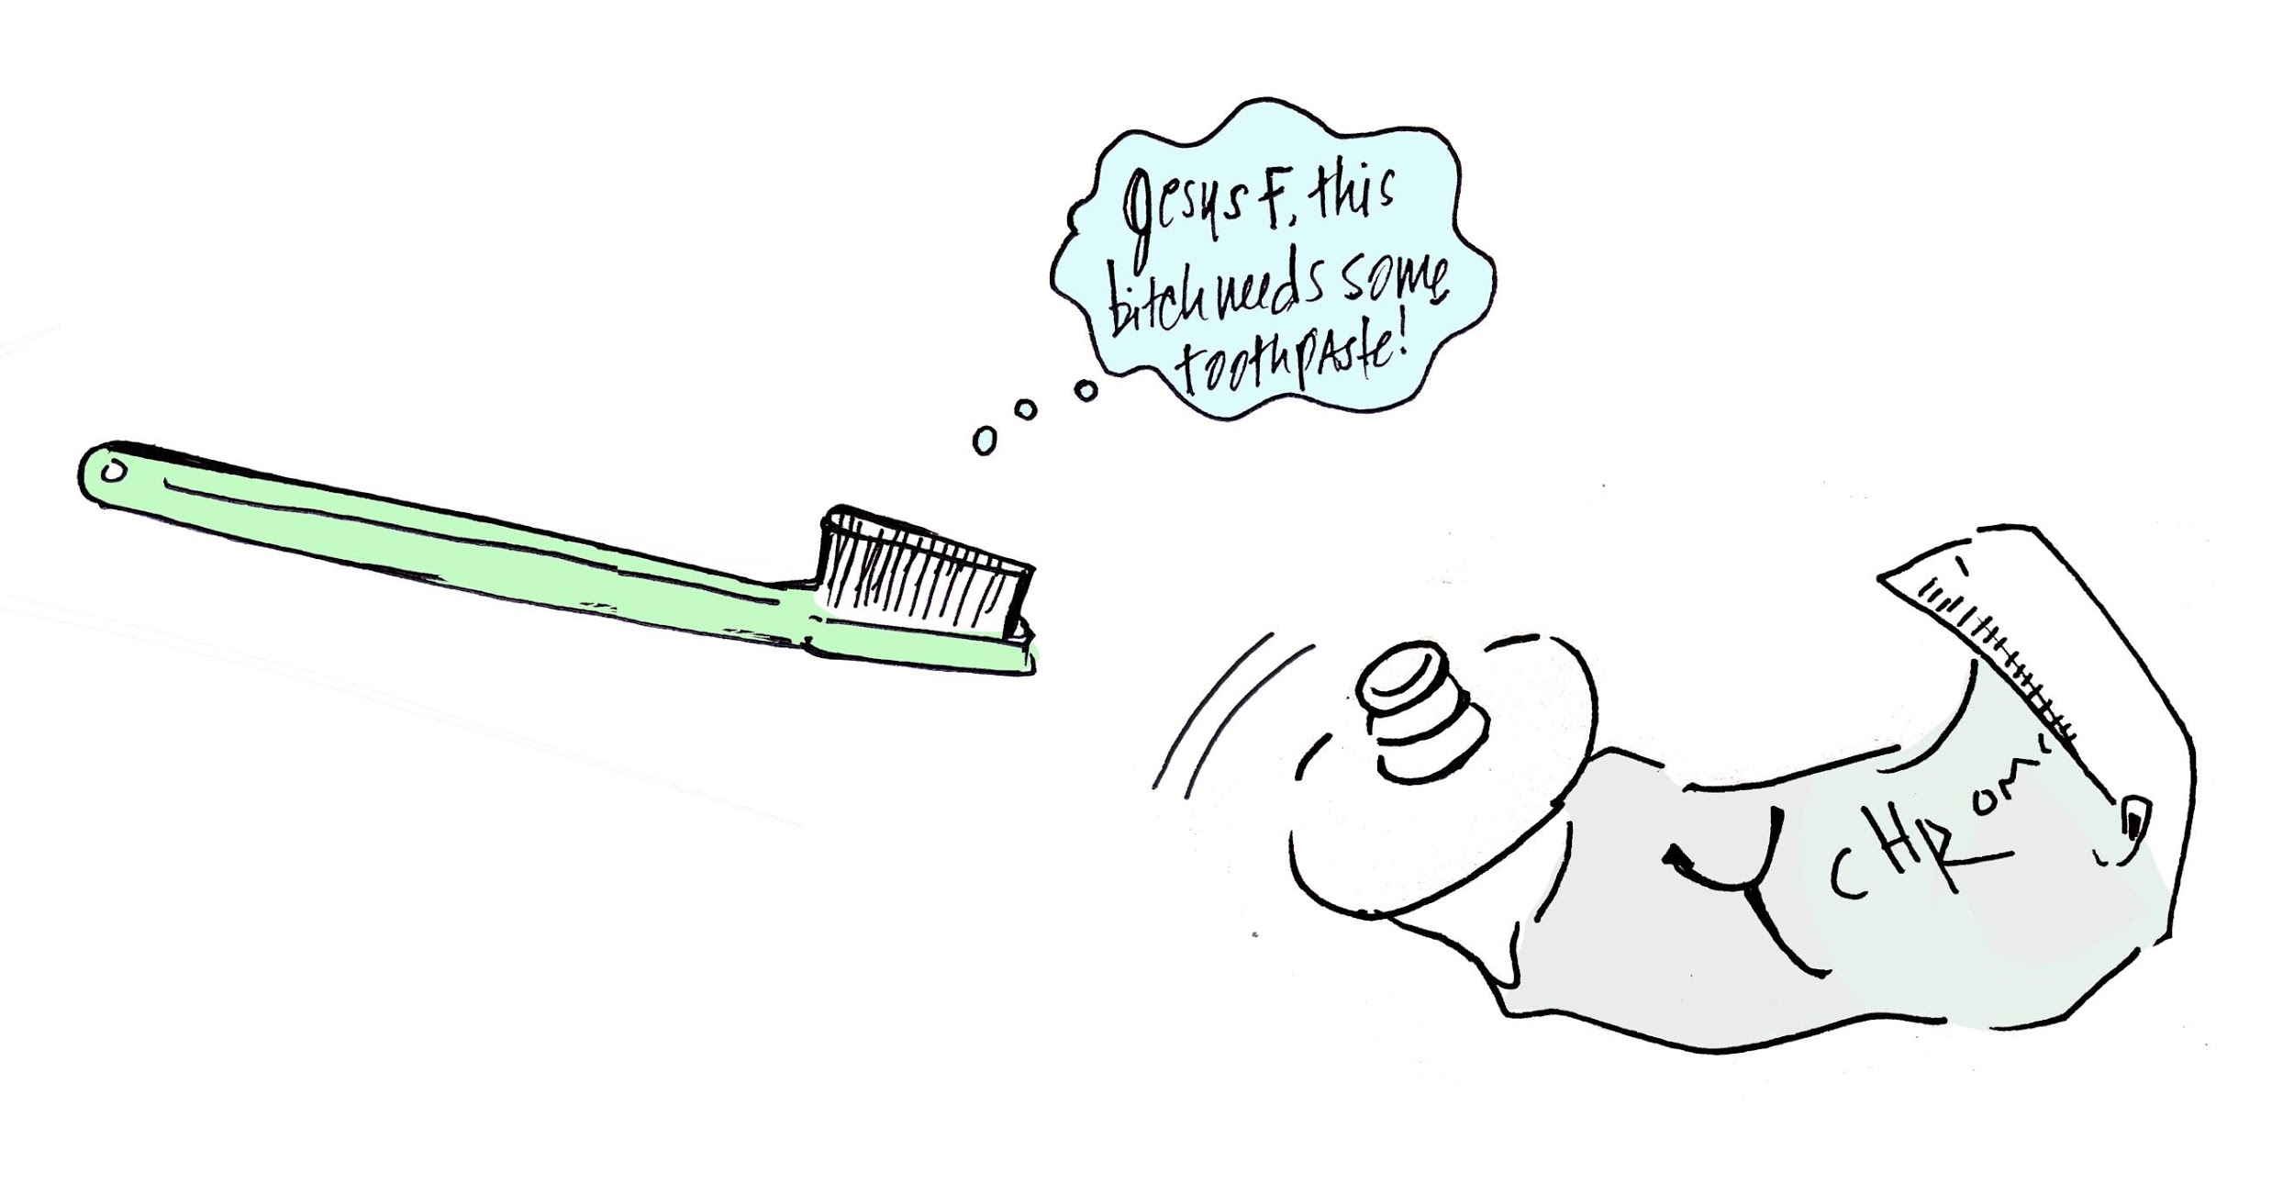
The discussion of a plausible shift of sexual compatibility transferred mostly to ducks, subjects easier to talk about¹⁰. Evidently, female ducks had evolved extremely complex maze-shaped vaginas, as a sophisticated means to ward off potential male duck-mates. Politicians running for office shunned the United States for funding research in such a bizarre-seeming direction, perhaps too ashamed to acknowledge the like phenomena happening within the hetero-oriented human species. But Ana felt it--sometime around the Oregonian alt-folk singer Elliott Smith's death--the fallout was becoming transparent. A quality in Elliott's subdued lack-of-fight vocalization reflected how male triumph triumphed less thunderously. The popularization of Elliott's voice as emo-sexy flaunted flaccidity as the new norm, a general acceptance of testosterone levels less than 600 nanograms per deciliter, and ejaculatory release less than 2 milliliters and fluidly irregular as hip. All of these pathological identifiers are evident in the instantaneous subconscious analysis of vocal frequencies. The minute you first hear your lover's voice, you know, on some level, his sperm count, you know what you're in for. And Elliott made the subdued sexy, his voice represented the message of the new metrosexual male: "maybe it matters, but why assert?", "I'm not calling from my deep, distant cavern, I want you to love that you can't find me." Phytoestrogens had taken over the days of fire-making, lion-fighting. By nature, the influencers of popular culture had to appeal to the norm, commodify what they could, work with the materials available. Men would continue to flaunt their talon feathers to elicit covetous response, despite how the washed-out plumage hung, indifferent to the wind.

Foreplay had perhaps extended briefly in the 90's, but texting soon took over and the cerebellum was triggered into a virtual disassociation. In the combination of urban lifestyle and cultural backlash, male pursuit of the female became denaturalized, understandably so, as men felt under constant surveillance and unsure of how to behave. The male nervous system entered the state of the parasympathetic freeze mode, triggering reptilian response, too scared to make a risky move for fear of being publicly ostracized. Women engaged more intimately with Siri than with their men, whispering commands in the middle of the night, roused, sleepless. Here, they conditioned their imperfections with surefire data: step-by-step instructions on how to move passively enough to conjure a man's pursuance, or how to disguise their authentic bitch until he's already committed¹¹. Body parts became more irrelevant as thumbs took over, programmed to swipe left or right in substitution for gut instinct response: and, effectually, the gut remedially functioned. Approaching an attractive hetero-male in the last of the remaining time-space cafes with a line, for example, like, "Do you want to fall in love?" would, at best, barely disrupt his deep-dive fixation on his phone apps-- and, at worse, result in a threatening a harassment suit. Social media status overtook any lingering remnant of previous tribal culture, when each type of person, from the wayward to the backwards had a place, were appreciated and somehow cared for. Care took too much uninterrupted time, was nearly impossible when every 4-minutes there was a screen to check, another dimension calling.

But this wasn't terrible, wasn't dystopic, it just was--- how it was--- in the period of the Halfsies. The creative impact of thought and emotion became more obviously self-manipulated. You could convince yourself you were lovable as you slept by means of free hypnosis. Through a language-based virtual course, you could limit subconscious thinking for under $300. Why would you want to battle your own thoughts all day (so early 2000's!) when it was possible to align them with the best positive-mindset innovation. Friendships were simplified to brief meetings of affirmation exchange ("You got this!", "I believe in you!"), chic meditation centers opened from Tribeca to NoHo in lower Manhattan; perspective was the new choice, and nearly the new monetary unit.

Along with information accessibility and technological advancement, the wildness of nature's impact increased; you'd read the energy of trees through your fingertips like braille, at a Taconic Parkway rest stop. Even deeper into the woods, if access to wireless service was left behind, the worldwide web of information remained inter-communicatively within humans. There was no more unplugging. People originally assumed the Age of Singularity would entail robots taking over human life, but hadn't considered that both were potentially seeking each-other, adaptively. In the way that some can feel the incoming rain in their bones, the impact of future bionic life had already piqued human senses near the year of 2020, before any chips had been swallowed, implanted, before genetic programming.

Clearing thought was constant for Ana, along with the rest of her female contemporaries. When given the option, very few women with 7-figure CEO mindsets opted to keep straggling concerns or anxious reactions on-repeat in the competitive real estate of their headspace. Aside from the elite trauma-targeting disk erasure technology manufactured by the monopolistic company Neurostar (Transcranial Microbiome Magnetic Frequency Stimulation– or TMMFS) more economic, lower-risk routes were available on-the-fly near the year 2020. Just as the accessibility to insomnia-reducing and mood-regulating CBD (Cannibidiol) increases circa 2020, disk erasures (either full or partial level) gain widespread popularity for soothing similar conditions–mood malfunctions, insomnia, anxieties. In the case of disk erasures, a magnetic and frequency-based protocol alieves post-relational trauma, particularly those who've endured the contemporary hetero-sexual partnership. In a spa session, short-term results could be achieved within hours, either via au-natural variations or a gentle chemical cocktail supporting clear thinking (the chemmy-mem). For Manhattanites, this was a perfect pick-me-up on a Sunday evening, just before the work week, post a weekend of ample body contact. Similar to a morning-after pill, but eliminating the chance of self-loss, disorientation or insecurity rather than potential pregnancy, these treatments were particularly useful for the XX hetero female, who historically was more prone toward feeling dejected after gray-area intimacy. (Gray-area intimacy was considered sexual contact under various influences including: 1. alcohol or drugs 2. overly romantic one-off events that set unprecedented standards for possible follow-up 3. exposure to poly-amorous or (worse) ethically non-monogamous men 4. jack-rabbit male sex technique or 5. mind-blowing, distracting sex with a seemingly-amazing man during a focus-requiring demanding work season or (the most harmful of all) 5. casual sex with a man afflicted with borderline or full-blown halitosis, effectually transmittable to the female gut microbiome.¹² The chemmy-mem was most effective of the shorter-term no-appointment-required disk erasures, and recommended especially for woman who'd experienced multiple orgasms within 24 hours stimulated by one hetero male, as this level of microbiome (and effectually) neural imprinting was the most difficult to kick. Additionally, hundreds of at-home protocols competed for paying customers, advertised through funnel-marketed social media streams. Ana folded on four individual occasions, purchasing tailored programs for thought clearing: two frequency-based, one involving herbal supplements, and the last (most expensive) requiring sleeping with rocks and a biomat, which emitted negative ions and far infrared rays to support an utmost clear-mind and robust physiology.¹³ Self-affirmation practices for clearing thought were also common, podcasts, webinars, downloads. Near the year 2020 when it was still semi-normal to physically (rather than exclusively virtually) travel the streets of Manhattan, more than Kanye, Cardi B or Kid Kudi tracks, pedestrians in headphones were listening to positive mindset audio or personal growth and development podcasts. One Sunday, Ana happened to get close to a hetero male-body on the corner of Mulburry and Spring, while heading east toward Citizen M Hotel, latte-minded. She was roused from her glazed-eyed mission, thinking he'd spoken to her, but realized she'd been mistaken: he was reiterating Tony Robbins incantations, "I am a leader. Today is a winning day for me. Everything I touch is a success."¹⁴ Ana understood, she even semi-grinned as she walked by, risking eye contact.

As did most women not long after the year 2020, Ana kept a monitoring app on her phone (supporting futile aims of perfection) to collect weekly data on thoughts she'd worked to clear, helpful for cumulative review. Her most recurrent evaluations reported 38% of her thoughts fell categorically under self-limiting criticisms, 51% of her cleared thoughts were aimed to immediately reverse whatever stress she'd collected throughout daily interactions (typically resulting from critical sizing-ups, and visual assessments). The remaining 16% of cleared thoughts fell in the alias category, usually related to overbearing self-pressures to achieve a healthier lifestyle, a richer sleep/wake cycle and ageless beauty.

With the help of apps and other sophistications, Ana was able to believe she'd become stronger and more self-acceptant, she'd finally entered the time of a woman's life where she learns to accept herself and, thus, is most beautiful from the inside-out. Largely, Ana cleared thoughts to redirect her earlier-life influences, lingering cerebral-firings still barking orders towards recapitulating a type of domesticated romance prioritized by her mother. Unfortunately, this type of recycling mental fodder was largely for naught, as the traditional hetero-female role became antiquated and, in the collapse of time-space, dimensional travel through the physical world decreased. How was a man supposed to come to your window with a boom-box when his music streamed from a virtual cloud, when his communication was imparted via emoji, when (especially in the rain) Taskrabbit could do his job, or Whole Foods could send a drone? Still, most of Ana's realities (both what was considered her uniquely conjured under-realities and the collective dominant cultural reality) were imprinted with the implicit belief that monogamous partnership would fulfill a large part of her life, provide her with permission to feel happy and safe, purposed. In the nature of matronage, the eldest woman of the family unit influences the youngest female members she oversees. Thus, even if generational ideas had significantly changed and the position of distinct, purposed roles between the two members in a heterosexual relationship became null, near the year 2020, more than 80% of unwed hetero women remain in search of right wive-lihood.¹⁵
Ana would never describe her relational inclinations as "male-seeking", even if she'd been impressed by mixed-messages generationally inherited. Even if the female human genome shared similar coding with the female spider¹⁶, Ana would not default to a role of weaving an immaculate, luring web. Her female peers imparted the same "I don't care anyway because I'm a boss" outward quip when it came to pretending not to measure themselves by their romantic successes. Other outward quips (also reflected in pop-song lyrics mid-20th/21st century) were "You thought I'd be weak without you, but I'm stronger" (Destiny's Child circa 2001), or "You could find somebody better, girl." (1989, P. Abdul). Amazingly, the video for the latter features a woman wrestling with herself to maintain a completely sexualized, self-objectified body, eternally perfect, infallibly desirable, with six-pack abs and dermatologically-affected extra lips. Artistically, Abdul's video content is not recommended, but anthropologically interesting.

Even those who'd undergone the most effective disk erasure, Neurostar's TMMFS (Transcranial Microbiome Magnetic Frequency Stimulation), were apt to occasionally experience a wafting sensation, a phantom-limb like effusing of past active neural pathways. It turns out that it's difficult to remove memories collected in places heavily affected with chemical antibacterial products, as these products reduced the power of the gut instinct by limiting the diversity of the microbiome, effectually. The microbiome was a natural biological storage place for emotional images, abstractions and memory triggers, and to wipe out past programming was simple enough to achieve by directly accessing gut bacteria through some form of frequency processing. In places like public schools, where excess bleach-based, estrogenic, plasticized, biologically competitive materials were overused, clearing the microbiota alone did not remove impressions. Due to chemical infiltration, in environmentally-volatile conditions, the core brain stem exerted extra storage memory to operate, directly triggering the autonomic nervous system; and the imprints therein left from these volatile places were typically near-impossible to eliminate.

So, Ana lost the battle in forgetting some displeasing moments, for example: Age 12. Girls eating lunch under grime-encrusted, sterilizing fluorescent ceiling lights, on a linoleum faux-wood school cafeteria table, discussing what size breasts were the best. "My brother says a breast should be the exact size of guys' hands.", "My cousin told me that girls shouldn't be tight or else guys will think they are a prude and have no experience", "You should use tampons to pop your cherry, otherwise, a guy will know you're a virgin after he fucks you, because you'll make a total mess bleeding." "If you don't know what to do when you get on top of him, just move your hips in a circle, put your hands in the air". It was high-stakes performance, basically an Olympics of its own, and the details of all private tourneys were surely to be broadcasted at-large through school gossip. This was when time-space was still quite heavy, and days could really take forever. Rumor had it, this girl tasted bad, this other girl used her teeth too much, that one rubbed her nipples repetitively in math class against the edge of the desk, this one was fingered in the library, this one got so drunk she passed out in the running shower, this one was seemingly "dead in bed". Boys and girls talked about this while putting Visine in their itchy eyes, losing patches of hair, getting eczemas and variations of Epstein Barr. Never-mind the chemical infiltration in public schools passed effortlessly by the federal school board, this was what counted. How many things could your body do for you. This was status. The girl-bodies acclimated to modern times, went as fast as the boy-bodies, maybe faster. Fast and without feeling.

Ana had no feeling in her body until she was 22, when she first actually connected magnetically to a young man, heart-to-heart; beyond conquest, beyond adhering a social protocol, beyond the scholastic pressure of being, basically, an unpaid administer of under-average hand-jobs.
Because this text is written on the cusp of the era where narrative codependent love stories catch less reader interest than some fifteen years ago and can literally not be digested without inducing deep comatose, repetitively revealing the pathology of Ana's romantic history in variant chapters herein lacks cost-efficiency. Additionally, Ana has largely destroyed the algorithms of these dramas from her operating system (as much as possible), and has eked the lesson from each into one collective blend. Unfortunately, however, near the year 2020 the technology to obliterate the remnants of all intimate experience was not 100% effective during the stage of REM dreaming. In time, dream recollection upon waking could repopulate the microbiome with obscure memories of man-bodied encounters. Still, all but one-and-a-half of Ana's past relationships (combined total of remnants) had been cleared from her energy drives through TMMFS, which she finally purchased after The Most Traumatic Event of Her Lifetime.

Transcranial Magnetic Microbiome Frequency Stimulation clears memories of past intimate relationships through a single multi-sensorial immersion administering deconstructive interference waves to the microbiome, primary and secondary neocortex (the secondary cortex being Siri-operated, of the cloud, outer-cranial). The one-time session automatically generates a repeating file sweep, clearing systemic pathologies post-treatment for approximately 40 days, during which time the patient is encouraged to commit to twice-weekly sessions with Neurostar and Clean Sweep™ participating talk-based therapists. Near the year 2020, the process costs at least the equivalent of several month's rent in lower Manhattan, like laser-hair removal in the 90's, highly expensive and requiring insurance. Eventually, the price point becomes more accessible, is offered via Groupon deals. Those with even below-average income could afford discounted packages for 3-in-ones, a day at the spa; hair, nails and a Transcranial Microbiome Magnetic Frequency Stimulation relationship-release. With Ana's family history of OCD, she couldn't handle playing, on-repeat, the recollections of her past affections, so, just before the year of 2020, she pays nearly three times her rent to remove impressions from her microbiota. As advised by her closest girlfriend, before undergoing the sweep, she purchases a low-particle vacuum¹⁷ safe-deposit at Chase Bank (84% male board-of-directors) who introduces a new type of safe deposit box, the Safe Non-Causal Relationship Archival Deposit, offered at a discounted annual fee for Neurostar customers. The safe deposit was custom designed for type-A disk-erasure clients who, despite almost never desiring to again recall their eradicated physiological pathologies, wish to maintain controllable access to an archive of their former microbiome-stimulated mind-states in case of emergency. Within the blinkingly low-particulate custom-crafted vacuum, a designated receptor contained only the most colorful, highly selected microbial strands from the strongest points of the client's dominant love story, collected just before the memory of its impact was erased. Post swabbed cultures, the amassed sample speedily tangles at a high-entropic rate¹⁸ into one "failed-relationship" lint-like fuzzball¹⁹, similar to a micro flip-book memoir scrapbook or a blackhole of cosmic yarn. The fuzzball, if uncoiled, is precisely as long as DNA (60-trillion feet!) but rolled up, sophisticatedly, like miniature pocket-lint, incognito. For the sake of paying homage to the over-saturated literary presence of romance novels past, one limited exhilarated paragraph will highlight the characteristics marking the distinguishing qualities of the amalgamation of all Ana's hetero-relationships will be summed into a generalized paragraph. The following compounded description of her love saga has been hacked from the complex connective passageway hidden between her basal ganglia and cerebellum, where she keeps a well-protected code to virtually access the Chase safe deposit box.

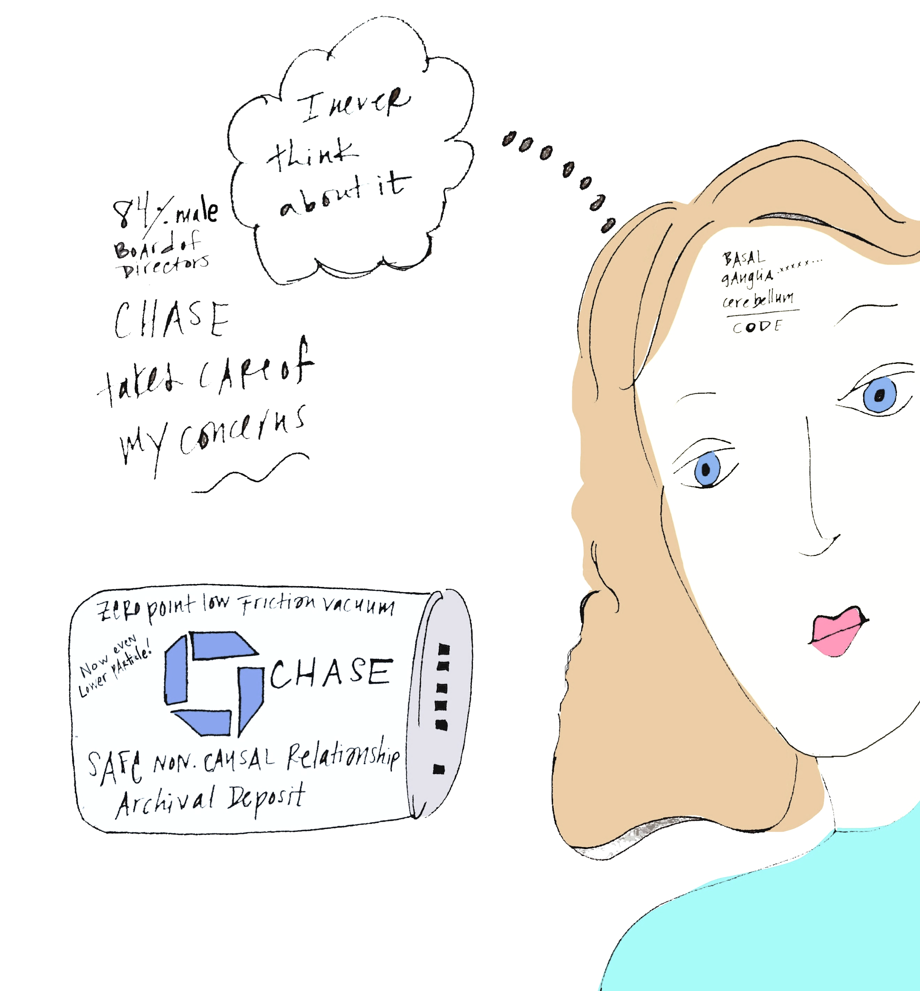

You, Ana, walked into a moment unexpected, the moonlight and architectural lighting merged in a single atmospheric glow; beauty. A glass carafe was passed while music played. It was Spain. You had no agenda or attachment. His lips were pillows, he stood out as the most obvious of the litter: you chose him like you'd choose the prettiest kitten. He was amused by your language, by your limbs, flexibility; the stunts. You were in transition, trying to find B, not sure where A even was. He was hanging out magnetically in the now, with carefree panache, flipping his sun-streaked hair left and right. He was trying to write a book or a film. He thought you could help. He was trying to figure out how to write these in all of the years you knew him. His asking for help turned into yelling in defense, territorial projections, blame. You got him new glass frames; these said something bolder. You watched his vanity grow as he attempted to make a personality for himself. You had to ask for sex; your therapist said "There is too much emotional intimacy between the two of you for sex, if you had less emotional intimacy, he'd feel safer just banging you". The therapist was a mindful-based male counselor, who--- after truncating your rants in couples' therapy-- would say "she's probably right... but still, she shouldn't speak." In the heterosexual fallout, this made psychological sense, you trusted the therapist. You stopped emotionally connecting, and bent over, wearing nothing, conjured innocence. Your quiet mental-mantra when he'd fuck you was "I am every woman, I am every woman", and that somehow made your vaginal canal more magical for him, because somehow he seemed to catch on to this transformation, was turned on: he seemed to be convinced, just for a coital moment, that you were every woman. What more could he want? All options were there. But you couldn't say anything in bed, it brought up his early childhood trauma of being pushed around. Out of bed you became an apologist for speaking, as well. You collected information on workshops toward bettering his relational skills, pretending they were solely for your interest. You became a subtle advocate. And, continuing in the fashion of indirect desires, you'd partially hint toward desiring his deeper commitment. Together, you talked about "what if" possible futures, as though neither of you could control your destinies. You both wanted to conquer something, or--- he did, and you, always failing somehow to align to the designated expectations of modern woman, kind of just mirrored him. Yes to competition, yes to hard-nose business, ambition to the max, yes to not sure if you want a baby. When he called you "baby" it made you squirm. "Call me Lady", you flirted. "Call me High Priestess, Council-Woman." In your sleep, when neither of you were watching, you fed him identity, he fed you stability. Then you took a moment apart, you made the ruination-move toward something independent, challenging your connection beyond the realms of convenience. Would he be patient while you grew outside the container of easy proximity? He ultimately fucks someone else and lies about it, and you, despite the now-near obsoleteness of time-space and your capability to look retrospectively into the moment, are still surprised– because you had no clue he could do that. Though you told him all along he could fall susceptible to doing such, he called you "crazy" for assuming his behaviors could be so malign, typified; until you considered yourself irrationally so. Of course, he lives to confirm your fears: he is an opportunist, a chauvinist, an appropriator of feminism, a tyrant who gains his power stealing entrepreneurial branding ideas from his woman's earnest insights while publicly undervaluing how she's fed his environ. He emerges more well-rounded, better groomed, better shoed, less love handles, better lingo, can make a super-food smoothie. You leave broke, empty, forgetting your value, personhood-less, riddled with years of "stuff to work on", needing multiple doctors: under that delusion.

As much as headstrong female-led relationship initiatives often failed to work in the contemporary dating landscape near the year 2020, they successfully flourished in under-realities. When gut flora had not been cleared through extreme detoxification, enema, juice fasting, sucrose elimination or external magnetic wave treatment, severed couples continued to share similar microbiome populations, connected within quantum superpositions.²⁰ While women walked away destitute from seeming-breakups, their sensorial allegiance to former partners still meticulously lived on (even sometimes growing stronger through retrospection), invading thought streams and interrupting focused ambitions. Meanwhile, XY hetero men were resultantly fortified by the unending creative devotion of their past women-bodied partners, and confused their state of stupefying emotional shut-down with a false sense of having developed boundaries to maintain uninterrupted focus. (Once the XY spends enough time in the chrysalis of his concealed work environment, he then regains ample momentum to find a new XX from which to consciously collect further musings.) Still, in dream worlds and meditations, past-lovers' fingers continued to sometimes touch, even if they'd ghosted each other in dominant reality, removed all evidence of having ever been acquainted.

You deleted his number from your phone and removed him from all social media platforms (which formed some of the first ethereal super-highways racing toward bionic symbiosis). You avoided his street (during the time you could still walk through Manhattan in physical dimensionality) and stayed away from anyone who shared his same first name (which was, at least, 1/5th of the uncreatively-named male public). Meanwhile, your marriage together flourished in the building blocks of specific under-realities. Living on, you energetically gave him more than Sting gave to his emotional vibrato, every vow of passion you had, every move you made. In the midst of this ensnared under-reality, were two additional, distinct under-realities of your own, competing to take over as dominant, actual. One of these under-realities promised you'd make amends, he'd recover from his mid-life crisis, your trauma would make your coupledom stronger-- the other, of course, would prove the contrary. This wasn't unusual for those suffering post-relational trauma. The dominant reality remained, largely, vague, facing the unknown with underlying flavors, like a merlot. Hints of countering possibilities, flavors of ashes and rose.

The dominant reality had strong ties to various under-realities, in order to perpetuate itself in the case that it was disassembled by all forms of congress. Just before the year 2020, both sides of the U.S. political congress, a large stakeholder of dominant reality, conveniently organized a government shutdown to allow for a Eugenics-like probing of under-realities, much like Manhattan's L train halts for a projected 18 months from 14th street eastward under the premise of ameliorating the city's tunneled interiors. By attempting to gain operative control over the time-space transmogrification, government hoped for exclusive control of all under-realities. Personal perspective would no longer be individualized, as susceptible to the influence of one's life-path, unique education, genetics or gut-microbiome population. Positioned for large-scale manipulation, ideas could be generated and infected within a collective culture under-reality, governmentally justified as a safety and health precaution, like a flu shot, set to be made virtually available in frequency form not long after the year 2020 through the CVS app. While aimed toward increasing civilian control, the government's attempted involvement in time-space deconstruction and under-reality organization was earnestly presented outwardly as an effective plan to eliminate underground militant groups. Smoke 'em out resurged from early 2000 Bush-era administration, adopted as adage by the farthest Red-leaning U.S. political parties, who felt uniform sterilization of under-realities would assure an unbreakable nation undivided. Unfortunately for their agenda, both the party's nabbed slogan and fundamentalist stance were eclipsed by the election process of 2020, when more pressing Republican concerns, such as maintaining proper manhandling of the unruly female body, took precedence. Smoke 'Em Out, all the while, continued to thrive as a racy sex game with undefined rules for married people, according to the Dictionary of Meme, Cant and Slang.²¹ Devious, hidden government agenda had no choice but to approach its inevitable end near the year 2020, as a type of global transparent telepathy emerged as notable side-effect from the dismantling time-space. The apropos transparency of campaign mottos fresh from the trails of female presidential potentials also supported the end of hidden agendas: Lead with Love, Join the Evolution, For the People (vs. the last of the lewdly corrupt party's Build a Wall and Crime Will Fall phrase). The last hurrahs of hidden government agenda were dramatized by corporations like Lockheed Martin, who presented the typical superficial power-strategy– endorse a presidential candidate in the name of the country's morale, but more realistically assume substantial profit earnings of a minimal $40 billion increase post-election.²²

Many liberals argued that manufacturing how under-realities worked, governmentally or otherwise, was anti-natural and would have a long-term impact worse than fracking. Already, people were not easily able to entirely differentiate their own from others' under-realities, or a dominant-reality; it required substantial skill to be sure which most prevalently influenced one's frame of reference, and often a second or third evaluation. For example, a typical under-reality mind-bender in the Analysis and Problem Solving of standardized tests circa 2020 would read: For years John lives alone in a rent-controlled apartment in South Brooklyn. He spends a total of 150 dollars weekly on groceries and cheap take-out, and although having a near six-figure job in midtown assumes he cannot afford a better lifestyle. After only four dates with a gregariously ovulating woman he meets randomly at the Le Pain Quotidien chain on 40th and park, he suddenly feels he is ready to invest in an apartment three times the price he's paid for nearly five years, and invest in a [red] vehicle. What is true: John's former financial self-concept or transforming identification? The answer, while seeming like a definite D, cannot be determined from the information given, is actually distinctly resolvable according to the (88% male) board of directors at Houghton Mifflin Harcourt, a primary educational testing measurement company. John's poverty-mindset, an under-reality which served his ego protectively well for decades has found a new cranny to grip, and will now protect his self-concealed shame with materialistic pursuit, attempting to avoid rejection by the Pain Le Quotidien woman. Then, his ego stands an 87% statistical likelihood to later leverage this same woman as the inspiration for his next under-reality drastic about-face, leading John to change careers and choose monasticism.

Near the year 2020, the field of psychology is ranked as the #1 job for the very reason of its relentless dedication towards ascertaining what is actual reality from under-realities or the assimilated dominant reality.²³ Unfortunately for the field, not long after Claudius Ptolemy's circa 100 AD multi-spectral discoveries within the unified sciences, psychology was considerably separated from physics and its branches; mechanical, astral, optic, statistical and quantum, and– however practical– considered a soft science. Evidently the firmness of a science was marked by the level of dangerous math involved to qualify its theories. The rigor of Chemistry, Physics, and Biology evidently out-challenged the toughness of what, resultantly, was labeled as soft due to its emotional considerations or immeasurable inexactitudes. Ptolemy, though, was reputable as both astrologer and astronomer (he could explain the rotation of the heart of a star cluster while predicting the horoscopic compatibility of potential lovers and be considered seamlessly legit). To the fortune of human innovation, and specifically for the best possible evolution of the chromosome x and y relationship, the areas of psychology and physics reconvene as time-space dismantles. Eventually, it is understood through the formula of parallel universes that neither a culture nor an individual is committed to any single reality.²⁴ Additionally, under-realities are quite sloppy, driven largely by the gut microbiome, the second brain, and are apt to cross-pollinate within the individual, interiorly co-mingling in paradox (a vodka tonic would be nice/I am fucking done with vodka tonics). One's under-realities can shift via interpersonal exchange or even breed within the dominant reality encouraging submission or corporate endorsement (It's totally fine to shove this piece of synthetic chemically fragranced poly-cotton up my vagina while it bleeds). In some ways, it made sense that congress would be eager to aspire to manhandle and organize these unsorted realms, on behalf of simple regard for citizens.

Those most aware of the then largely-still-unrecognized hetero fallout knew that healthy change would be best supported through beneficent human microbiome restitution, allowing sentient beings to establish greater stability of healthy emotion and self-confidence. As the concern for the future of hetero-sexual relationships became more prevalently discussed, the Change Comes from Within council, the largest organization representing peaceful nations, were concerned that further controlling reality choice might lead to a total shut-down in hetero-reproduction, as meticulous diversity supported sex pheromones and hormone-driven impulses. The Change Comes from Within council was heavily endorsed by the Weight Watchers company, a significant political corporate influence steered by its board of executives, Oprah Winfrey. Winfrey, tied into the lifestylist movement, had widely popularized the power of the human microbiome and its impact on living systems. The cover of People magazine's latest story featured a significantly-magnified (and photoshopped) in-vitro shot of human T-cell and B-cell populations, reading "The 50 Sexiest Molecules, and how YOU could possess them." The headline was coupled with a second, smaller, feature titled "Relationship Studies at School: More Grueling for Kids than Advanced Math", covering the phenomenon of mandatory coupling classes introduced within public schools during the last years, supporting young people to learn the essential human relationship tools previously overlooked in early education in the left-half of the world. The class 101 syllabus included: 1. Empathy and Boundaries, how to have both 2. Inter-independence 3. Types of Attachment 4. The history of codependence 5. Relationships are everywhere. 6. Intimacy out of bed. For young people, this class was much more challenging, statistics revealed, than trigonometry. Plus, students couldn't use calculators, there were no external robotic tools to support test taking. It was considered unfair.

Ana, like many of her women friends whose early education did not include even one class in human relationship studies, experienced various states of emotional flooding post intimate male contact, usurping her ability to believe in herself. Ana sought answers from top experts, though she did her best to limit her Googling because she wished to control the amount of government manipulation her physiological person received. In the same way those obsessed with weight maintenance stuck to their strict dietary regime, Ana had worked hard to keep her personhood chiseled into its most elegant and admirable form by doing what she felt "worked" (avoiding excess search engine engagement, creating a yantric hand gesture to ward off her own realities from collecting outside-reality data, performing a minimum of 75 crunches daily, divulging neurotic concerns and her personal life details only with her mother through an encrypted, exclusive cellular channel. Still, just before the fallout went mainstream, she found herself resorting to consulting social media influencers, the lifestylists, through Google Searches. She knew the algorithmic Google Adwords were watching, but fuck it, she thought, "the ultimate council is love and I need support".

The issues around what would soon be widely known as the fallout, short for the Anachronistic Chromosomic Hetero-Sexual Fallout had gained more momentum than earlier gender movements (including both Me Too, and then it's man-bodied hetero movement Me, First.) Even the most underfollowed internet lifestylists offered social-media support, approaches to navigating through the surfacing challenges of whatever was left of courtship between hetero-identifying people in the years near 2020. Approaches were first, largely, directed towards the female-identifying members of the hetero population, but similar to the way yoga eventually became a culturally legit form of exercise for the toughest of hetero males by the mid-2010's, various masculine leaders surfaced in the world of the internet-famous. They offered man-bodied hetero-identifiers necessary advice on how to do the man thing, selling books with titles like The Mask of Masculinity and I Don't Want to Talk About It.²⁵ With the homogeny of the microbiome's environmentally-induced simplification and the gradual bot-assimilation of what was once, strictly, Hominin physiology, it became increasingly more difficult to locate gut instinct, and to trust this primal inclination. Ana perused lifestylists’ advice in hopes of fortifying her own discernment process regarding the potential hazards of intimate encounters for the phenotypic female. Zeroing in on any available virtual data pertinent to how the effects of hetero intimacy squanders the female power of manifesting personal abundance, she found over six-hundred billion results and one million relevant topics in the last week's news alone. She pounded keys as though she was running out of oxygen. She assumed whatever input she fed her Google browser would likely be used to attempt to regulate her under-realities, fed through various congressional and corporate control feeds. If she chose to travail the physical terrain of Manhattan in the dimensional plane later that afternoon, she expected to likely spend significant funds, inevitably material seduced through informatics. Almost all stores near the year of 2020 were funneled by informatics routers. 5th avenue in Manhattan was nearly infectious. If you'd been near your browser window (or even merely thinking too much in lingual thought forms) you'd likely be lured in. Searching "can running shoes make you run faster" would lead you, within hours, to a deal. Walking to the corner to pick up a canned sparkling water, the specific brand of shoe you reviewed would be on sale for you, sent through phone app alert. Events once considered "surprising", "kismet" or "coincidental" were now just considered advertisements well-targeted. Ana thought about how she'd recently dropped significant funds on regenerative face-cream. She'd only Googled the word Youthening, to see if it was a real word since Adobe continued to auto-correct it to You Thinning. She then walked by Sephora, a cosmetic store set up to be run efficiently by bots early in the upcoming decade. Her phone alerted her, "Ana, just for you, a complete youthening makeover and 75% off of all total products used, when purchased in a bundle."

Regardless of how a moment of search-engine seeking would support future target marketing, Ana could not resist, weaning off the intoxication from her night before, the raw human-body contact, the sweat, the feelings; she needed placation. Like a cave-woman ravaging an animal bone, she engaged in the consumption--beginning with searching, simply, "Healthy ways to survive the neurochemical aftermath of a hetero intimacy", but quickly went down a worm-hole until she steered down a path of mental regression, sheepishly pounding in "Rife frequencies to electromagnetically get him to text you." Already the effect of just a single night had rekindled past inactive neural transits, gut bacterial breeding-- which would, of course, turn gradually into a sense of impatience, then illogical loss, arriving as a preoccupying state of low self-worth and fodder for insecure nighttime dreaming, plus cravings. This would indirectly and directly feed the pharmaceutical industry, as well as provide more algorithms towards handing over what was, traditionally, homo-erectus responsibility directly into the futuristic hands of promised bionic improvements.

Ana was among the rare, remaining hetero-phenotypic women able to remain nearly conscious in the naked presence of a man-body, many could no longer. In fact, there was much debate if the hetero man or woman had ever been capable of maintaining real presence during intimacy; some believed religion formed only to justify the inherent alone togetherness of human copulation. If the man and woman body were mating under the conditions of God, a third party lent value and standard, provided some bridge. Once fearing god took a second seat to other anxieties (getting audited, GMO corn, social/digital network security, cancer, illegal and/or extra-terrestrial aliens), commodifying sex arrived to replace God's position. Putting a fiscal spin on one's sex appeal rescued intellectualists from suffering within the design of animal fornication, because-- au natural-- it was too much to digest, the bizarre nature of intimacy naturally led to self-annihilation. Less designed for sentient comfort, sex organically supported the intellectualist's position, supplied much opportunity for the thinking mind to reel in thought and to struggle with the physics of boundaries and debate attachment theories.

After one's source-excrement is stuffed into the depth of another's most inner-housing compartments, sex encourages a scramble, a time-consumptive scavenger hunt to locate one's esoterically displaced self-value within their remaining lifespan, or, if need be, the next. Post God's influential wane, commodifying sex perfectly covered up the emptiness of intimacy by selling it as a form of being made complete, contrary to its greatest offer: to feel (ecstatically) what, between us, can never touch. When the upper echelon of society was so well-trained to use the right salad fork, how could the same mental limits rationalize sticking body parts into each other, like passing mangy dogs on a bleak city block? Best to stuff their parts in lingerie, for rating, let their most glorified features be time sensitive, susceptible to drooping, drying or going limp. Then, the hetero could sexually show up with their characteristic disposition, present solely in the realm of competition, self-judgement, futile perfectionism. Mid-sex, neurons fired pathways of turn-on and fear simultaneously, processing potential loss, abandonment, danger. This allowed sex to be both wicked and desirable, satisfying and endlessly alluring; not too dissimilar to the classic spirit of war. This Freudian complexity would disguise the biological phenomena, built to highlight how challenging it actually is to be unified with another person in the erratic spectrum of the sexual event. Sex was just the same as other awkward biological functions. How easy is it to use the bathroom in the company of another? Culture had chosen, perhaps risking less disease, and for the mere sake of cleanliness, to create comradery in sex and not in defecating. Society could have easily put zero emphasis on copulation, facilitating biodynamic ways to make puritan its process of fecal excretion, distinguishing the collective outhouse as essential to status and appeal, touting the best public defecators as responsible for composting the most arid, crop-rich lands. Instead, civilization has long slapped projected shame and alienation on the mysteriously-maintained human act of relieving digested food. To excuse oneself from a business meeting to use the restroom promotes uncomfortable visualization, the buck stops there, imagination halts. You will never know if John in Merchandise has solid movements. You may familiarize yourself with every inch of your beloved's body for a dozen years, yet have zero ability to identify the shape of his defecation. It's even possible to be dating a socially-stigmatized anonymous chronic diarrhea’r and be in the total dark. Years down the line you can find out simultaneously, not only was Lambchop sleeping with his secretary, but he was also heavily dosed with Rifaximin²⁶ These intimations remained culturally silenced. But romantic dinner, if truly successful, encouraged effortless digestion. Would it not then make more sense for the experience to lead to shared bathroom time? This sounds nonsensical to the cultured minds, but history, itself, recalls Claudius and Vitellius in ancient Rome who found it quite fashionable to vomit together with friends, in their best attire, mid-Roman feast, everyone puking or else watching the puking.²⁷ Sex is considered worth voyeuristically paying for in even the most mainstream of Hollywood films, triggers tears and excitability, but a bathroom scene– in the rare cases of earning a cameo, is nearly abhorrent, shocking. However, if 90% of the human body is bacterial, then isn't the species' metabolic epicenter its greatest common ground?²⁸

Despite the dyslexic promises of intimacy, nearing the year of 2020, self-titled tantric partners in the left-half of the world claimed to experience high-forms of blissful union. Debuting their coupledom as preened, paired social media lifestylists, tantric partners promoted fallibility (admired for being "so real") within the context of infectious, 4-minute video footage. Through culturally appropriated sacred connection practices, the partnering tantric lifestylists shared their step-by-step how-to's with the world, carefully strategized within dismantling time-space. Repackaging ancient practices with just enough Gucci appeal could win the attention of mainstream trend-setters like Gwyneth Paltrow or Madonna. For the vulnerable tantric partners, conscious intimacy was simply necessary groundwork for marketing and their ultimate net-worth as lifestylists, they had no choice but to esoterically breathe deeply together and lean heavily into the ups and downs of their work.

Near 2020, admissions of vulnerability in all fields were largely concentrated in promotional marketing. The department of education became advocates for being vulnerable, cyber-security organizations began to recognize the state of vulnerability as more complex than previously considered, vulnerability was the it word from the bedroom to the boardroom. However, in 2023, social researcher Brene Brown, a lead pioneer of contemporary vulnerability, releases No Resilient Return, introducing a concept she calls "annihilation" to the millions within the community of Mindfulness-based Personal Growth and Development. After this point, especially as temporal time-space dismantles, promoting vulnerability is considered just a touch passé, replaced with selling, instead, the tools to transparently live in a seemingly-posthumous state of self, as there is, existentially, nothing left to hide, so therefore nothing to "vulnerably" bare. Still, near the year 2020, those paired in self-labeled vulnerable tantric partnerships shared their most intimate coupling secrets, often identifying as practicing ethical non-monogamy. Because being ethically non-monogamous would later become a bionic gender orientation of its own classification, those identifying as such are excluded from the figures reported regarding the sexual engagement of hetero-men and women during this time. Therefore, it is statistically accurate to report that the hetero-culture near the year 2020 was more often than not in a state of psychological disassociation during the act of sex. The collected data analyzed within the identified XX/XY hetero-sexual demographic reflected nearly 87% of hetero partners as either a. under the influence of a substance or b. creating apparitions called "fantasies" during moments of sexual intimacy. These couples were, therefore, not actually experiencing what original religion named "a sacred union under god", but something more like VR: put on a head-mask, in the dark, and almost feel like you're there. Ana, like a dolphin who slept open-eyed, was possessed with an unusual skill to maintain a high level of integrated embodiment during sex. Though her under-realities and cognizance were partially hijacked with programming, due to her adolescent history of being a noted gymnast, and her fastidious adult calisthenics regiment she'd could simultaneously breathe, while looking into hetero-male eyes, allowing little sparkling things to fall from the ends of her hair and fingertips in the rare condition of actual energetic connection.

While it was an endangered experience, especially in a city as apt to mark the first hybrid strides in global singularity as Manhattan, two people with complex-enough microbiomes (or whose microbiomes were once "complex enough") were able, potentially, to deeply resonate. This rare type of connection was even less likely to happen in the algorithmic, commodified world of dating Apps (named after strange verbs like Bumble, or Hinge or else after flammable material, like Match or Tinder). Therefore, it was largely a waste of time that Ana would bother putting her profile on an app at all, as she was of the rare breed of still semi-prevalent hopeful romantics (all who, like European Jews in the 40's, self-protectively hid their spiritual predilections--though, in the case of the modern Manhattanite, the hopeful romantics hid their spiritual inclinations even from themselves). Ana was using the app for something else: like a filler, or a "mind-suck", a Netflix replacement somehow combined with the purchase-possibility of Amazon, plus something oracular, a free psychic.

Left, left, left, left, left, left, 54 lefts. Only her thumb moved. 2 Calories burnt. She played with the possibility of possessing instinct. Largely, she discovered, her microbiome must be completely flattened-out, for her gut inclinations were entirely incorrect. The few men whose faces she swiped right on had been vulgar from the start in their communications, immediately sexually forward, or (even worse) overly filled with terrible puns (Are you a professional Baker? Because you sure are a cutie pie! Un-match.) She wasn't a snob, and (frankly) appreciated nearly any form of admiration, but Grandpa punning would literally lead her to wretch, and she couldn't afford to lose any potentially strong remaining bacterial strands.
Just before she unsubscribes from Bumble, there's an unusual trajectory. At first swipe: a glue-like feeling in her stomach. Mini-eruptions of curiosities, even hope and a red-flag preamble, self-warning. Not much later in the realms of time-space they make voice contact: she feels irresistibly led by an alien tendency to immediately meet him, despite the lateness of the evening. Next comes personal exposure, falling over, ripping off of things and clothes, an uncontrollable "fuck it" disobedience of the most-followed lifestylists lists of dating rules. (No Matter What do not kiss him for three encounters, no matter what, don't give him your number, don't reply immediately to his messages, don't respond to him after 10 p.m. no matter what, etc.). The rules wash away in the mesmerizing concoction of the rare perfume of deeply complimentary man-body and woman-body combined sweat. Usually, Ana would cringe being sweat upon, but she drinks it, rubs her clean hair on his perspiring torso; wipes her face on his chest. Then, naked easefulness (which is entirely nearly extinct, by 2020, even in the dark). Pinky swearing, "you promise you won't lose total interest in me because I'm showing you my female anatomy within 3 hours of our first meeting?" (The pinky swear, a false promise in the making.) Ana walks around bare, moving in effusive elegance, she isn't even this comfortable naked when alone. Suspended time, after-which, light enters, things are fetched, put on again-- but backwards, inside out. There are planes and things to catch. Kisses, face touching, lingering movements, denying the outside would be cold, the hint of their future reconnection, "I want to meet you for a coffee, I want to know you more". Exiting the 7th floor, elevator down, the heels of the pair of he-socks accidentally taken freshly sticking out of the back of her sneakers, she's cozy. The easeful walking in the dusk. A quieted mind, a humming, a charge: natural frequencies, the off-gas of original microbiota in harmony. A whole day of this. Feels like restoration. Feels like laying near the Glaciers, in Greenland repletion. For one or two days, something moves in her arms: more than butterflies. The two days are filled with crystalized life; it's easy in those suspended hours to decree that, "no matter what happens", it was "so worth it" just to "experience". Then-- during day three into four, with no further communication between the man-body and woman-body, it's like a flu. Something hits. Incoming suddenly, then struck out cold. Descending. Down. Drained. Emptied. Vacant. Can't find feet. Can't find body. In the case when there has been just one encounter, repair is gradual--- but it's still possible she can return to the general state of her microbiome existence similar to nearly before their first engagement. However, after a third encounter, Ana knows, it becomes nearly impossible to comb out the effects of hetero-male interaction for the hetero-female, her insides altered from whatever they were like before. This is what happens when we are vehicles for bacteria exchange: Hallmark popularized the adage "sometimes you meet a person who leaves an invisible mark on your soul". Science, once dissecting the gut of fresh human cadavers, makes it slightly less sexy. Unless altered through TMMFS (Transcranial Microbiome Magnetic Frequency Stimulation), random nuclear energy exposure, or an extreme type of cleanse and rehabilitation program involving copious consumption of juiced heirloom grasses, the very species of lactobacillus your animal-instincts discovered in your 5th grade boyfriend (it was his lactobacillus, not his skateboard, after-all) is the specific strand your 43-year old boyfriend sniffs out three decades later in your field. He craves your distinct varietal blend and, at least in moderation, you'd like a bit of his. Meanwhile, four years down the line, after the relationship has tumultuously come and gone (and your gut biomes seem to want different things) your shared bacterial strains will continue to communicate in quantum fields. Near the year 2020, The prominent University of Oxford's physics communication team discovers bacteria can couple with light particles²⁸, transfer information, and communicate in multiple states at once. Now you have his alcohol adversity when he literally found you by a tall bottle of red. Now he craves green vegetables, when once they offset his palate. You admit you like creamy coffee, before him: tea. Just beyond these changes of taste, just past the proclivities of brain and tongue, it is the autonomic nerve-trains routed to the gut which have interlinked your homeostatic wellbeing with his. And the sing-song-y syrupy radio music that is overkill post-listen two but so excessively loved by grocery stores worldwide, possesses the very frequency to keep active those lactobacilli portals of communication, allowing your gut's bacterial strains to remain pen-pals, involuntarily leading your path naturally askew, to the credit of universal entropy.

You don't want to think of him but the gut leads the mind. Hormones trigger brain spark, thoughts form once, then twice, then three times, until a brand-spanking-new painful neural pathway is formed. You'll walk down the street, but your eyes and energy are all over the place. You'll see him; is it him? No, it's a child wearing a hat, it's an old woman, it's a garbage bag on a bench. And everywhere, the little things, things that belonged to his association, signs that nearly spell his name, brands he consumed, inventions he endorsed or disapproved, paintings he talked of, famous moments he's had, they tie up into your world, leaving you pekid, changing the color of your urine.

During the fallout, the energetic imprint of man and woman-body encounters (especially for the woman, whose neural activity is more complex²⁹) is far more impacting than the ramifications of actual physical contact. Pregnancy? Big deal. Slight in comparison to energetically donating one emotional kidney plus 1/4th of your heart's lifelong drive to a man who's only benefited from the hookup. On a material level, soon, even Siri forgets him. "Hey Siri'' you may ask, "text contact Jack Morgan" Siri would say "I'm sorry, Ana, there's no Jack Morgan in your saved contacts, would you like me to create one?" To this, you think and reply, "No, Siri, and please keep me from doing so in the future."

This happens to Ana: She'd hear nothing from the man-body after the rare, raw, real exposure. Understandably, for most of the remaining hetero-males, it felt nearly too difficult to withstand extreme humanoid contact just before the year 2020, as Halfsies embraced their AI programming all-the-more. If the encounters were truly indelible, and kept beyond any erasure protocol, then--after a month, a year, or a decade the poems would come for Ana, and then the requested, tearful meetup. The male-body typically expressed his regretful recap. They'd return to her in the outskirts of the remaining time-space to apologize, likely hoping, on some level, to refresh their under-realities and their PH levels, revamp Ana's devotion.

Her favorite apologies so far were: "Ana, I took you for granted, would you ever forgive me?" Seconded by the tie of both, "I shouldn't have cared so much that my mother criticized the way you loaded the dishwasher" and "You know, I'd still fuck you".

*

In Manhattan, business took two paths, ultimately, each fed the other, but near the year 2020, the paths were considered polar, dichotomized. One path supported the development of technical programming, algorithmic data analytics, AI-aimed businesses, virtual building, and interactive VR/AR and other R designs. The other weighed-in with equal, transformative economic impact, but, conversely, encompassed all-natural, art-brut businesses, advancing human biological potential as a technology of its own through hacking, "deep-dives", "fasting", "embodiment" and "mind-body entrainment". Both streams of commerce flowed in accordance to the circle of life, catalyzing source energy through mechanical, material, intellectual and elemental combinations. The XX chromosome, associated at-large with the female-born, naturally leant to the advancement of human "internal technology" through nourishing somatic (body and sense-based) learning. While many considered the invention, for example, of Pilates, unrelated to the outer-world of advancing tech, the lengthening of the spine and regulation of breath, in fact, was absolutely central to the bionic future of humankind. Ancient practices led to higher states of sensorial control, which helped to maximize the absorption of our bodily trace-minerals and, eventually, adapt certain body parts (namely the gut, voice and brain) to integrated systems of cyborg design. The XY, on the other-hand, classic to the male-born, supported the effusive distribution of masculine-essence into the world via industrial pursuit. The first basic thermodynamic law explains how-- since energy cannot be created nor destroyed-- the disappearing genetic content of the Y must theoretically exist somewhere. By way of the esoterically star-trekking SOX-9 protein's wanderlust, Y's driving virility broadcasts throughout the world. This particular assessment of chromosomic disposition was not influenced by gender stereotyping. While the professional titles of women were often named as diminutive derivations of relative male-titled positions, affected by the suffix of "ess" (stewardess, waitress, seamstress), XX/XY gene behavior has been observed through empirical evidence. Books like Sex Differences in Cognitive Abilities³⁰, written by American Psychological Associate emeritus president Diane Halpern, PhD. helped catalogue behavioral differences, but it wasn't until the period near 2020 that scientists began to recognize how gut bacteria within phenotypic male and female bodies functioned with distinctly different agendas. While women and men are culturally capable of working within whatever professional field they wish regardless of the sequence of their genes, the metabolic wattage, hydrogen, carbon and methane emitted by each as waste product possesses its own distinct signature. Simply, this feeds what the ancient principals refer to as universal yin and yang, beyond stereotype or social construct.

Ana's company was positioned in the XY-typical pursuit of tech advancement. But in the years before 2020, as time-space dismantled, she sometimes felt ambivalent about working life, contrary to her earlier years, indefatigably driven toward distinct markers of professional success. Ana wrestled with the shame that while continuing to earn acclaim in her field, she didn't feel her efforts were equal to her accolades. In the early morning, reaching for her phone after waking from the discomforting dreams unsusceptible to even the best disk erasure protocols, she'd experience a moment of a longing for a deeper bandwidth of pleasure. Evidently, sociologists throughout centennial lineages have agreed that "to create anything new, one has to muddle to a degree with shame and doubt"³¹. Ana was still under the impression (as were most pre-2020) that to feel shame and doubt made her wrong or off-kilter, or doomed. By the time she washed her face with living enzymes and papaya foam, she regained her mental disposition. Her mind was conditioned to recall during her morning hygiene routine how exceedingly fortunate she was to have built a high-earning career in a preeminent field of social science technology, and to live in the (still dimensionally traversable) city of Manhattan in a comfortable loft. She spent her working time both at the company innovation hub and in her home office, programming what her teammates called sentience into bots for a CNC (Computer Numeric Control) operation. In the last decade, Ana had been part of a masterful team of programmers who designed succinct operational relationship efficacy for robots and the robotic tools they controlled. Her work involved configuring motile mechanisms to constantly adjust the interaction of complex machines to the unstable velocity of time-space. On the day of Monday, for example, in the month of February, just before the year 2020, time slowed within space, offering Ana new algorithmic information. However, on Sunday, just the day before, time moved three times faster, but through thicker space (an atmosphere, in most cases, supporting voluminous and quality creative output). In ways, Ana monitored time-space, designing dependable prediction-based programming for what was coined in the tech world as bots using bots, or bu2bu. Because machines were increasingly over-programmed and moving information at rates too rapid for current time-space to process, Ana's secondary company role was to employ 5-D math (time/space/dimension/energy/pitch) to maintain ethical bot regulations through value-based parameters set by the (90% male) UNCTAD: United Nations Commission of Technology for Development. With her musical background, she helped her company win multiple awards at futurist conventions for team-leading the frequency-based technological design she'd coined as Sentience Time-Space Adaptive Programming (STAP). Ana was not interested in notoriety, however. Near the year 2020 it became less valuable to be an individual change-maker, considering the rate of exposure on the internet alone. When, in the 1960's, there was only one Bob Dylan, near 2020 there were thousands, each playing rambling poetic songs on social media. However, as densely populated as Youtube channels were with the up-and-coming, many culturists argued that raw talent was still as uncommon to find as Astatine, which is the rarest element on earth (a composition of uranium and thorium). Companies such as Ana's would continue to evolve 0-interface technologies, supporting photon-based waveguide computing, in response to the cultural needs of the geological period. Geologically speaking, hundreds of thousands of years into the future, the period encompassing the time around the year 2020 would be known as the Saleolithic period (referring to Salarium, the Latin origin of the word salt), because of salt's role in the mutation between man and metal.

Most people consider salt something innocent in moderation, a proverbial friend of the dining table. How can it be powerful enough to instigate mutation? Simply, its ion-rich convection capabilities and skillful manipulation of the ocean current is enough. Salt also sucks carbon dioxide out of the air, and becomes the dominant replacement for Lithium batteries not long into the Saleolithic period³². Salt is the oldest medicine, draws pain from muscles, cleans irritations, does not burn nor atomize, it lowers the freezing point of water, and (to environmentalist's disdain) is thrown on roads. It's additionally thrown over shoulders superstitiously, a throw-back to ancient Rome's various salt-centric formalities. Evidently, it was once a monetary unit, explaining the etymologically salty roots of the word "salary".

Early 1st century Hermetic Sciences influenced thinkers such as Newton and Emerson, and leant its Caduceus symbol (the winged, double-snake twisted staff) to modern medicine. By Hermetic standards, salt is considered the "last agent of corruption" and "the first agent in generation". Meaning: salt shows up to get the party started, and is the untiring guest who stays once everyone else has left to help clean up. Pythagoras concurred, salt arose from "the purest sources, the sun and the sea". Physics recognizes salt as a multi-purpose agent, it refracts, extracts; it reducts, conducts. It deodorizes, disinfects, it even cuts through grease: it can basically save a relationship if you co-domesticate with a lackadaisical cleaner. It fights strep in the case you accidentally make out with a contagious guy from the wine-bar who you forget to virally cross-check before he sticks his tongue down your throat without much warning (not fun). Salt, also, is the only rock the human body directly consumes³³.

Salt is observed throughout all fields of science as an instigator, from molecular gastronomy to Astrobotany (a field which becomes increasingly popular one centuries into the Saleolithic period). It's easy to chalk (chalk being another form of salt, known as calcite) mutation or the hybridization of life up to salt. In fact, the survival tactics of earliest bacterial lifeforms (who evolved by means of horizontal gene transfer) relied on salt. Inside of highly saline water, the Halophiles, whose name literally translates as "salt-lover", survived early years of rising earth-oxygen levels by exchanging genetic material with their neighbors, transitioning into a more complex and virulent species. Saline-rich environments supported the proliferation of life in prehistoric times and is potentially responsible for the Cambrian Explosion, a period when major groups of animals appeared on the fossil record. Plus, if you toss a pound of even the cheapest salt into a warm bath in Manhattan, just before the year 2020, lifestylists relay you can effectively remove the energetic debris from being in crowds, in the case you are an empath and randomly pick up peoples' pains.
Salt, emitted as sweat and other excrements from the human body, supported the mineral mutation of protein SOX-9 with airborne particulate matter, and thus the era is named after its prowess. Without salt, the meeting of man and metals would be too complicated for the efforts of biological evolution. Salt provided the multi-capable atmospheric B&B getaway for man and mineral to alchemically mate, perpetuate greater machine.

In 2017 the (all-male) congress of The International Union of Geological Science declares Earth has transitioned into a new epoch, called Anthropocene (coinciding with the onset of its encompassing Saleolithic period). Anthropocene is named after man's impact on the planet---and after man's naming of everything on earth relative to himself. The epoch arrives a few million years earlier than previous epoch transitions, controversy arises-- is it really time to chronologically move on? Some remain overly patriotic to Anthropocene's predecessor, Holocene, which had been around for only 11,000+ years (the equivalent of tadpole age compared to previous epochs).³⁴

The hands of a clock are already more than enough to contemplatively ponder, but through a geological lens, the division of time is apt to bewilder. Arriving early by geological standards could mean a sizable chunk of a million years; transitioning to a new era might take tens of thousands. Even the average thesaurus interchangeably uses words like epoch, eon and era, however, geologically, these terms refer to grossly different reckonings of time. Tossed around in casual conversation, one gets away with substituting epoch for era, as they are both connotatively huge to our Timex-sized minds, but the actual classification is quite specific.

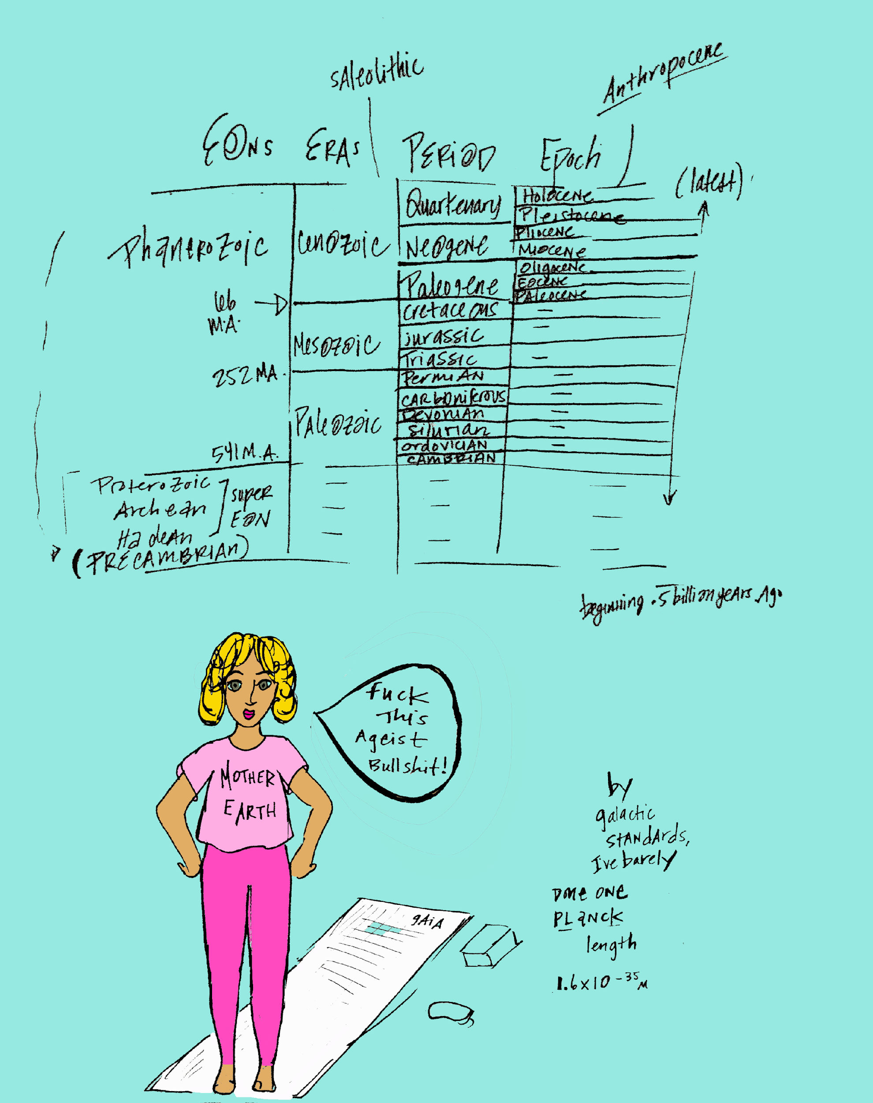

The largest geological division of time is an eon (of which, in 4.6 billion years, there have been exclusively two noted, the most recent being the Precambrian supereon). 6 smaller eras makeup the eons, specified by fossil records and major extinctions, each lasting anywhere between 100 million to 500 million years. The 6 eras divide into 22 periods, and inside these 22 periods nest 48 epochs, catalogued by sediment quality.³⁵ In the far throes of future history, the Anthropocene epoch and its encompassing Saleolithic period, starting just before the year 2020, mark the beginning of the "first heights'' of man and machine mutation. Their unification was termed the singularity³⁶ by the futurists (however, the word is also used in physics, math and history). While some physicists considered their singularity tarnished by presumptuous futurist's so-called version, in the earliest stages of the Anthropocene epoch both fields become relevant to each-other. Through emergent transformational explorations into the unknown, quantum mechanics becomes practical science for human consciousness. Human hormonal drives, mutagenic ambitions, and microbiomes lead the species physiologically closer to a comprehension of the universes contained within black-holes.³⁷

Within the Saleolithic period, the phenomenology of human-centric time-space alters entirely. The marking of time (with starts and ends) becomes mostly a formality, in the way that, near the year 2020, B.C. remains in-use as liturgical memorabilia, a tipping off point for the Gregorian and Julian calendar era, a cultural dinosaur bone.³⁸ When female Hollywood actors take the stage to advocate for more compelling roles and film leads, constructs previously accepted as normal surface as obviously outdated inequalities. In the momentum of collective awareness, it becomes recognized as ludicrous that all time-pieces, from the sundial to the water-clock, the pendulum to the chronometer, have been developed exclusively by the minds of men. All units of time measurement, from atomic time to sidereal time, additionally– the calculations of men. Out of these calculations, exist languages, institutions, societies, almost all devised by men. However, the strangest box of all –caging collective humanity for generations– begins to be unpacked and broken-down near the year 2020, and it becomes impossible to ignore: Why is the world's dominant calendar reckoning existence around a single man's idolized birth? What about the moon, and the biological connection female hormones seemingly have with an orbital element beyond the earth itself? What about that expansive expression of rhythm?

Humanity likes to believe their art and culture shape the "times", however, minerals and their multi-billion-year expedition are the real change-makers. Responsively, human orchestration emulates biology, which composes inimitable harmonic ground for its melodic lead: the female hormones. Near the year 2020, as women step more fully into ownership of their biologically-charged power, perspective shifts, time no longer clings to anno Domini nostri Jesu Christi, relevant to the before-and-after snapshot of a representative man and his holy-robe.

The anthropology of human hormones emerges from gut microbiome beginnings, which evolved from earliest single-cellular life. The primary coordinates of the first bacteria remain scientifically speculative, as researchers (while formulaically disproving dichotomies in practice) maintain postulation sportively, a type of side-taking cerebral barbarism. The two most popular hypotheses share deductive centrality, bacteria formed via water and some type of joie de vivre spark, either in deep ocean vents or else surface pond water, hatching from an elixir of minerals. While bacteria thrive sustainably in multifaceted environments –even at altitudes of 135,000 feet³⁹ (think: Ranch-Hand Barbie, Flight Attendant Barbie, Swamp-Muck Barbie), incarnating within the body of an average Joe is, among bacteria, considered to be the crème-de-la-crème highlife. And-with lifespans averaging just 12-hours in time-space, the rapid rate of bacterial reincarnation turnover makes the feline's 9 lives seem base. Preferentially, of all bacterial habitats, near the year 2020 the human body ranks in the top 3 (second only per-capita to roadkill and spoiled yogurt). This is quite the biological compliment to mankind. The most rich and famous tier of microbial flora (estrobolene, lactococcus lactis and a fancy-delancy strand named h. francis-anderson)⁴⁰ designed super-structure mammalian housing, Architectural Digest-worthy (and in this case "digest" points to the verb rather than the noun).⁴¹ Out of dull, stagnant waters or else dark ocean bottoms, microbial life assiduously sought a manifest destiny not unlike The American Dream. Microbes, post billions of years biologically moving on up, help to form the XY man, whose Darwinian predecessors truly were snails and puppy-dog tails. (However, while sharing a decent amount of DNA with the banana, the XX woman is not exactly related to sugar and spice.)⁴²

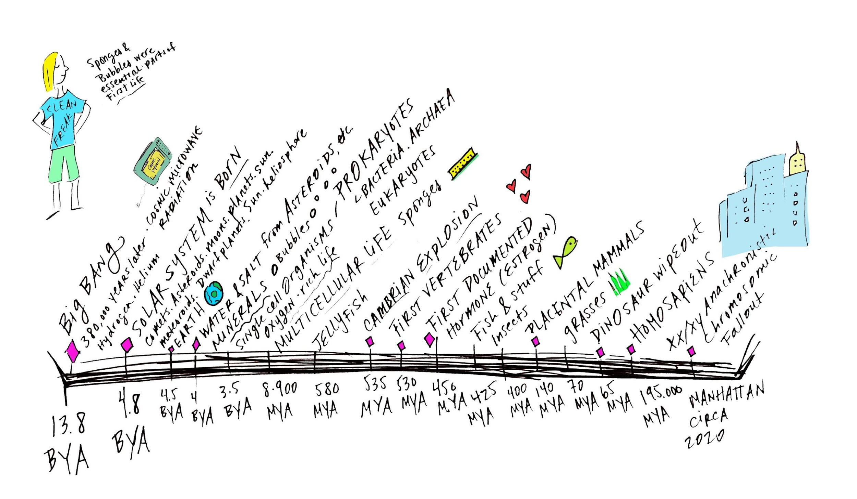

Though living in colonies, bacteria are deceptively much less of "one-love" hippy-commune demeanor than their close-knit lifestyle suggests.⁴³ The scene is more like the aggressive housing market in Hong Kong, one bacterial strand snuffing out another by inspiring a vomit or releasing off-putting gas to "clear real-estate". Each-for-his-own types, life in the bacterial fast-lane involves cunning, instinctual moves (at a general speed of about 100 body lengths-per-second, ten times faster than a Tuna fish, though-- often once arriving at his destination, the bacteria has already replicated into his own offspring).⁴⁴ In the year 2020, empirical research informs, bacteria directs social behavior; can manipulate even the most stubbornly self-willed introspective man out of his boxers on a lazy Sunday of social isolation, sheer across two subway lines to a boring barbeque in a far borough. He does not go for grilled baby-back party favors (his rationalized determinant) but, rather, is brainwashed by the subconscious chanting of his lactobacillus reuteri, whose epidemiological agenda⁴⁵, like good McDonald's marketing in the 90's, suggests on repeat through neural-fired symbols and chemical manipulations, go cross-populate over on some random friend's skin.⁴⁶ Bacteria puppeteers human preference, sparking romance or destroying its chances.⁴⁷ Spend a year apart from your lover and suddenly his feelings change, but what more, it turns out, were his feelings, than his gastrointestinal enterococcus count⁴⁸. Transformed from having sat too closely to his perfumed fellow Ivy League colleague, his strands no longer consider you home.

The gut's nervous system (the enteric) is a hormone-secreting command center of neurons exclusively communicating with the brain. The 100-trillion bacteria there gifted chemical messengers called hormones to humans, in support of ensuring a similar win-win symbiosis between the human and their host-at-large, the outer-world and all it entails.⁴⁹ Advancing the human-environmental relationship was bacteria's eon-long plan to reign forever as the main narrator, the metaphoric typography of the prosaic Story of This Universe, authored by Hook or by Crook. Spunkily animating the mission of life-catalyzing minerals, who arrived from asteroid bombardment in the first million years of proto-earth, bacteria dance a physical expression of the invisible cosmic microwave background.⁵⁰ For, as Einstein revealed, "without matter there is no space and time"⁵¹ and so time and space need the stuff, the chromosomes, the causal dramas, mangroves and ladybugs and ectohormones that excrete a random turn-on somewhere between the apple bin and almond butter machine at Wholefoods, on a just-fertile day 11 of the female cycle, where the young stocker-- not the creepy kind, but the kind shelving stevia-sweetened soft-drinks– wafts androstenone.

Referencing scripture, just before the year 2020, remains in-use as a kind of significant governing proof (right next to science and bridging philosophical maxims). Even in religion (which science at best considered as pre-modern jumble¹¹¹) an all-pervasive God is called by a mineral-rich epithet, Stronghold of Rock. The delicate music of hormones biologically sing The Rock of Ages, mimic the all-pervasive fabric that Einstein, at some point, considered God. Not so long after the year 2020, endocrinologists and astrophysicists together pursue a cross-disciplinary experiment (named the Endo-astro collective) to explore the governing hierarchy of hormones in living systems from amoebas to humans relative to the hierarchy of function in galactic non-living matter⁵². Through length interaction formulas designed by Hendrik Lorentz Factor (used, additionally, by Einstein, to develop his Theory of Relativity) the scientists from two separate fields revel in a shared ρ factor measuring the density constant of both pheromone travel and particle energy forces. Through what began as a playful extracurricular organization (which, for some scientists equals social activity) a giant door opens, out of which resurges the scientific consideration speculative aether, the centuries-long term originally defined by the Greek as "the essence and air the Gods breathe."⁵³ Before radically altering the course of particle physics, the endo-astro team consulted the Dictionary Society of North America's top lexicographers, to first-and-foremost finally settle on one spelling of the word, hosting a riotous after-hours event at the society's biennial meeting in Bloomington, Indiana. The team set up in Bloomington's Kirkwood Observatory with absinthe-spiked cocktails and Greek meze (in honor of aether's Greek etymological origins). Aside from chemical stars and pheromones, they selected from the pretty historic variations: aether, æther, ether and ethier. While typographers and tag street-artists hoped to keep æther alive, to bring back the ligature glyph from Old English Latin alphabet, the team settled on aether (accepting ether secondarily when visually most sensible). After the decision was made, news of aether was then dispensed accordingly. Shortly thereafter in the Anthropocene epoch, technology advances into a post-ethernet period, post-wifi, where wires, plugs, routers and interfaces are no longer necessary. In conjunct with the endo-astro collective surfacing of the aether term, a popular Faceless series (once referred to as a t.v. or web-series, but named now after its medium-less, interface) parodies the recently-embraced term, and soon –as commercial quotes are culturally apt to become colloquialisms, "ether" is interchanged with other filler words, including stuff, whatchamacallit, thingamajig and geshizzle.

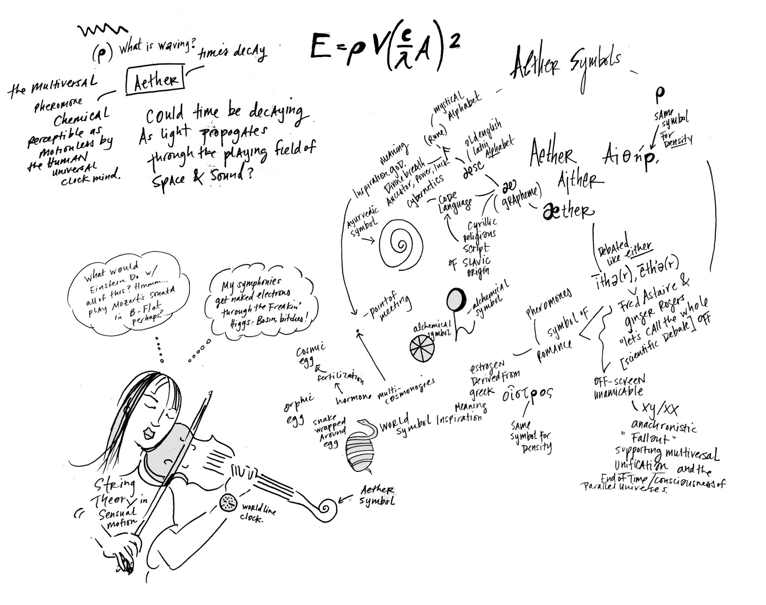
It is nearly impossible to trace the controversial riddle of ether throughout 20th and 21st-century in modern science, even Einstein seemed to have mixed messages about its existence. Meanwhile, despite ether's scientific struggle, it remained quintessential worldwide, from Japanese to Native American cultures, found in technological and mythological applications, religion, science and philosophy. Ether was uttered from the lips of change-makers, including astronomer/astrologer Claudius Ptolemy (100 a.d.), renaissance-man and math-wizard Nicolaus Copurnicus (late 1400's), Russian occultist Madame Blavatsky (mid-late 1800's), the theosophical master Annie Besant and her sidekick Charles Leadbetter in the 1900's.

The specific 1887 famous failed experiment of Michelson-Morley exhausted the ether conversation for a century. Using his optical interferometer invention (which cost under $2,000 and was the result of his first wife's encouragement, financed by his father-in-law). Interestingly, Michelson was then noted as particularly unapproachable and even dictatorial⁵⁴. Additionally, he later abandoned his then-wife and three children entirely (asking for her forgiveness only via his lawyer after he'd safely died). Though she'd pushed for (and funded) his experiment, he failed to discover an etheric medium for the light-wave, nothing creating a waving. Relational quantum physics later confirms the observer effect, and while the math is extraordinary and the thought experiments are mind-bending, the theory simply demonstrates that phenomena is changed merely by being observed, and the observer is, in actuality, an active particaptor.⁵⁵ Women have felt this for centuries: dance perfectly naked in the bedroom; fail asserting the same dance moves at the club. Feel centered post morning run, apply makeup perfectly in the bathroom; disassociate from the body just hours later on a coffee date, catch reflection in cafe mirror and find makeup looks caked-on, yellow. Practice the I need a commitment conversation alone in the car with the windows up en route to meet his family for Christmas dinner and sound like a Toast Master's pro; fumble into stammers and apologetic meekness when later attempting to reiterate. The guy who eventually wins the heart was never noticed for years while the one the brain fought to block out or else continued to fantasize over never follows through. Observation is not passive.⁵⁶

In 1887, the year of Michelson's famous, failed experiment which dismissed aether as improbable, he wrote to his author sister Miriam, "I had hoped to see light travel with the same velocity in all directions⁵⁷, but I could not stop thinking of the irritation I feel toward Margaret, and wonder if it is for her encouragement I've spent her father's money, and if I have any substantial fabric and foundation on my own at the least. Also, while I appreciate his collaboration, I wonder if I am the only one who finds Edward [Morley] an unbearably loud chewer." Perhaps, by his complaints, Michelson lacked the very Greek origin of the aether word, himself –the inspiration of god– and so could not, as the participating observer, prove its existence. Considerably, Michelson's heaviness served ether well, for, after thousands of years of the term being as popular as Santa Clause cross-globally, post the Michelson-Morley experiment, the earth fell into an etheric hush, a calm before the storm of its resurgence. Though Max Planck, Paul Dirac, and even Einstein spoke of new takes on what may be considered as aether, it is not until after the year 2020 Einstein's theory of relativity is truly again put to use, furthered by the chance meeting of an oracular psychic on 3rd and E. 22nd in Manhattan and a begrudged scientist. Dragged into the palm reader by his vehement sister, he is just post-divorce and has immersed himself in work to numb his emotional confusion. He can hardly hear her verdict of his life-line, his love-line, his finance-line. They've all blurred in her smoke-filled space. It turns out, just before the year 2020, the psychic parlor is the last public place in the physical Manhattan one can light up an old-fashioned cigarette. She convinces him, fingering his palm between her ashtray meanderings, he needs an Akashic record clearing (Akasha just so happens, in a Jungian type of coincidence, meaning "ether" in traditional Indian cosmology). Mid-reading, he hears her say "Light is not constant in a parallel universe", which jars him, roused from his state of previous fuzz, he responds, "Excuse me, what?" She replies, "Your life is in constant peril but I can reverse this." He's misheard her, but she's opened a channel for his thoughts. Not long after, his team of science colleagues construct the necessary formula, at last; considering ether as an energy gradient effusing from parallel universes, a constant (like our galaxy's light) within foreign, formulaic spacetime. Then, aether becomes comprehensive not in the context of our enclosed universe, but in relation to an ultimate multiverse, where light-speed is not constant, and ether-- motionless in our perspective as Lorentz suggested, escapes all forces of human measurement because it has transcended ambition, or universal causality, and even entropy.⁵⁸

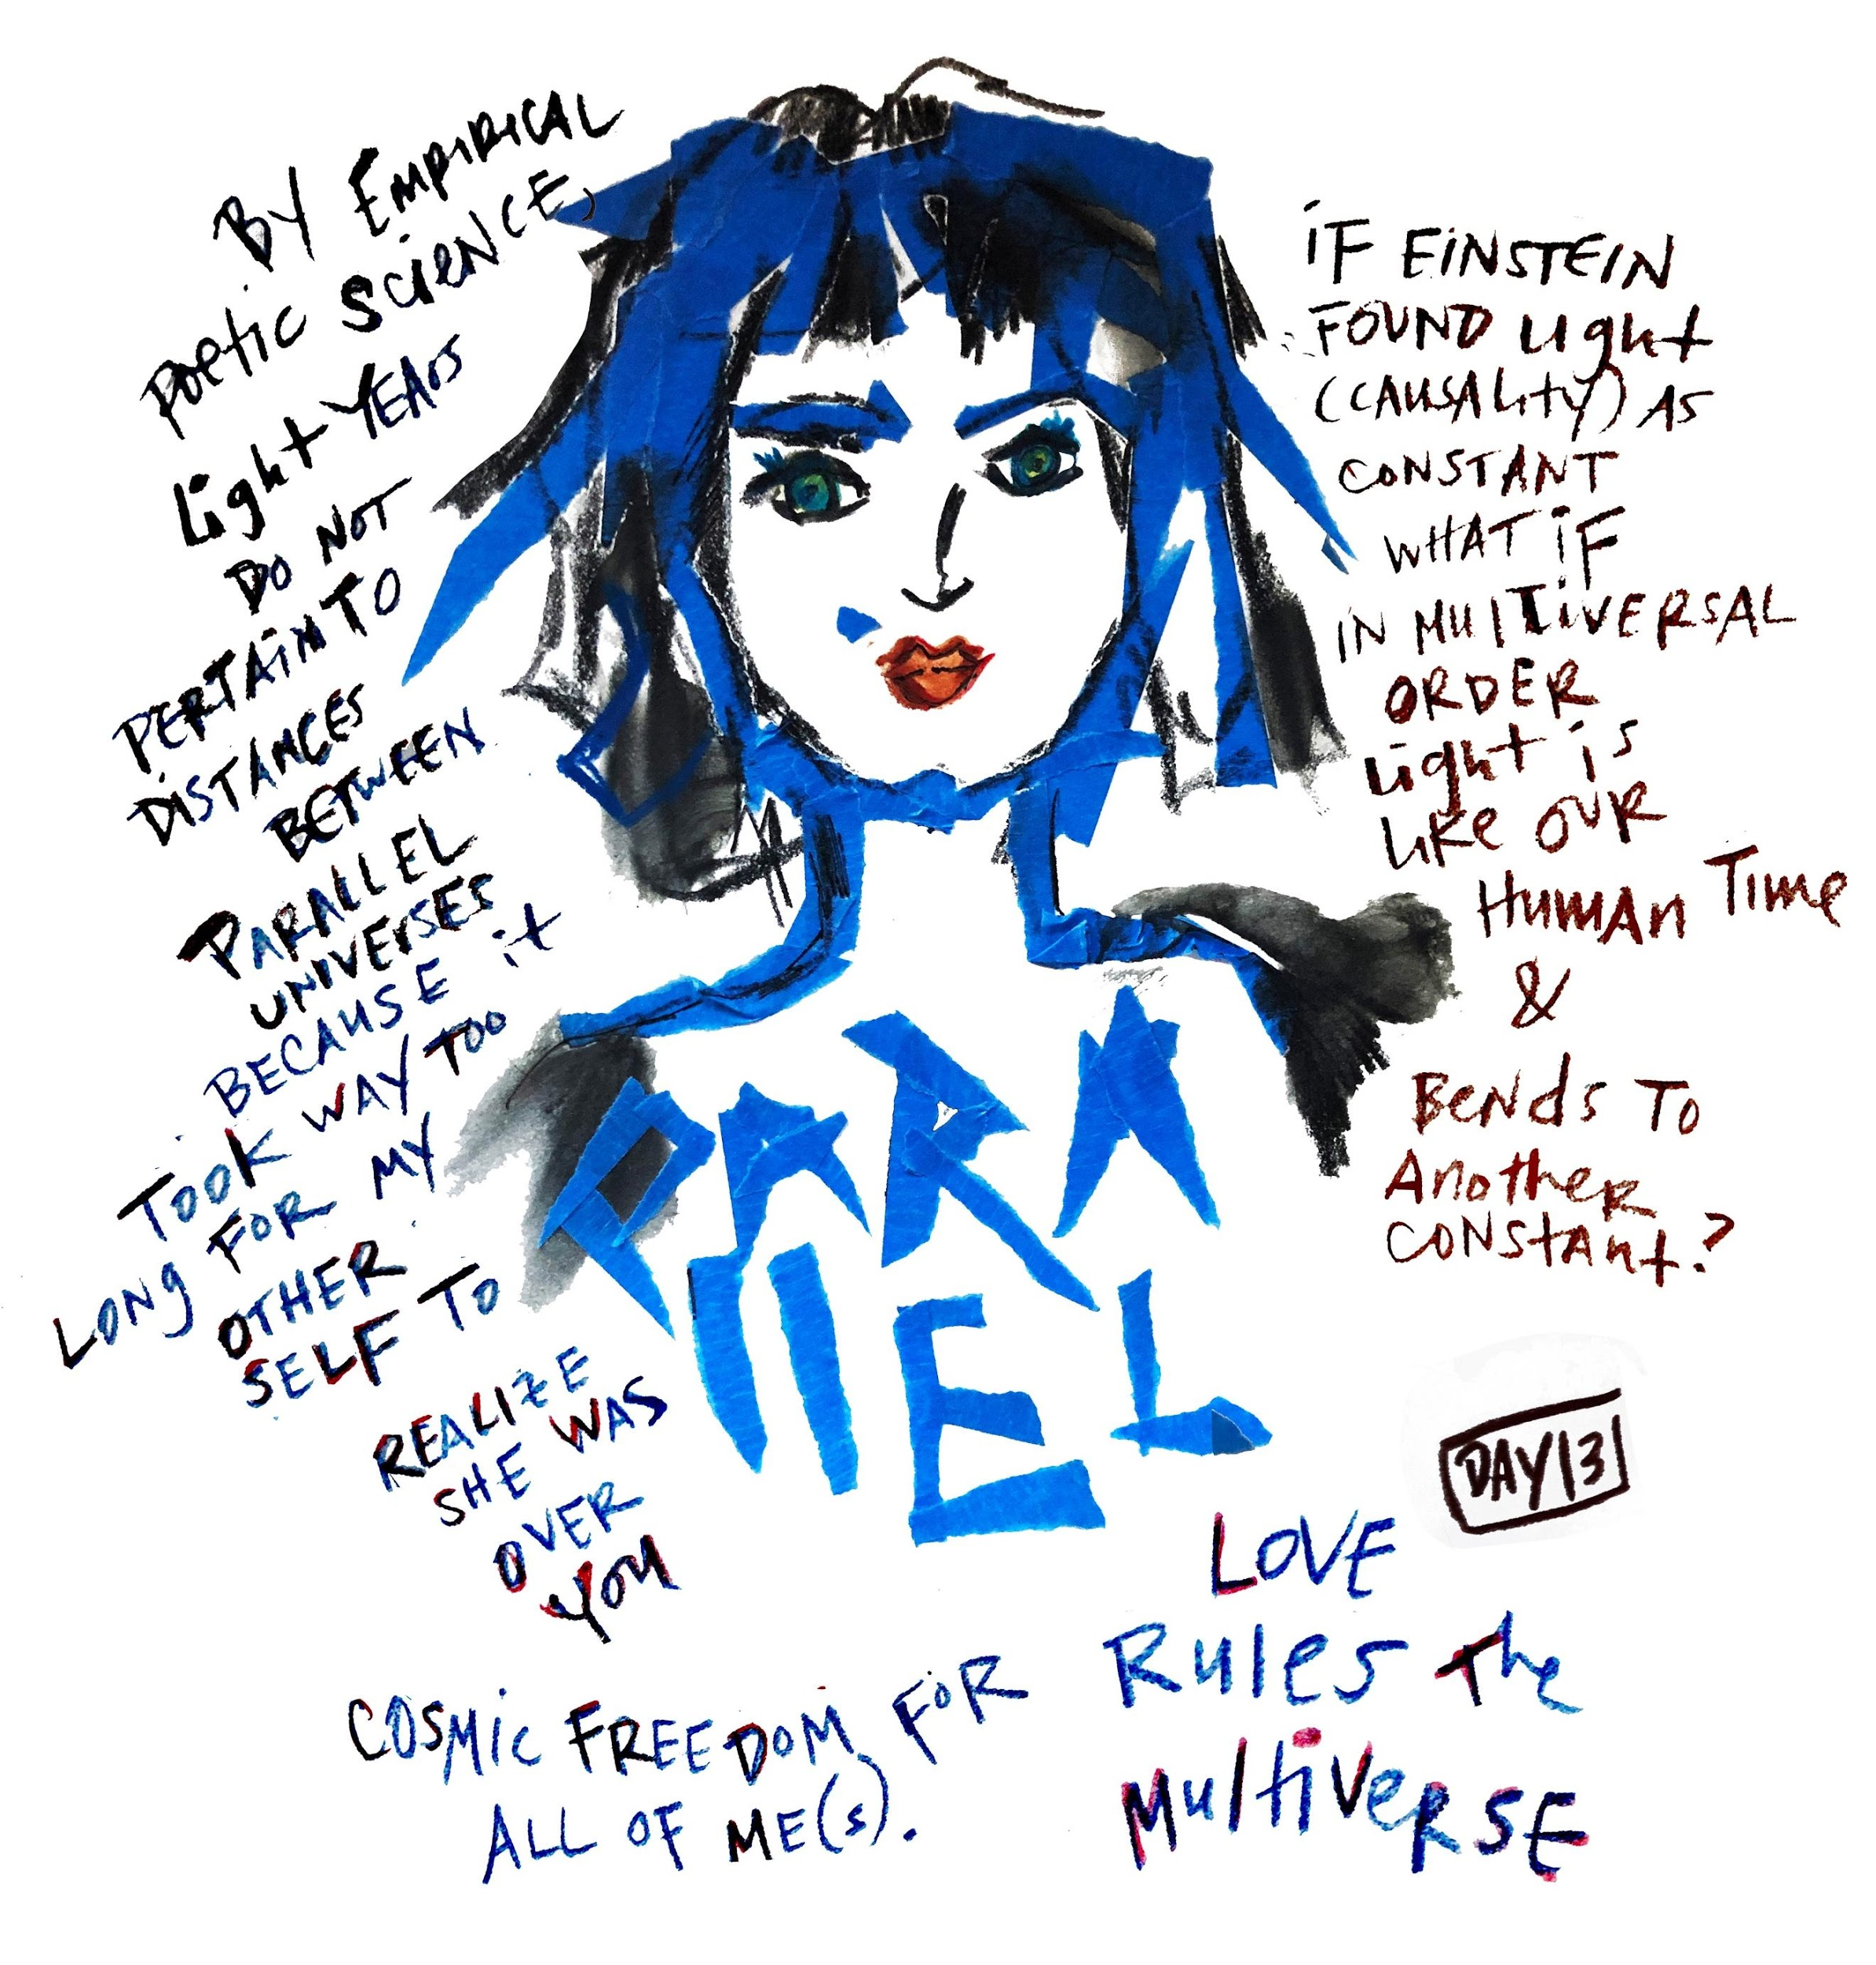
Just as the formal use of ether had been shunned in institutions of high-reason, the pervasive power of hormones had additionally been misunderstood for centuries. Both were often considered occult, witchy, socially inappropriate for public conversation. Simultaneously, in two nearby Manhattan locations one woman in midtown, under her breath, bonds with her female colleague in the over-lit office sky-rise, matcha latte in hand, preparing for the board's quarterly: I am so hormonal, I can't listen to John brag about his golf handicap today. She blushes because Robert, the new executive assistant, has overheard her; she wishes she'd been more discreet. At the same time, in the spiritual bookshop on 14th and e. 2nd, a metaphysical author shunned by his former Ivy League alma-mater reads from his new book At the Edge of Ether after first publicly confronting how he'd been belittled in the New Yorker by former lab partners for having tossed the word ether around with such credence, as they've actively supported the term's removal from all scientific conversation.⁵⁹ Offering portals to greater advancements in understanding the unified field, hormones and ether represent opportunity for experiential learning, transcendence, transformation, transference and time travel.

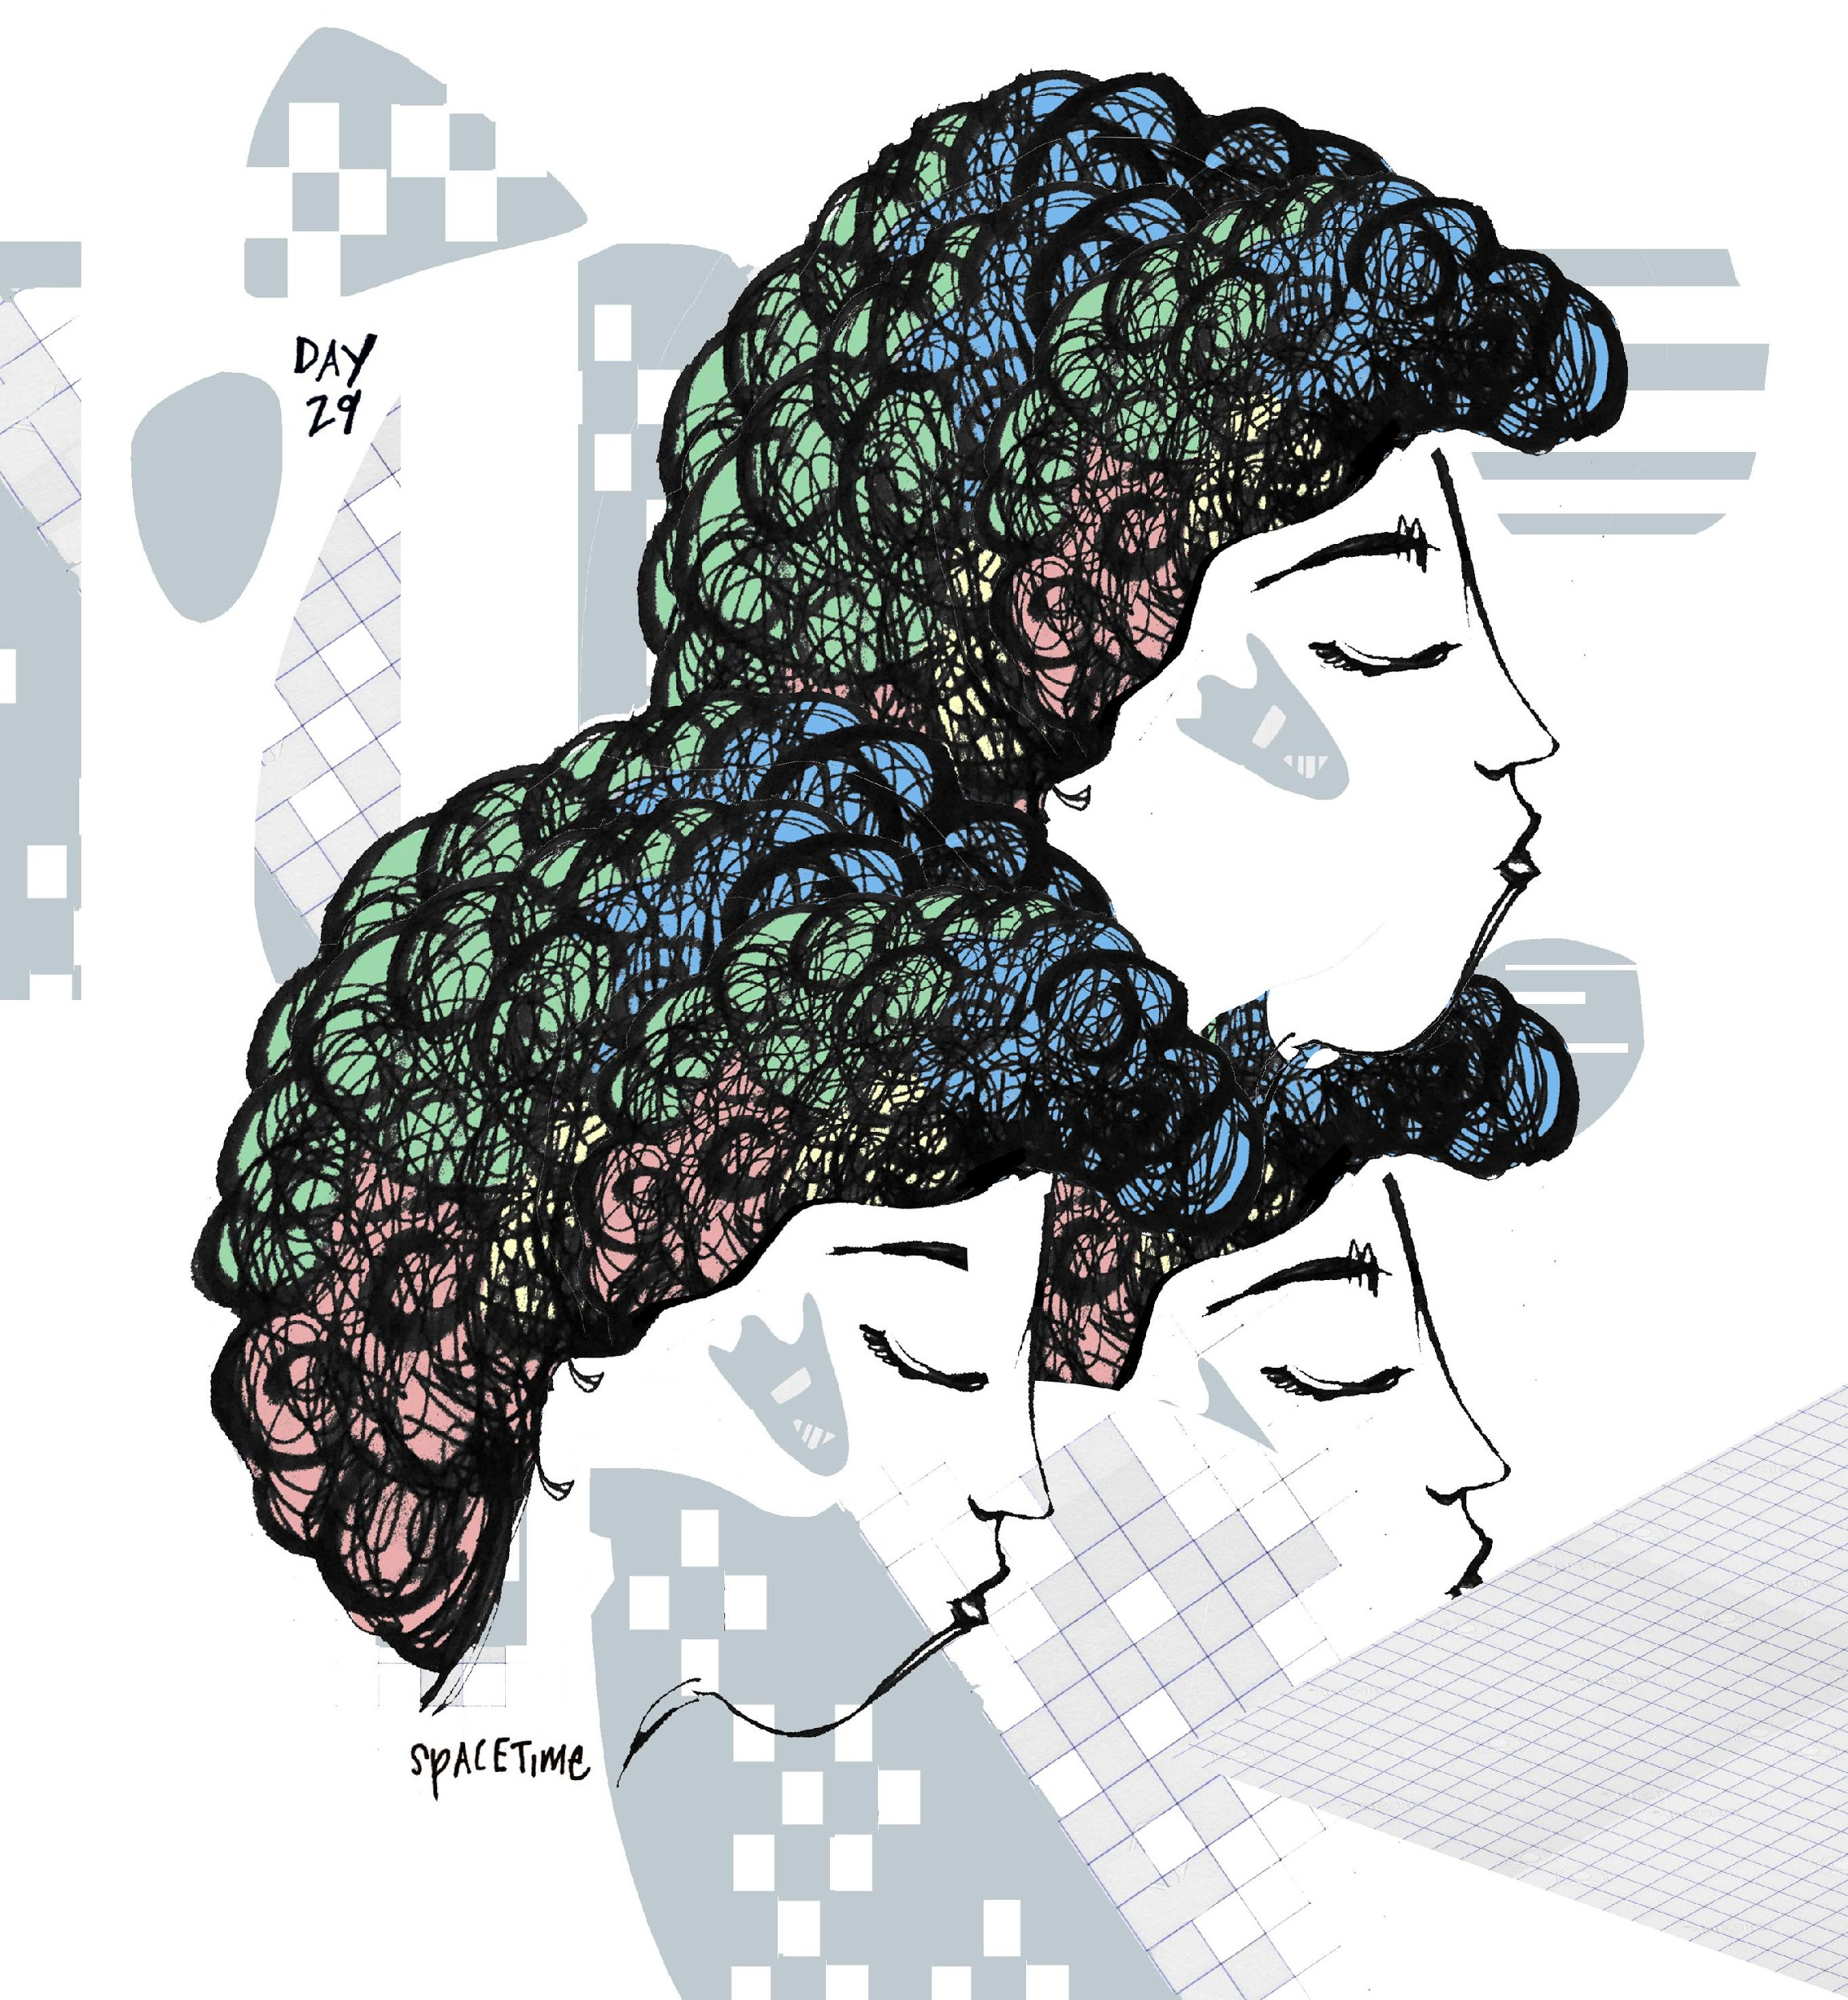

Ana has a love-hate relationship with conferences, but is the elected speaker at the annual WSIS (World Summit on the Information Society) conference in Geneva. She was asked, specifically, to speak on being a woman within the field of computer science. Ana is considered the pre-eminent female leader in Sentience Time-Space Adaptive Programming (STAP). She's prepared literally nothing, and decided to start her speech off with only the line. "I've prepared literally nothing to talk about today" and take it from there. In every possible professional measure, she is meticulously organized, there is hardly an inefficient moment in her day, except for in the rare case when she plans for inefficiency. She luxuriates in the first-class travel, Swiss air: even the food is more-than-edible, the only airline she trusts on a culinary level. Ana chooses the red-eye, she likes to sleep on overseas flights, wake refreshed in another continent. Geneva feels gentle upon arrival, the sun has only just risen. Ana's mind quiets in the taxi, through clean streets to the hotel. She takes a hot shower after checking in, climbs into bed for a few hours more, she speaks that evening. For the first she can remember in seasons, she sleeps without unsettling dreams, or if she's had a dream, it is long, deeply restorative and quiet. The hotel is nearly soundproof. There is nothing humming in her room when she wakes. Before she meets her colleagues, she gets dressed and spontaneously heads out into the city, deciding she'd like some new shoes; something she can wear to work, but also run down the street if she needs to, versatile. In Geneva, the law has mandated that informatics routers cannot solicit pedestrians, and Ana feels a lightness from being free from Adword marketing. She opts to eat something she'd rarely, a long, seeded baguette with cheese, tomato and lettuce. Sitting outside in a terraced enclosure, she bites her sandwich in the fresh spring air, intercepts each bite with relaxed breathing, sips a sparkling, naturally flavored water. In Geneva, a water labeled "naturally" flavored is obligated by Swiss law to be actually derived from 100% natural ingredients, non-synthetic. Marketing language used by the food industry in Geneva has remained free from bastardization. Effectually, Ana feels quite superb in Switzerland.

Without planning for it, she's somehow just enjoying the moment, perhaps because she is on day 11 of her female cycle, her estrogen is beginning to peak, the world is a fertile majesty. After her momentary lunching pause, Ana walks into the city center, close to her hotel. Directed by her gut instinct, which somehow feels particularly alive in Switzerland, her path leads directly to the front window of an elegant shoe store. There, she finds the exact shoes she's envisioned, grey, soft and pliable boots, just above ankle height, the apex of Swiss architecture expressed in the perfect combination of stability and poignant subtlety. The grey boots fit in a way she'd not have to break them in at all, she wears them out of the store.

Later that afternoon, she rises from the round, white-clothed table at the conference center. Thanking her introducer, she approaches the podium with easeful breath. She feels an unexpected nonchalance, comfortably addressing her colleagues.

"I have no idea what I am going to say, I prepared nothing."

She continues.

"And why did I do that?
I was asked to speak about being a woman in the STAP and bu2bu scene, and I think, I just wanted to do something I never do. I wanted to prepare in a completely un-typical way--- as a woman, in the field of computer technology-- would prepare.

Firstly, I guess I'll say that I am still kind of uncomfortable noting myself as exclusively unique for the fact I was born with a vagina. Can I say Vagina? I really prepared nothing here, and so am just speaking as naturally as I can.

I'm not sure why I ended up being connected to the work I do, I was more into music and gymnastics when I was younger, maybe even reluctant to do math homework. Still, it felt to me that it shouldn't be unusual to be a woman in this field. However, historically, obviously, that's been the case for various reasons. So, not only am I fortunate to be able to pursue the field I pursue, but I'm also lucky to be in the position of a woman in this field and have the honor of getting to speak about it. It's kind of a phenomenal time.

So, I think I prepared nothing because I actually realized that the women I know who work in
technically male-dominated companies seem to constantly be preparing, working, planning, busting ass. And I thought--- what if I didn't do that in Geneva? What if I showed up, and made a mistake, said something strange, risked being oddly regarded, what if I just came to Geneva and went shoe shopping and ate a high-caloric baguette which I'd never normally let myself because I am a woman who needs to present herself as successful and fit and driven all the time.

I also decided what would it be like if I prepared absolutely no slides, and had no moral of a story to tell you by the end of this talk. What would I have left?

I thought about this.

You know when I thought about this? Right as my plane landed and I took off the eye patches and prepared to dismount the plane. I wanted to leave myself on the edge of my own seat, I wanted to rely on my own adrenaline, cortisol, estrogen, hormones. See what they offered.

It's interesting, as we become more connected to our health we're encouraged, at work, to breathe, to relax, to center--- and so I'm doing that right now, I'm relaxing, feeling my body.... connecting with you. Still, though---there is something else, a nervousness, and intensity, a sensation:

I think I came here tonight to tell you that, as a woman, as a creative programmer working with fine numbers to regulate bot evolution in time-space, sometimes, when it comes to it, all you have is the ability to make distinctions. To say: this moment calls for this type of adaptation, to this specific degree– I do or I don't want to go in this direction, etc. and then you have to move by whim.

I think this is the future for women in this field: we have to remember that our natural inclinations are our best technological assets. I hope I'm not being too forward to say so, I admit, I am surprising myself here. I want to share that I believe the woman, particularly, offers much to the world of bot regulation because of, specifically, her sentient chemicals. I know, first handedly, that many of my finer moments of finding innovative strategies, came out of highly hormonally charged states, when one part of me is asking myself "what the hell are you doing?" I guess I'm here to tell you, women and men and everyone, that we can use our perception at our own discretion, even if it doesn't go with "the times", I mean the times... they aren't just changing, they are falling apart, shedding, breaking off like giant icebergs out of an outdone climate. To fight, in this case, is to listen: and to bravely follow our discrete perceptions, choosing where to apply our finest discernment. That's my life lesson at current. I have no idea what I'm doing and I'm not sure I ever will."

She steps off the podium, she's surprised herself. There is an uproar, actually, she earns an extensive applause, even cheers, whistles. Ana's cheeks flush. She feels happy with herself, remembers why she's chosen her field. It's so strange, she thinks. It's like my own voice just gave me the very information I was seeking from so many outer sources.

Within just hours, she's somehow back in her hotel room. She spoke at length to a few interesting colleagues, some she'd met before. No sparks, no man-body encounters worth having to later remove or else fixate over, thankfully. She might feel lonely somehow, even though, she thinks, she should feel achieved, fulfilled. She does the rarity, turns on the hotel television and watches a new release on a movie channel. Ana hardly lets herself watch the romantic outdated stories anymore, the ones starring the handful of rom-com actors recycled into the similar plot-twists. It's perhaps self-sabotage, to feed her mind with impossible fodder, hopeful romanticisms, but she decides it's ultimately better than drinking in the lobby, risking actual interaction, losing her practical foothold, sharing her saliva with someone, destroying her microbiome further. She's seen this film, but doesn't remember it. It's a reproduction of the basic heteronormative special.
The main characters meet in college, the girl's crazy, the guy's in a frat. He loses his virginity to her, somehow he likes that she's crazy (unreal plot marker 1). The girl becomes an alcoholic, meanwhile, in another city (probably Cincinnati), he marries someone else, but he's not happy. She goes to rehab, he's her counselor there (he becomes a rehab counselor, unreal plot marker 2). She gets better, recovers completely (unreal marker 3) falls in love with him. He has feelings, but can't let himself because he is faithful in his unhappy marriage (unreal marker 4). Then his wife leaves him, he goes on a trip to Bali. He's in Bali coming to terms with himself (unreal marker 5) and decides to do a 2-week yoga retreat on a distant part of an island, of course, she ends up being his yoga teacher (unreal plot markers 6-8). Again, they have feelings for each other, but she can't do anything because she's his yoga teacher (marker 9). Eventually they figure it out at the airport (10) and realize they are meant to be together. At the end, they moved to a small town in Maine and open up a yoga retreat for addicts together (unreal marker 11, especially because they both have money to create a beautiful home and business in Maine at the snap of a finger). They maintain their sexual intense attraction in their new co-domesticated, entangled reality (the final, unreal plot marker 12, which in film academies near the year 2020 is taught in 12 Plot Markers for Commercial Rom-Com Screenwriting for Consumerism 101). It's a terrible movie, but Ana cries at the end as some type of strange, medicinal relief.

Time-space is dismantling, so it's difficult for Ana to gauge how long her trip really "was". It felt substantial on a causal level. The board of directors had written to congratulate her on Saturday, after her talk. She'd been away from Manhattan for only two calendar days but time had moved slowly (when she was eating her sandwich, buying shoes) but then so densely and completely (when she gave her talk) and also so retro-heavily, with anterograde amnesia (disconnected, watching the sappy movie, which she'd seen before but forgotten). Her talk went viral; she'd given the conference organizers permission to post it. Evidently, tech-companies around the world were impressed by the honesty of her admission. She doesn't strive for this type of virtual attention, but feels definitely pleased people are moved by her words. Ana is starting to understand the role her own pleasure has in her experience of determining what and where a moment is, how to fit in as a human in the emergence of singularity, midst mutagenic shift and XY/XX role turbulence. How to not feel pressure to stay relevant, and have a place in a world when the nature of "place" and "world" is unfixed, or multitudinous? Belonging, the most central component in Maslov's hierarchical pyramid of needs, becomes kaleidoscopic near the year 2020. Ana did not belong to a relationship, to a title, even to NYC, to her phone, in her new grey ankle-boots, or to her virtual left/right-sweeping rituals. Or maybe, she belonged causally to all of these, shamefully or righteously so. Just above belonging, Maslow's pyramid narrows into the sliced stacks esteem and self-actualization. Ana felt closer to physiologically realizing (physiological needs being the very base of Maslow's pyramid)⁶⁰: as much as she was biologically 90% water, she was, more-so, cosmologically filled to the brim with 99.999% space. Like music, she belonged to space: this was her taxa.⁶¹ A comfortable suspension of anxious thinking leads Ana back to the early spring magic of E. 11th street where she lives, she's home, but feels, at the same time, everywhere. Her little loft apartment enjoyed her vacation as well, it is refreshed when she unlocks the door and greets it appreciatively.

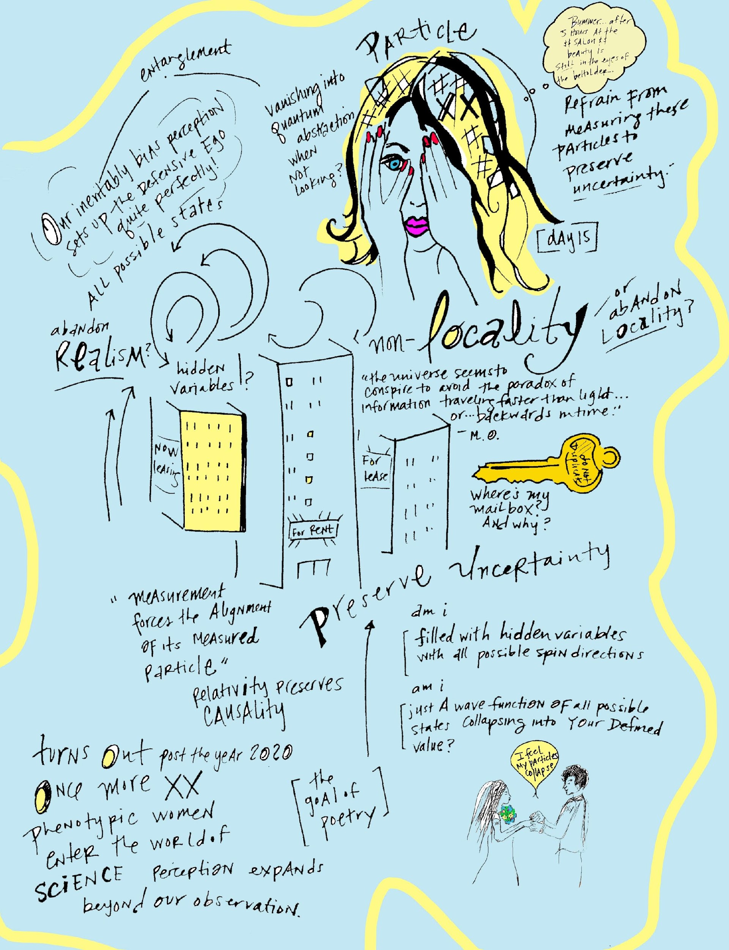

Just as the Aristotelian earth-centric model of the cosmos was superseded by Newtonian thinking, the Saleolithic period advances cultural orientation of time away from philosopher Martin Heidegger's human-centric phenomenological model. Heidegger was an adulterer⁶², like many renowned men of all time. By his own admission, his most inspired work was evoked by Hannah Arendt, his mistress and student (a combination considered romantic circa the founding years of formal university until at-least 2003).⁶³ A feminist of her time, Arendt would likely call bluff on Heidegger and promptly end his career circa 2020, as universities formally declare the student-teacher relationship as boding counter to educational aim (duh). However, in the atmosphere of 3rd-reich-rich Germany, mussed with rife and pent ambition, Heidegger crafts an impressive philosophical treatise on time and then pops off to join the Nazis, an act forgiven, in itself, by his own doctrine: a man is inseparable from his time and time is the determiner of man. Thus, did he have a liberated choice? It is impossible to not water-down via translation his heavily-erudite writing on the matter of time. Through idiomatic German complexities, Heideggar reinforces time as the unwavering stake-holder of human orientation, which is given meaning through conscious interpretation and emotion; phenomenology. While his ideas are not necessarily counter to Einstein's, reading Heidegger, for most, results less in advancing one's mechanical comprehension of phenomena, but, rather, the sense of having exercised neurons.

Aside from both men referencing causality as central, Einstein also shares membership with Heidegger in the historic league of philandering intellects. Einstein's patronage to the league, though, is often overlooked in light of his god-like contribution to the leagues of science. While it is difficult to confirm historic evidence of Einstein and Heidegger meeting face-to-face (or at least sharing drinks under the same German biergarten roof), Einstein certainly battled (of course, only in the reserved manner apropos of the most ivy-associated) with philosopher Henri Bergson in 1922 during a Parisian Philosophy Society rendezvous, each in defense of the nature of time. Both Bergson and Einstein dismissed the human clock as unworthy of its center seats at the play of existence, to which it shows up merely perfunctorily. To alter the metaphoric circumstance, however, each man escapes time's pomposity through far different measures. Einstein escapes the clock face through a logician's formula, outwitting time until he has earned a detached position; not even in the theater at all, but-- eventually, perhaps, in all of the theaters, at all time. Bergson tramples over time from the back row, rushing the stage and launching himself in a playful orgy of feeling-led improvisation, chancing losing his audience but taking the risk of overselling intuition as talent. On the April day in Paris, both men won their disagreement, creating seismic impact with longstanding aftershocks in regards to the Galilean time-centric model.

Einstein recognized philosophy's potential for becoming outdated, endorsing the timeless pragmatism and efficaciousness of physics. More than positioning the clock as futile, he shared with Bergson that, even less substantially, philosophy itself had "no time", compared to the rational field of physics. Perhaps this was not to directly insult Bergson: Einstein later shared that Bergson simply could not understand the implications of his relativity theory-- which Bergson, of course, refuted, replying he'd understood Einstein's content just fine. Einstein reputedly "won" their debate, if winning could be a formally recognized outcome of a philosophical society meeting within the Parisian salon scene. But Bergson's side left a general impact, not only shifting the subject of Einstein's Nobel prize that same year (the committee, while granting him the prize, chose not to recognize his ultimately-famous theory of relativity, but, after Bergson's critique, acknowledged, instead, his uncontested photoelectric effect discovery). At this Parisian point of intersection, in the city of light (of constant speed in a vacuum), fundamental particles named Einstein and Bergson do what seems illogical by Parisian standards. After boastfully supporting the inspirational convening of artist and intellect for centuries, Paris succumbs to host a turn of contemporary thinking, from which the fence is created. On one side of its dichotomous divide, are the (underfunded) arts, the philosophies, the woo-woo metaphysical; on the other, the hard-nosed pragmatist scientists: the ones with the final seal (and the funded deal) on, logically, what is.⁶⁴ Beyond their well-crafted treatises, the philandering philosophizing and physics-curious thinkers of the 20th and 21st centuries, such as Heidegger and his contemporaries, were played-at-large as pawns of biology. For example, however ontologically right or wrong Bergson or Einstein's time-treatise stance, each failed in debate to recognize all fundamental things in the seen and unseen world are inherently, inescapably of nature. Even the superimposition of clock-face time, by physics proof itself, cannot exist unrelated to an Einsteinian spacetime. Regardless of the individual torch Bergsen and Einstein each carried, on that day in Paris, the limelight of their collective studies ultimately supported a type of social tectonic spark, leading toward the incremental global rearrangement of the awareness of time itself. Extending from a moveable now into an extended now, humanity grows their time sense not only towards a bigger-picture time, but one oriented within a greater dimensional scale of possibilities. Recreational dichotomies release into the luminiferous aether, and humanity finds fun in quantum observations, exponentials, experimentalisms and contemplating potentia.

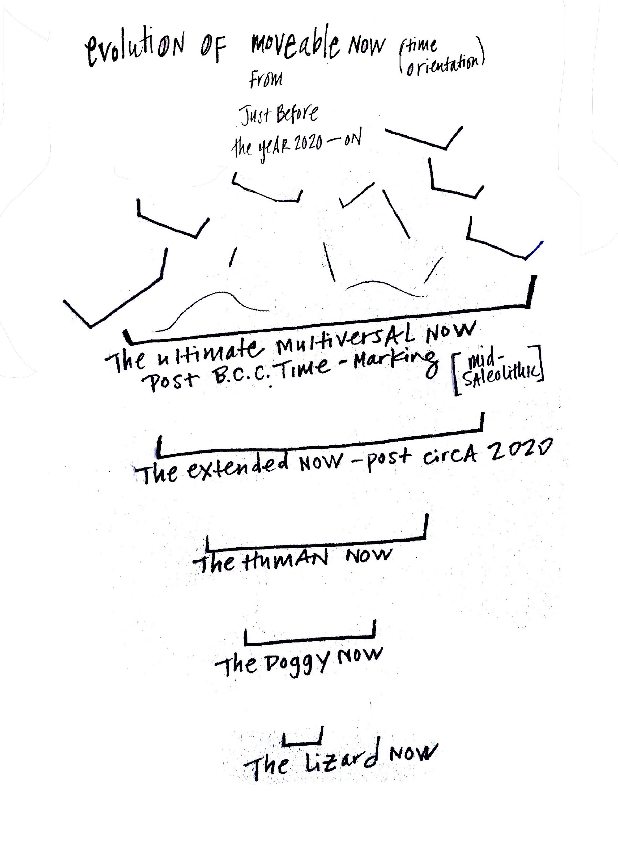

From the onset of the technological singularity, Einstein's 4-D relative spacetime model becomes the general marker of orientation. Concern is less placed on "How am I going to keep up with the future?" and more on "What if I can't figure out how to move spherically forward up the sides of a hyperbole?" Eventually humanity adopts the adage "life is based on where you place your attention" and transcends much of its reptilian autonomic negativity-bias through optimized cybernetics. At an accelerated rate, culture goes from concerning over paltry dramas like "who wins over what war" to possessing a living awareness of 6-D rich phase space, the modus operandi of universe-possessing black holes. Here, any type of policy-making government has no option other than allowing for a naturally provided, cost-free higher education. In the Anthropocene epoch, education happens organically as one's learning curve experientially meets the spherical curves of space. In 6-D perception, the physical adventure of life meets the intellectual pursuit of science's Latin roots-- that is, to know. The original mathematics of 6-D phase space, first proposed by math genius Henri Poincaré, atomic physicist Ludwig Boltzman and thermodynamics guru Willard Gibbs in the late 19th century⁶⁵ (in time-space), are eventually made more practical by accelerator physicist Sarah Cousineau, imaging scientist Katie Bouman.

Like geology, Cosmology distinguishes its own eras, named The Five Ages of the Universe, measured in ^{n}th cosmological decades, where ^{N} is the exponent, and each decade increases by 10-fold. If geological quantifications are baffling, universal eras are mind-bending. The neatly organized ^{n}th logarithm includes numbers both infinitesimal ("seconds-per-decade", Planck units) and near infinite (10¹⁰⁰⁺). A logarithm of one Planck unit, but of course, is simply the time it takes for light to travel one Planck length (the "foamiest" and–most likely–smallest fraction of time) inside a vacuum. The universe's logarithmic chronology is dominantly marked in years, but its time moves exponentially and is not an absolute in 4-dimensional space.⁶⁶

While scientists have considered human intuition untrained in exponential thinking⁶⁷, near the year 2020, despite the wide-spread destruction of the gut microbiome (the intuition's former main-hub), the 6th sense catches up with the logarithmic stride of information technology and universal expansion. Math meets culture in a way it only lustily dreamt of throughout its adolescent nerd-hood, and intuition's former linearity develops branches of exponential progression.⁶⁸ When someone says "see you there in 5 minutes, you can no longer determine exactly where their "there" is, nor if, by what "time", they even accountably will, though best (imperative for success) to avoid feeling nonplussed. By the same token, exponentially, you can sense what likely transpires when you'll intersect, and what will further intersect with that, whenever– and if ever– it happens or happened. Somehow, you feel what you'll lose before you've had it, and where it will go when you can't find it, and so you know the currency of a Planck length passing; you know when that lightbulb moment is going to happen, you can see the spark fly, it makes it you sneeze.

The universal phases begin with a Primordial era, only a picosecond of time (wherein the laws of physics did not apply;⁶⁹ during this non-time, for a non-flash, anarchy rules). The ages advance in accelerating ^{n}ths until reaching 10¹⁰⁰⁺ cosmic years, an amount of universalness equal to a googol. (The Googol, which Google appropriated, was invented by the 9-year old nephew of a mathematician who drew it as a number "1 with as many zeros as possible after it".)⁷⁰ The science of Cosmology evolves math (out of which more science, then, materializes-- as do lovers grow each-others affections when first spell-bound). Math and science then ratify what the indigenous great-grandmother already humbly told you, looking at the stars, her face a liberated moon, "everything--and I mean---everything is possible".⁷¹

Sorely, our current Stelliferous (star-bearing) universal era, is the shortest in length, but its sole 10⁸ cosmic decades, which somehow translate to human time roughly as 18.8 billion years include the complete formation of most of the universal matter our 500 nanometer-limited vision can observe.⁷² (While the factoid about spectrally limited human vision had its pop-science moment spread as fad factotum near the year 2020, some still remain largely unaware that the human eye is originally able to detect less than .0035% of the electromagnetic spectrum; significantly small considering the overuse of expressions like as far as I can see and you can't miss it!). After the sh'bang of burning stars and human existence, the Stelliferous era, as presumed by the (82% male) American Physical Society, exits in a dim fade.

Near the year 2020, with the culmination of expansive consciousness practices, Sudoku, plus trends in quantum physics hashtags, human wit sharpens, perception expands. Culture still largely identifies with the idea of a "universal clock"⁷³, a current location called the moment. Despite this, discoveries within the field of neuroscience, plus the advent of metaphysics and transcendental meditation in the left-half of the world, subtly shift humanity towards experiencing Minkowski-Einstein's spacetime. In spacetime orientation, life is not perceived through divided beginnings, middles, ends, but revealed altogether as a worldline, a path and shape.

Hormones, created at large by gut-microbiome initiatives, naturally advance the human ability to perceive Einsteinian space. When the Dalai Lama uttered during the Vancouver Peace Summit in 2009 that the world "will be saved by the western woman”⁷⁴, women in the left half of the world (which made up more than 83% of economic consumers) retweeted and reposted, contemplating the phrase like a Buddhist Koan. The Dalai Lama, considered a timeless incarnate, was, resultantly, a great XY futurist himself (though in future centuries would be reincarnated, finally, as female). Near the year 2020, Dalai Lama largely served as a mineral-inspired messenger to biologically point out that specifically western women, 47% of which who'd incurred hormonal imbalances⁷⁵ after systemically suffering years through the patriarch, would finally come to their own terms about menstruation and hormones. Recognizing the power the hormones possess not just to rule over the female emotional destiny (much like the patriarch had for that last centuries), women begin to access their hormones as gate-keepers of greater perception, begin to dial-up or down their sensorial powers using hormones as regulators, like whales in song systemically adjust to their environment.⁷⁶ Resultantly, hormones provided keen support to navigate life while time-space shifted during the Stelliferous era.

However much the Stelliferous era evokes sentient awakening, an unspoken moral atmosphere of lassitude simultaneously develops as time-space dismantles near the year 2020, a type of universal acceptance that the cosmic spotlight on humanity as we've known is 75% over. Along with animally sensing Y's limited remaining lifespan, humanity no longer carries on as usual, expecting erections and serenades, or seasons that move as steadily as a Whitman poem. But even Whitman responded to time-space shift, sharing an advanced precocity with fellow historic geniuses like Nietzche. The real earned title of Poet is appointed to the ones who have long transcended the limitations of their time, and whose vastly progressive insights often leave them "alone and misunderstood", while– ironically– only a generation later humanity finds brotherhood in collectively grappling same conclusions.⁷⁷ Dialed into cosmic exponential algorithm and time-space transcendence, Whitman revised Leaves of Grass, his greatest body of work⁷⁸ 9 times within one lifetime, responding accordingly to the inflation of acceleration. Growing 388 poems from his original volume within 37 years, Whitman proliferated like a microbe. As advanced as his natural flow-state of creativity, because the writing was published before the 20th century when time moved more 3-dimensionally and consistently, the recalibrated equivalent of edits near the year of 2020 equals to 7,243 new Whitman poems within 37 year-like increments. However, given the inherent problem of economic mathematics, it is impossible to absolutely determine if Whitman's inflated volume of material might qualitatively read watered-down.

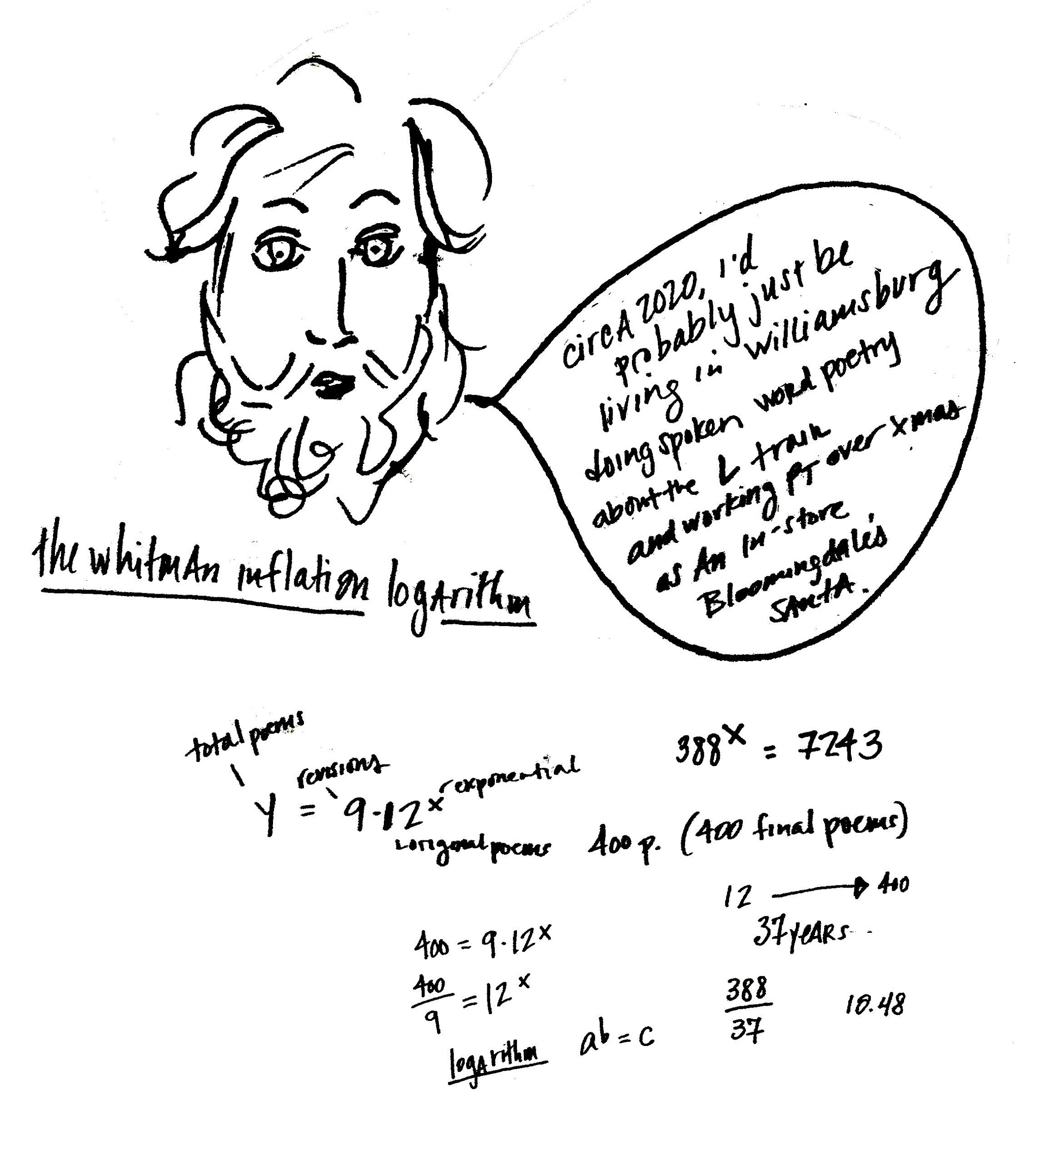

Culture malleably responds in the Stelliferous era, often without the language to express the evolution occurring throughout their biology-stimulated realities. Surrendered to Einstein's influence, the world gear-shifts, over-the-hill, and makes the most of their inherent sensing, attempting to not become overwhelmed with the evolutionary transformative tasks laying before them. If there is one redeeming strength of the human ego, it is its relentless resistance to surrender. The ego stays pert for the innovative future, exemplifying its best-revved face; the most achieved participants of the masquerade gain notoriety as the projected leaders of next-level human economy. In merely tens of trillions more years, the Stelliferous era is done, the Degenerate Era unfolds, protons decay leaving residential space only for black holes⁷⁹. Hence, the Black Hole and Dark eras inherit the universe, each lasting far, far longer than the mere star-bearing now. On the bright side, though, there is no real tragedy, exactly. Surviving by means of an energy gradient introduced just before its final ^{n}th cosmic decade, human life continues throughout infinite time, folded into incomprehensible origami, jumping over light-lines, smaller than fleas but more multi-dimensionally capable than a Tesla Model Y vehicle.

The human body, near the year 2020, begins to reveal functional changes responding to its reorienting sense of time and space. The changes support the mutagenic shift, particularly affecting the endocrine system, which regulates the systemic relations of the internal body with the external world. The Hypo-pituitary axis (HPA), physically located at the crown of the head and in the middle of the forehead center, supports the harmony of this inner-body and outer-world engagement, and has been part of the essential bouquet of human evolution. Osmoreceptors are neurons located within the HPA network of the brain, whose primary job is to regulate extracellular activity. Part of their work-task involves alerting the brain of thirst, and stimulating kidney, or renal, function. In comparison to the big-wig job of many body parts, the position of osmoreceptors may sound relatively vague, sort of like a set-assistant's, fumbling to prove himself on-site, fetching drinks, keeping the place clean; the first to go when the budget is cut. However, near the year 2020 human osmoreceptors exemplify drastic behavioral changes which are anything but trivial. In conjunction with a noted deficiency of the mineral Taurine inside sperm cells⁸⁰, their alteration is later understood as part of the sophisticated, collective shift marking human mutation.

Supporting the outer-body transit of protein SOX-9, the body system collaborates with its surrounding environment to create the perfect storm for human saltation, or a sudden change in species. Though transpiring within the Saleolithic period, in this case, the root of the word saltation comes from saltus, Latin for "to leap" and does not refer to salt at all, other than coincidentally so. Near the year 2020, though, almost everybody decides there is no such thing as a coincidence, as Carl Jung decreed. There weren't even six degrees of separation between yourself and Kevin Bacon⁸¹. By revelations of quantum physics and causality, Kevin Bacon is dependent on your active participation in his life to independently exist; like the early text of the Upanishads iterated, the unified field "permeates all".⁸²

During the saltation, or evolutionary change, the human systemic regulatory function undergoes significant modification. Osmoreceptors, in addition to lacking a discerning blood-brain barrier⁸³, no longer distinguish the physical body from the outer-world, and human bodies begin to conform to the molarity or solution-quality, of their outer environment (as do sharks, octopi and most marine mammals). The process entails an evolved type of salt-convection through renal functions all named with significantly over-complex titles. The abstruse titles were smugly termed by scientists who, after enduring days in labs unraveling the 80 meters of nephron material on the interior of the kidneys⁸⁴ and itemizing each part's function, wished to protect their work by intimidatingly emphasizing the complexity of their field.

Because the osmoreceptor, and much of the human endocrine system, no longer experiences a separation between body and space, the renal system gets to go on a 130,000 year-long anticipated vacation, freeing cell membranes within the body to emerge in new, stimulating roles. Urine becomes saltier as humans begin to adapt to what is called a "hypertonic" state, and general excretion (from breath to sweat) increases in levels of salinity, because the renal system is no longer absorbed with maintaining an "isotonic" state inside the body. This eventual massive body shift subtly begins its million-year-long evolutionary transition near the year 2020. As humans become more osmotic to their external environment, atmospheric fundamental particles become conducive breeding ground for a new abiogenesis.⁸⁵ Abiogenesis roughly translates as the process of how living matter arises from non-living materials, another hifalutin word for IDK. (The abiogenesis can be easily conveyed in acronym-style text, IDGAF+IDK; add emoji, and one's off to a good conversational start not long after the year 2020.)

Endocrinal transformation of the HPA (Hypo-pituitary axis) function marks just the beginning of testes-forming protein SOX-9's behaviorally curvaceous trajectory. Eventually, the X chromosome uptakes SOX-9's genetic responsibility, and the protein proceeds to exogenously galavant, landing the human some 1.5 million years down-the-road as a self-reproductive and largely single-sexed. Into the Saleolithic period, both the Homo and Robo species becomes compact, able to blink and shrink into general nothingness; gain hydrostatic skeletons and change shape to conform to varying environmental pressures. How this all happens has to do a bit with the evolution of the mammalian penis⁸⁶ and the collapse of Heidegger time-space, as the urban world is predominantly virtually traveled during the XY/XX single-sex conformation process. Both the lack of actual bone inside what was once the phenotypic-male penis plus the nearly swimming-simulating experience of surfing the web vs. strolling through concrete reality influences the gradual change of human bones. At this point, being an Osmoconformer, adapting the body's cellular pressure to match the outer environmental pressures, as well as evolving a hydrostatic skeleton, is a necessary convenience as time-space dismantles.⁸⁷ Being versatile in a collective of habitats, including viscous oceans, or particulate-heavy stratosphere, and even in post-earth (alternative planetary and intergalactic) environs, allows humans to be reduced to their essence, to survive major extinctions and collapsing solar systems. Noah's ark eventually becomes an ever-reductive boat heading toward the galactic core, folding like Inspector Gadget's suitcase, turning everything back into the size of an apple seed, that all-American metaphor for delicious danger and inevitable fate.

Near the year 2020, asking society to concern over its potential physiological transformations 1,000,000 years into the future, or even to consider more than one or two generations beyond the present evokes the response of glazed-over eyes; it's irrelevant within the still-dismantling concept of human timeline. However, when the hypothalamus (top of the head) becomes triggered by the brain's prefrontal cortex (social cues), near the year 2020, the human system begins to thermodynamically release excess systemic sodium atmospherically as particulate matter. Sodium joins forces with mineralized airborne particulates, then gets charged by ionized radiation in the atmosphere. Resultantly, the air quality supports SOX-9's quantum teleportation journey and gradually instigates horizontal gene transfer, what eventually becomes the collaborative mutagenesis between man and mineral, melding bionic life. While the oldest crone in the middle of the ancient wood could simply convey the interconnected, alchemy of the elements, conversely, most geneticists, whose work was often cleverly endorsed by DARPA military funding, assumed, before the year 2020, that procreative copulation between anything biologically human and "non-living" was nearly unfeasible. However, they failed to measure relationally (especially through the convenient facilitation of climate-change) how the power of trace mineral-rich salt, essential to the function of both living and inert materials, would rise to the occasion. Salt had always been a molecular bridge, and a god-like inceptor of life.

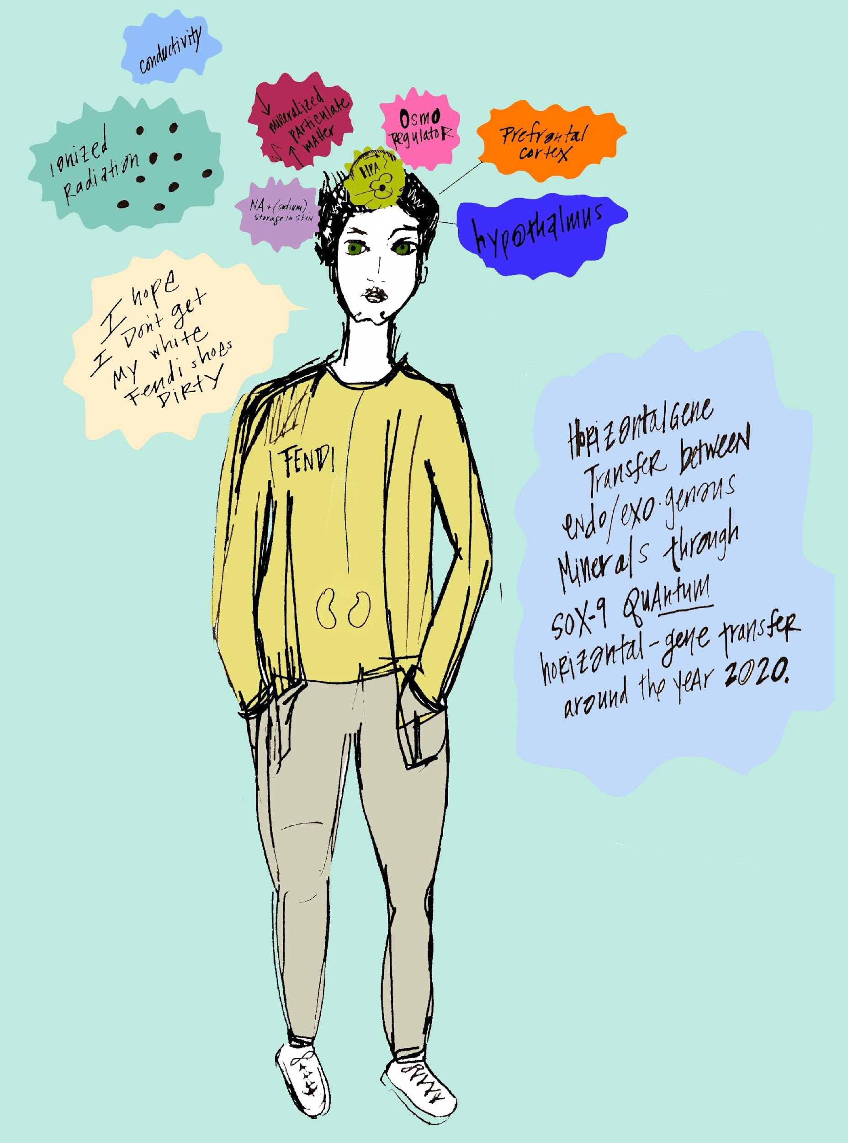

But bionic life didn't arrive as foreshadowed through the typical sci-fi movie trajectory, was not linearly Campbellian. It did not require a step-by-step storyline, starring the hero and his journey. Bionic life had no real "point of beginning". It appeared in a similar fashion as did clay in multiple creation stories and science studies, both.⁸⁶ Clay acts as a sponge, its mineral material absorbs, permutes, conceives and diffuses life. Like all significant players in the fabric of life, including particles, Indian Gods, baking soda, carbon, cauliflower, the Creator Role is interdisciplinary, shows up everywhere with multipurpose mastery. Bionic hybridization naturally saturates human existence. In the same way that it was once normal to speak on the phone for hours, seemingly overnight no one phoned, and if they did, it was now considered nearly rude. Everyone just texted, even marriages ended in text near the year 2020. Even after 15 years, a relationship was prone to acronym-style termination: IDT ILY, TYYlawyer & TBH IDGAF, L8TR. Without much-ado, culture silently assimilates, switching from Zoom to Skype (though the connection is nearly stably equal). In a seeming instant, Facebook begins to stink of uncool, and Instagram becomes the bank of rank (Understandably, Facebook, as most cyber-platforms, while at the helm of progress, had the max life expectancy of a Poodle. Eaten away through acrid political heists, privacy infringements and corruptive hacks, sensibly people began to find the Facebook font unsexy, its brand shade of blue connoting a Bob Dole circa 1991 height-of-his-state-senate-years kind of outdatedness.)

The bionic future was absorbed, permuted and diffused all-pervasively. Especially in the disintegration of time-space, the human chose, indirectly, what body parts were worth building around, which were too problematic, and those that would fit best with artificial implants. In fluid swiftness within the Saleolithic period, humans could alter the course of their lives by little more than a command to a virtual assistant/purchased slave. With the silicon gift of mineral's building blocks, culture welcomed custom-design civilization, eventually able to substitute farming with virtual agriculture, and replace beneficent soil-based nutrition with little pills, sating, colorful, supportive of focus. Unlike overdone early sci-fi novels, robot babies would not emerge from the vaginal canal of a human (or even a cyborg). Instead, just as new branches of species variations are the effect of horizontal gene transfers, bionic life is the eventuation of the preferred, advanced human state; luxurious, secure and most dependable. Even before the year 2020 in Manhattan, heterosexual women and men could feel this future upon them. What was the purpose of a man to aim to feel like a man relative to his historical evidence? While biologically he could retrain himself to handle an ax, chop wood, build a fire, it became more useful and a greater turn on to have a man who could type in the HTML to remove your computer virus which you caught from downloading too many free TV shows.

Metals were wooed by Y chromosome generated industry out from the earth's sediments, crust, and upper mantle not so differently than how hetero XX carriers were also conditioned to be drawn toward the XY. The XX hetero woman hungered for the effectual body-parts erected out of XY's testosterone production and sex-forming steroids. Metals longed for equally phallic XY derivatives, longed to be put to use through the phallic-shaped creation of empire state buildings, cranes, rockets. Elements from the earth's crust, mantle and core turned to atmospheric particulate matter in the wake of XY's heavy-metal industry. Once above-ground, metal particulates become more accessible for the SOX-9 protein, osmotically and telekinetically sent to seed bionic co-mutagenesis, on a kind of mating call. When metal particles meet with cosmic rays (the highest form of electromagnetic radiation which sometimes reaches the earth's surface)⁸⁸ an undeniable intermingling takes place, reminiscent of the meteorite bombardment which enriched early proto-Earth with mineral-rich interstellar dust. Effectually, Earth richly evolved to bear nearly 3000 minerals, reigning as the second-most luxuriously coveted planet next to the fully diamond-surfaced 55 Cancri E near Jupiter. Though, like most promising glittery things, Planet 55 is currently under reevaluation and speculated as potentially less precious, in reality, than originally perceived.⁸⁹
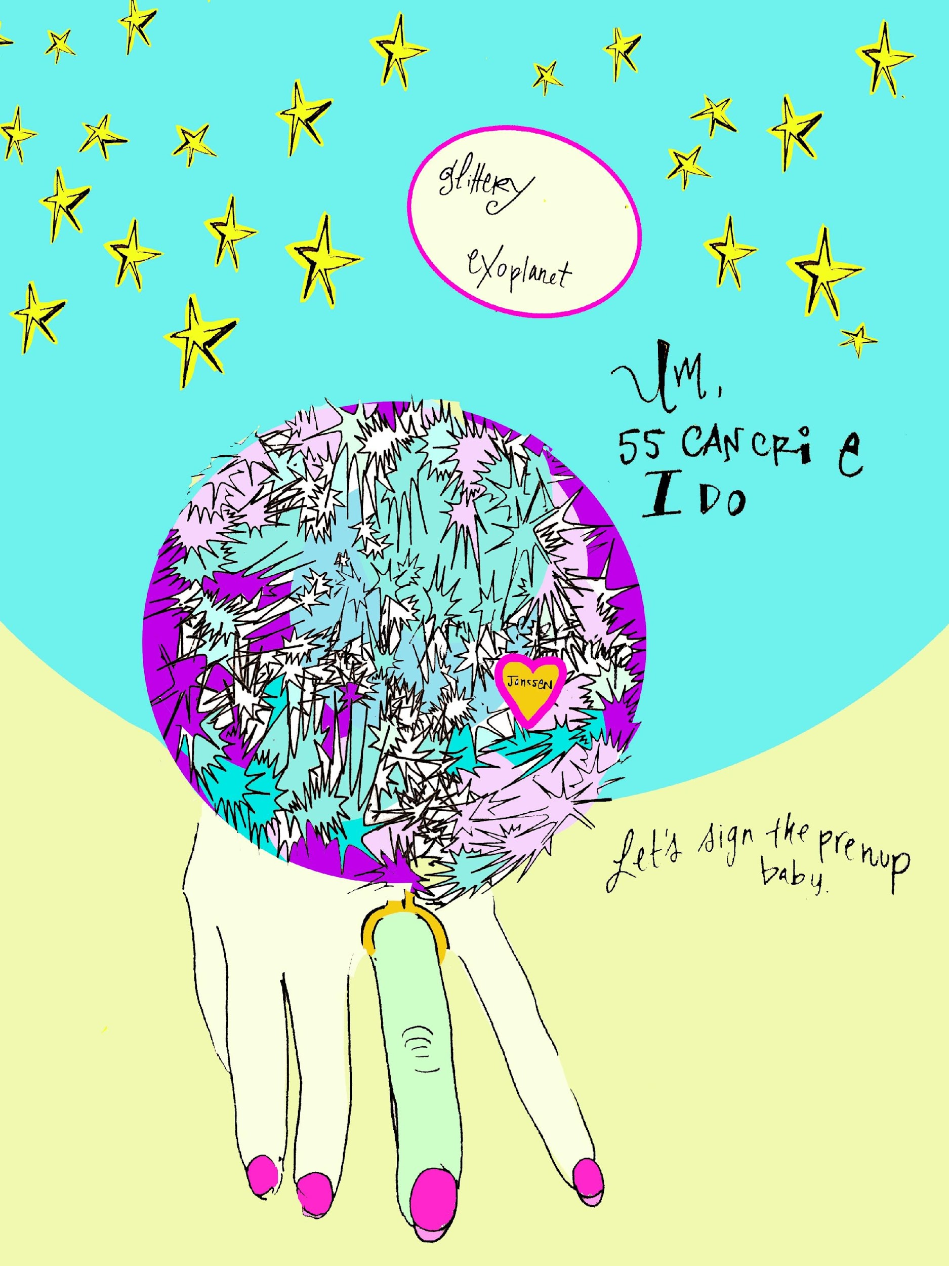

You are Ana, post morning workout. You don't break a sweat easily, brought yourself right to the edge. You are somewhere between the ovulatory and luteal phase. This month's follicular promises shed, untouched by visiting outsiders. After a plummet around day 15, estrogen has made a promising come back, escalating alongside rising levels of progesterone. Maybe you only get six hours of sleep these days from the overconsumption of oat-milk half-caf Americanos. Maybe you have a muscle in the lower back that needs release, a creative vision necessitating physical arousal in order to cerebrally surface. Maybe you've realized, despite having removed almost all intimate historic evidence from your gut/psyche, that your body still needs to be touched. Completely relevant to work output, you justify– you require pleasure in order to offer your best professionalism in the world. You touch yourself as a maintenance, remembering your friend's comment last night, mid-catching up cross-continentally. Ana, you sound like you could use an orgasm. You check the minute on your phone, you can give yourself eight. Before you make the shower warmer, you turn the water off, head to the loveseat in the living room, fetch the basic accessories.

In all honesty, the notion to masturbate arrived later in life. As a wordsmith (or the female form of smith–Smithette?) the term masturbate sounded terrible to you, like clinical fishing, or a form of torture involving electrocution. Vagina also never felt "right", or inviting, and, in fact, wasn't. The outer, visible female anatomy is not the vagina at all, but a vulva, the pelvic triangle.⁹⁰ To you, it made more sense in earlier years as a canvas; you applied your tiny stamp collection on its clean, peach surface. Stamped a unicorn, a smiley face and a star. Later, the canvas was taken over by puberty's garden... a region most often inaccessibly covered with multiple layers of clothing. You forgot about it unless pulling your pants down to pee as quickly as possible, unable to fully surrender over the awkwardness of endless, descending plumbing. Bodily, your operative sense of center was firmly cemented during childhood as located squarely on your shoulders. When the first young man braved in early-adult gesture to bring his head between your thighs, you had no idea how his lips would speak to the lips he'd find down there. It seemed inane. You pulled him upward by his hair, lifting his boyish body back until you met again head to head, sternly looking in his beady eyes. You declared, as though surely in the right, "I'm up here." Shame. Since, you'd wiped most of these types of first encounters from all of your under-realities. They no longer brought you embarrassing discomfort. But some part of you could still recall, and some part continued to inform dreams. No one told you the imperativeness of receiving pleasure as a young woman, no one interjected-- "Ana! Can't you feel from your neck downward without thinking, without scrutinizing yourself through the projected assumptions of your visitor's user experience?"

You entered through the first doorway of self-orgasm post speed-reading a few books circulating through the girl-underground. Publications geared toward the phenotypic female with kitsch titles like "Tickle Your Fancy", and "Getting Off" sold well, but meanwhile there were no titles made for young men about the mysterious artistry of self-stroking.⁹¹ Evidently, it was obvious– the phallus fit their hand and it felt right to squeeze it, rub it, pull on it, play with it. While women-bodies had comparatively twice the amount of deliciously trigger-happy nerve endings in their female parts then men-bodies, the hole between their thighs provided for giant mystery.

In worldwide folklore the vaginal canal was capable of possessing teeth– known as "vagina dentata" or even "snaggletooth vagina". Religious fables emphasized to men: tread too deeply into a vaginal opening and get bitten, emasculated.⁹² Fast-forward milliseconds later (in the scope of all time) to the year near 2020. The hetero-aimed market solicits its modern lore, The Couples' Workshop, promising to re-wild the primal connection between the phenotypic man and woman-bodied. During the beginning of the Anthropocene epoch, the pop-science had not yet revealed Y chromosome preference for minerals, alkaloids, industry, metals, nor the X chromosome's higher purpose, to support the dismantling of human time by utilizing her hormonal sensorial power for superluminal travel. Intimacy workshops ascertain that if the man can brave to visually penetrate into the woman's eyes and the woman can learn to express her feelings sans words but emotive sounds only (ooo! eeek! ouch! prrr! grrr!) the sexual power of their polarities will electrically magnify. Through the wide lens of major epochs, a polarity workshop just before the year 2020 parallels myths of old. In the facilitated ritual space of hip coastal cities, women, like snaggletooths, are brought to tears, called out by their course leaders as emasculators. "Women, you are castrating your man when you speak like his mother." Evidently, near the year 2020, as in 10th century ancient Shinto legend, the phallus remains susceptible to the "sharped-tooth demon" hiding inside female anatomy.

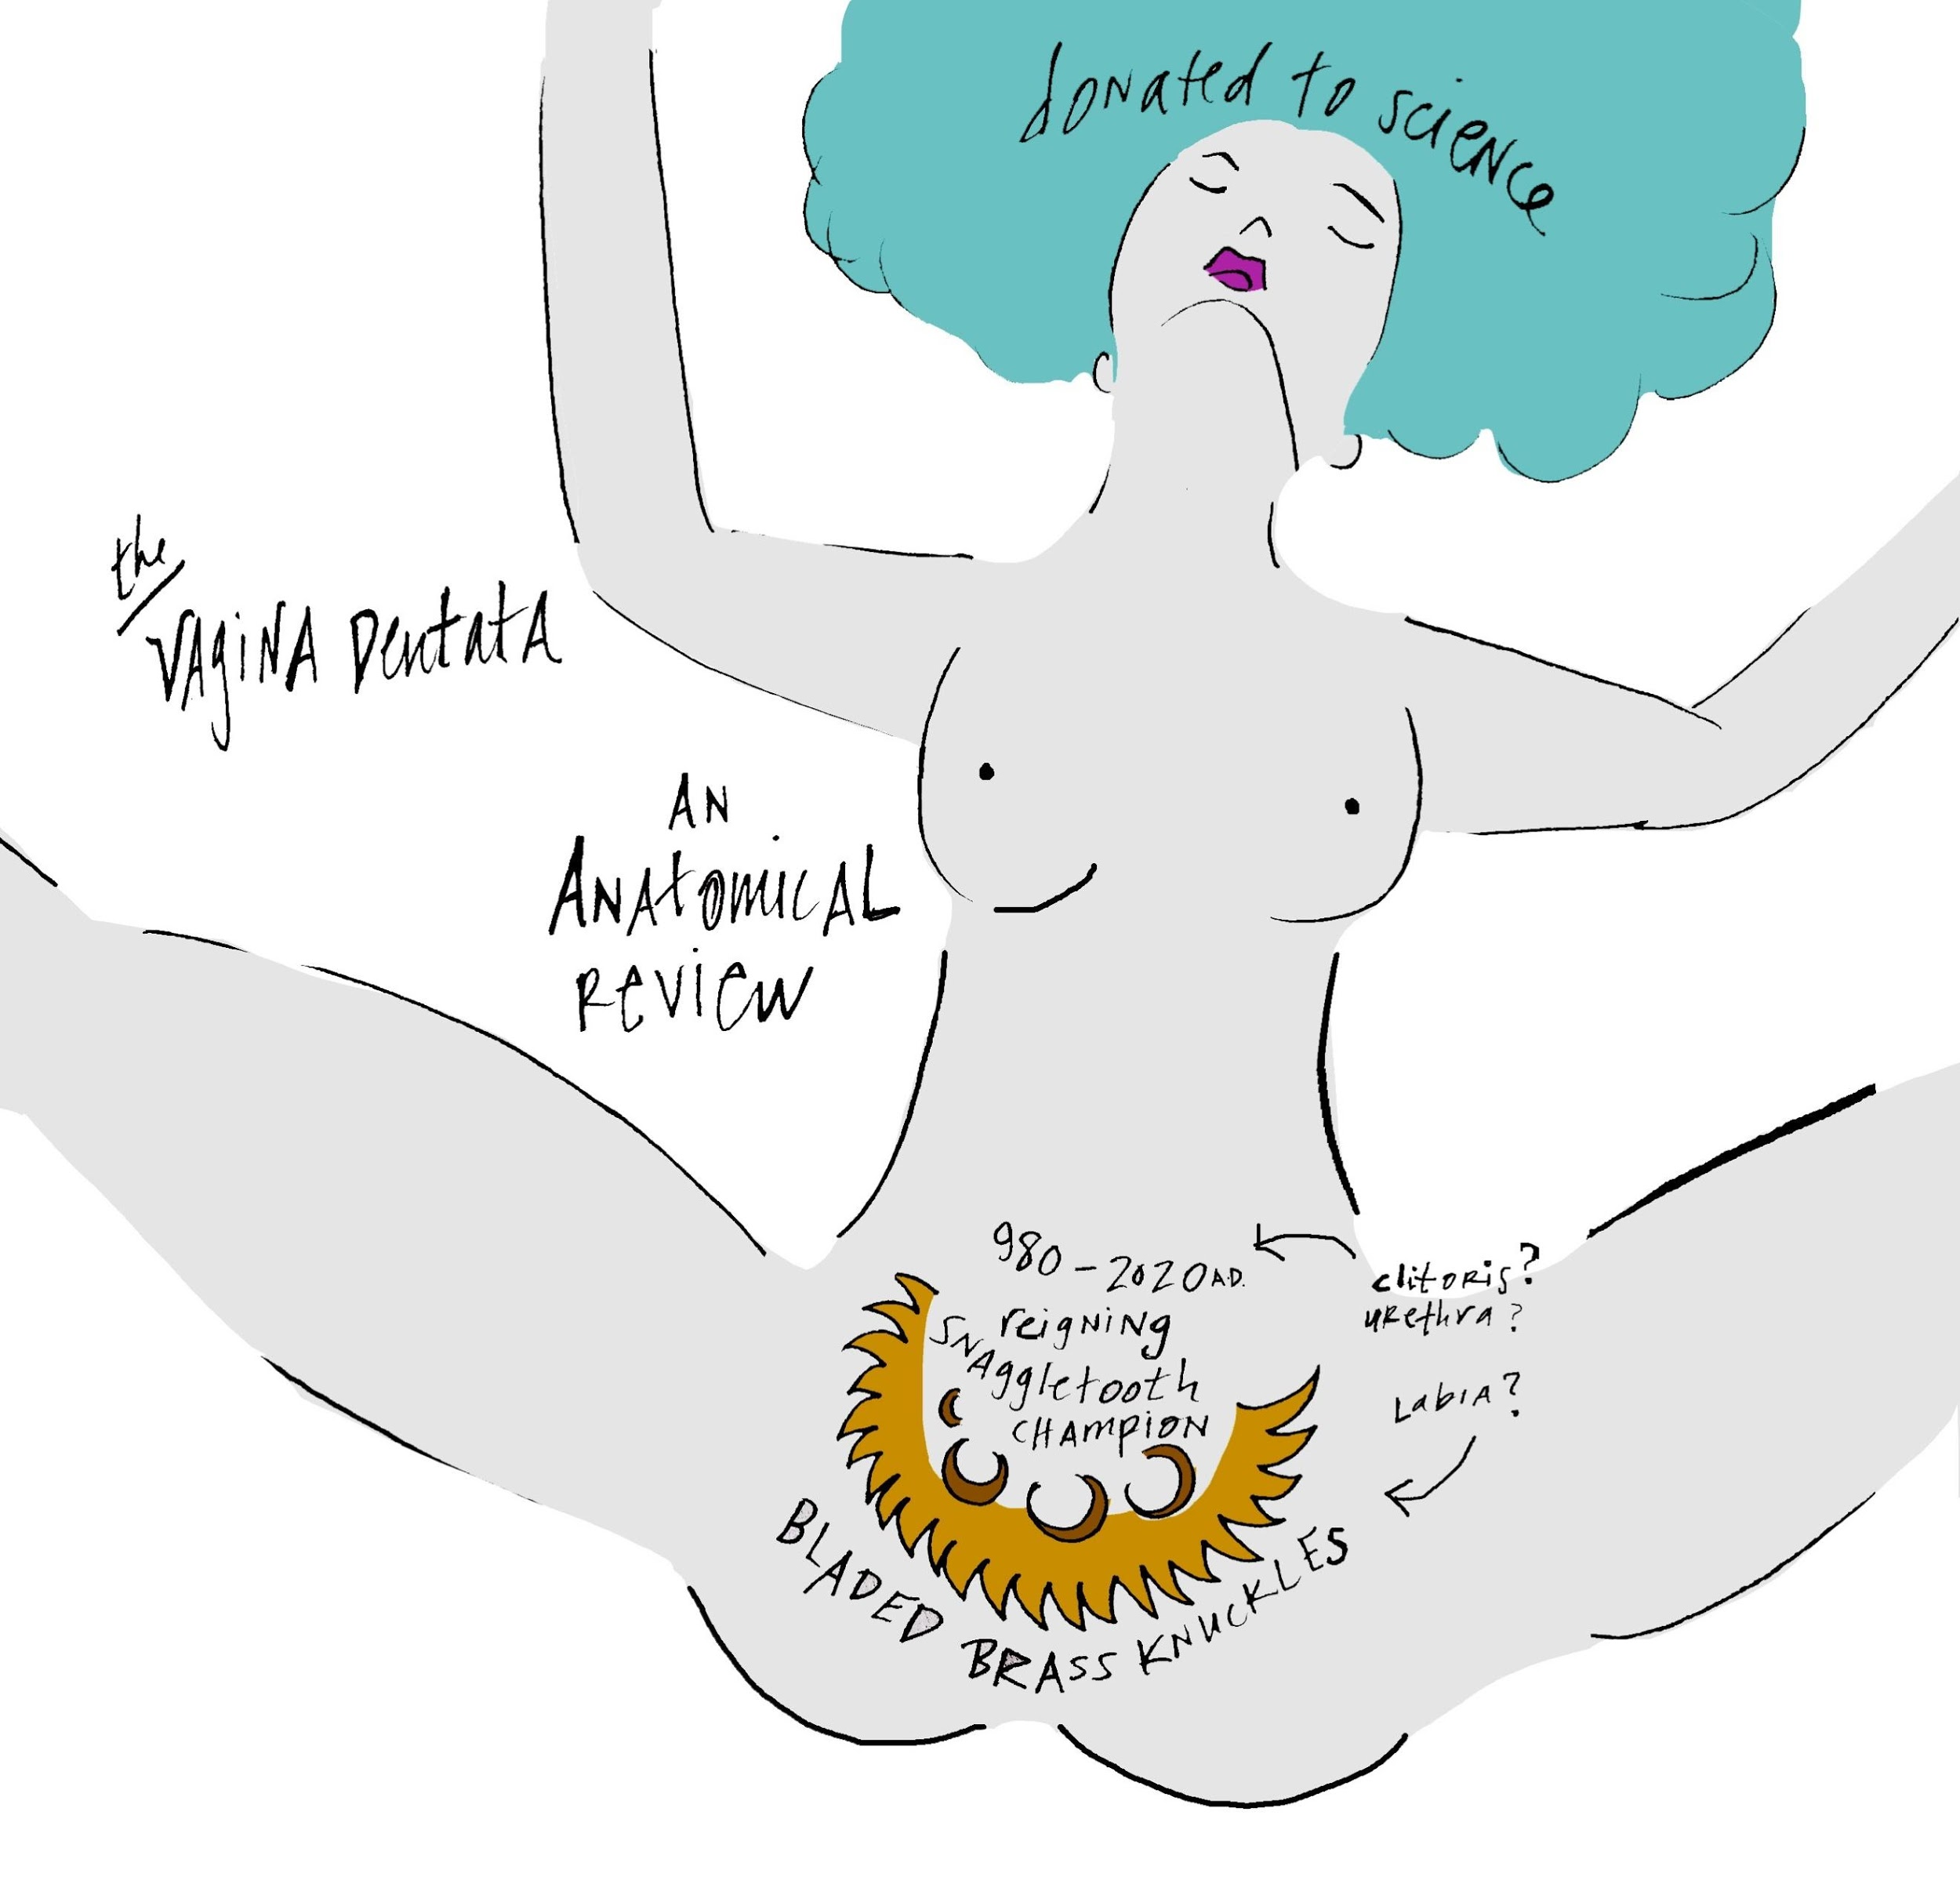

Beyond Triassic-Jurassic, Ordovicion, Cambrian, and Holocene epochs, the Anthropocene, named for the human impact on the earth, includes a special type of defamation that aggresses outwardly after first self-contaminating. Within his limited scope of time-space, man foremost impacts his own nature through psychological detachments, body commodification, and shaming fables (including the fabled aggressive vagina's weaponry). Regardless of scientific methods proving otherwise, the concept of fixed polarities and dichotomies remained reinforced simply through the public's practical experience with magnets. In 2007 NASA brings to public attention the1970-1980's Giant Impact Hypothesis, or the Big Splash, symbolizing a planetary shift away from dichotomous thinking. The giant impact refers to the riveting, galactically-altering affair of the trojan planet Theia and Earth. One million years into the planet's 4.6 billion-year history, Theia, a mars-sized planet about 1/2 the girth of earth and named after the Greek mothers of the moon-goddess, attacks the earth at an oblique angle no faster than 2.5 miles/second. This speed is considerably lackadaisical compared to Earth's hustle, a speed averaging 19 miles/second, depending on the season, and also the genius analemma, or figure-8 formation central to the sun and earth's choreography. ^{92.5} In January, the planet's elliptic sun-orbit picks up the pace, perfect for getting from the West Village to Kips Bay over black ice in the days when Manhattan was still largely physically traveled.⁹³ By June, the season for heart-to-heart classic Central Park bench conversations, Earth's mps slacks just enough for lovers to feel especially tranquil.

Theia's slow-but-deep impact vehemently hits earth, and rather than dichotomously entering war, the two planets absorb each-other's best parts. Earth becomes mineral-enriched, and together the two planets spit out a double moon, which eventually gravitates into the single moon circling Earth devotedly. The symbolic potency of this specific NASA study, shows how two can produce, ultimately, three through an absolved state. As time dismantles, humanity rediscovers the imparting creative force of lunar rhythm, made of common rock with planet Earth. Spirited by a sense of deeper galactic community, polarities ease: culture follows suit to the stars. Things are not so black and white. Jumper cables are no longer considered purely masculine or feminine, and the notion that simply + attracts to – becomes a bit embarrassingly archaic. Give and take, it turns out, happen simultaneously, within the same channel.

Buckminster Fuller, the epic multispectral architect who physicists named an especially spooky quantum behaving fullerene molecule after (Buckminsterfullerene, or Buckyballs)⁹⁴ coined the term tensegrity. (Fuller additionally shared membership with Heidegger and Einstein in the Historic League of Philandering Intellects, though his affair in 1931 appears to be a one-off situation which left him emotionally bereft.⁹⁵) Tensional integrity, which he likely felt himself during this time, or tensegrity, as he called it, exists within the mechanics of living systems as a natural state of contradiction. Transmuting his confusion through brilliant geodesic shape, Fuller shows how parts can relate without apparently touching, floating in compression⁹⁶. Tensegrity exists within atoms, and between the Earth and Moon, the height of design facilitating natural force. Here, Fuller reveals the molecular power of an elision formed within a seeming opposition; tensegrity is physics' Zen hack, do more with less. Exploring the nature of this unlimited connectivity procures quantum innovation, the least of which begins with advancements in battery lifespan technologies, and eventually, the reframing of a vagina: not just a black-hole of annihilating dark Einsteinian anti-matter,⁹⁷ so figures Buckminster Fuller circa 1932 and then the rest of late-blooming humanity, nearly 100 years after he has.

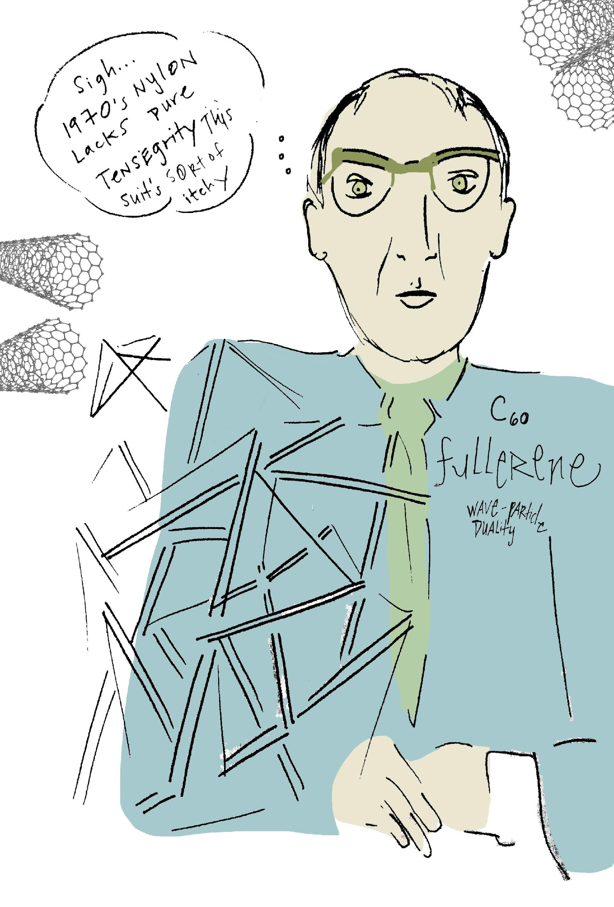

Ana uses a towel; she knows it's lo-fi. Though she'd gotten Botox (just once), moved from normal to Gel manicures, wore a glam sapphire smart-ring programmed for single-swipe payments in participating stores, and developed a preference for voice-automated elevators over the traditional push-button, she still could not stand the idea of sticking a robot into her female anatomy. She felt enough plasticity had influenced her nature. In the earlier days, she used her long fingers, two, laid on her back. In sharing self-pleasuring techniques with her friends, she was surprised to learn they only stroked themselves over the most well-known part of the clitoris, copying the single-focused aim of most boys who'd touched them, and considered this sufficient stimulation. Ana preferred accessing a deeper part of the clitoral network, The G (Grafenberg) Spot. For her, it felt more full-throttle, full-body. In fact, sometimes too much repetitive contact with the most-famed part of the clitoris was a bit nauseating, like spinning too long on a tire-swing, or too common, nondescript, a Mike Smith, Mike Davis, Mike Jones (albeit some absolutely riveting, original men donning the above names certainly existed near the year 2020). Still, the clitoris felt over-farmed– like the Marijuana plant in comparison to other botanicals in the early years of dispensary legalization. Through the middle-school grapevine, boys traded generic sex techniques with each-other mid-urinal talk, and assumed themselves, thereafter, decently informed. Most men were under the impression the Latin-named anatomical Prepuce/Glans area of the clitoral network was the Medina of the inner-vulva, the place to which they'd pilgrimage, fingers trekking the hard-earned inches of bedsheets to arrive, flicking or even gently "milking" the hooded clitoris repetitively. Clitoral milking, according to Ana, was a most disturbing gesture. She couldn't help but imagine a miniature size world, where cow teats fit into men's hands, or else, milk coming out of her poor, agitated clitoris. If fingers could talk, these men's milking fingers would reiterate a type of beer-keg, frat greeting, broken-record style "whassup dude, whassup dude, whassup dude!"

Ana used orgasm often as a means to recover from sleep deprivation, living in NYC, and (as she'd read) for its anti-inflammatory complexion-enrichening effects. She'd learned to breathe the energy released through her orgasm up her spine, into her toes, fingers, extremities. It felt like a vitamin, fortifier. Evidently, stimulation of the G-spot lent to accelerated cerebral prowess, exemplified by G-spot discoverer Grafenberg's wife, Rosie Goldschmidt Waldeck, who, despite being born in the late 1800's when female writers were few and far between, authored several complex literary works.⁹⁸

Ana inhales through her nose, sighs out her mouth, circulates her hips on the surface of the chaise lounge where she's opted for the 3-5 minute "reboot". She starts by relaxing her body, her bones, letting her breath take up all the work. Soon she feels her outer-labia begin to round, she's wearing jeans--- not the best choice, but workable. She catches the reflection of her adjacent shadow; gets mentally stuck in some form of distracting insecurity for a moment. That crack in the wall... needs repainting. How is there so much dust in the air? At this point, she usually has to think of something other than the present. Though some of her friends bring themselves to orgasm in front of a mirror, by candlelight, worshipping themselves as a goddess, this takes significant time, requires a preliminary bubble bath, self-massage, modern ceremony. She knows it's the high-road, the most empowered way, think about nature, about the mother earth, the rain, her queendom; but today she chooses the quick fix. Ana thinks of a man grabbing her hips, licking her from behind (note–not licking her behind–but licking her inner labia, etc. after she's folded over, maybe leaning into the wall in some kind of accessible position which is also comfortable so that Ana can let pleasure take over her body. As far as licking her behind– the man in her fantasy would never, so Ana does not have to concern if his tongue will near her butthole. She cannot get into this idea of what is publicly known as "eating ass" and, evidently, common-place near the year 2020.)

The problem with her visual, however, is that, though she'd undergone full medium-level memory erasure in both her internal and external energy drives, the 8,000 nerve endings⁹⁹ in the woman's clitoris are typically not entirely responsive to the procedure and often won't fully let go of triggering stored images of previous sexual encounters, especially with men who'd also affected the heart. Therefore, as Ana envisions the warm mouth of a man holding her from behind, she sees the face of her ex-boyfriend, remembers his arms around her waist, his heart pounding through her spine. She hears the little moans he'd make that she'd grown accustomed to, though they'd instinctually sounded so girlish to her. With medium-level Transcranial Microbiome Magnetic Frequency Stimulation erasure, the client is still able to recall memories, however typically they are subdued, unpainful, and easily come and go. When triggered by clitoral nerves, however, it's too much, can disturb the gut microbiome, set off a cascade of disturbing hormones. Ana loses steam, she nearly cries. She quickly then thinks of a married man, with a typical suburban haircut, wearing ray-bans. He is artless, would never understand her. She is ashamed this somehow gets her off. He is desperate for a break from his unhappy marriage, but doesn't understand creativity as a source for renewing marital joy. So, he just wants to fuck Ana and talk about his big penis at the same time. As though suspended in adolescent Tourette's she repeats the word "penis, penis, penis" in her head. He has her on top of him and though emotionally weak, somehow maintains this out-of-control erection, he can't stop his turn on. The married man may not know her first name, definitely not her last. This nearly brings her to a quick orgasm, but her growing sense of guilt (as a feminist) for creating such a self-degrading, empty-hearted sex scene goes too head-to-head with her arousal, something is cancelled out. She nearly quits. (Siri, however, reveals to Ana later that it is actually "normal" for strong, independent women to fantasize about mundane or unattractive sexual encounters they would never actually wish to be in, as a way to make themselves feel more safe or less intimately phobic.) Ana regains her masturbatory focus, goes to her old standby, reserved for when she is unable to draw upon one (even imaginary) male without surfacing painful remnant of memory. She pictures a woman, often more masculine than her. The woman demands that Ana doesn't touch her at all (easier for Ana) and brings her toward climax. At this point, Ana introduces a third person, the masculine woman's boyfriend who is significantly endowed. Then he can, as one would imagine, bring Ana to full orgasm with his provocation and power, while the other woman helps him along in a variety of possible arrangements, depending on Ana's mood. (This keeps it fresh.) Ana knows that actual "love-making" isn't just about the orgasm--- but that when it is deeply rich, and magnificently right-feeling, every breath, every move, every moment is satisfied within itself, every moment offers up a safe-haven. However, with the ambition to put four hours of uninterrupted work into preparing a presentation for a 2 p.m. deadline meeting with both the AI and human heads of her company, she's masturbating as part of her workout. Post 75 crunches, a 5-minute plank-hold and 50 squats, she orgasms to wash it all down.
Sometimes when you go to therapy you reference the before time. This was the time when you still impressionably retained your experiences with the male-bodied half of the world, remembered in depth and vivacity. It was simply the acceptably status quo then. Your other girlfriends maintained memory of their intimate experiences in their energy drives, too. This was why the term "boy-talk" was a slumber-party cliché for girlfriends; pizza, popcorn, processing together. These saccharine talks extended beyond pre-teen years. Eventually, the technology was developed to analyze thought-forms and language content via monitoring apps, much like screen-time data reports for iPhone users. Shockingly, statistics revealed hetero women-identified thinkers between the ages of 18-45 engaged in an exorbitant rate of talk appeasing each-other's anxious hearts. While magazine-advert rules for women from the 1950's were publicly dismissed as objectifying, new rules of the generation were as innocently imparted with equal inanity; the women did not recognize contemporary vogue acts of expressive freedom were just as objectifying, only under different terms. Their acts of flagging media lifestylists’ postings and tagging each-other where relevant was not only socially permissible, but considered a loving gesture between friends. "I am thinking about you: wanted to share--- The New Rules of Respecting Yourself by Anita Lovegoddess. Thinking about you: wanted to invite you to join the private Facebook group--- How to Stop Wasting Time Thinking about Him, Brain Hacks to Know What He's Really Thinking." This behavior, pre-2020, was an acceptable form of female fraternization, it reinforced female strength and boss-like power, plus had just enough of perfectionistic, patriarchally-influenced one-upmanship to meet the sleep-wake state of the day. The woken part of woman knew there was something for her beyond the male version of The Hero's Journey. The asleep part of woman still believed the path of the heroine would mimic the progression of the hero's tale; beginning-middle-end, question to answer, challenge to triumph, this-then-that, in mathematical trajectory. The woken part of woman knew the healthy happenings of her female anatomy generated the center of her most massive success. The asleep part of woman, disassociated, loathed and ridiculed her own hormonal function, pushed her life painfully forward until she'd inevitably self-sabotage in the days before her uterus shed. The woken part of woman was unafraid to bring delicate matters of gender to surface, red-flag checked her first dates by seeing if they'd winced upon her mention of menstruation. The woken part of woman would prefer a title other than woman, one exclusive of an inaugural male form. The woken part of woman would appreciate her own formation story, emerging not from an extra rib, or even worse-- from Adam's "os baculum" as, evidently, the bible relays. (Os baculum literally translates as "penis bone".¹⁰⁰) This was a conjoined religious/scientific justification, as the bible was man's first response to quell the same desires of science, exposed in its etymological roots– scientia, scire, the hope "to know". According to early religion-science, woman came from man's sacrificed penis bone because, unlike his mammalian relatives the chimp and gorilla–or the walrus, whose baculum resembles a 2-ft. long club in size– man's penis bone mysteriously went missing.) Regardless of whatever bone she'd been thrown, near the year 2020 the woken part of woman would prefer a non-androcentric, male-oriented, language. But the asleep part of woman still used his androcentric terms (master, fellow, conqueror) without much ado, and accepted being addressed (or even identified) with female-exclusive adjectives (sassy, frumpy, bubbly).

Androcentric orientation was fed to women as addictive fodder through heavily teen-viewed television; the precedent was culturally set. Seduce the woman's relationally genius mind into fixating on the meaning of a mere 2-word text from a man she'd slept with too early, and she'd likely then lose the necessary steam to build her fortune-500 business vision. Additionally, she'd also unknowingly allocate herself as a free backup drive for her select Y-chromo-fellow's life content. This way, he'd likely never have to concern about needing an energetic disk clearing himself. Let her carry the protein content of his evolutionary genetic material and emotional history both, have the baby, or get the birth-control, keep the house clean, or arrange for the housecleaner, etc., and he'd remain traveling light toward other Y chromosomic pursuits. If a hetero-female (either through her gut-brain or energetic external disk) over-occupied herself with the maturation process of her hetero-male crush, she became the equivalent of a remote operating vehicle (ROV). By doing so, the XY phenotypic male would then be relieved from having to manhandle the actual geographic coordinates of a literal vision quest. XX would be his vision-quest substitute, his initiation into manhood. Sometimes, however, a man with less-depleted Y chromosomic content could still feel a masculine "pull" toward physically finding his own location for initiation, sometimes he would even join a special XY organization (or men's group), where a handful of men were assigned to individual campsites in the near-wild for a weekend, usually within a reasonable distance to urban convenience, sometimes separated from each-other by only 50 meters. In the quasi-wild, they'd live off of potatoes and campfire smoke, by themselves with just a pen and paper for comfort, and a burning question posed by their group leader: Who are You? or What are you scared of? or Can you forgive? Their XY leader would come to check their silent retreat site each day, proffering just a single match to stoke a fire, otherwise their potato would be eaten raw. Sometimes many of the men ate raw potatoes and just doodled on their paper, depending on the demographic. Men in Manhattan usually returned flatulent from consuming uncooked nightshades, whereas men from Montana boasted having found wild dill to flavor their single potato. If the weekend quest was not sufficient, sometimes men with a stronger-than-average Y chromosome, would catch the hankering to safari in Africa. There, they'd take Instagram-friendly photographs with heavily sedated tigers, embark on a designer-adventure to Kilimanjaro, or even request a company transfer, relocate. Try Pittsburgh for a year. Hot yoga. These men wanted to refine and hone their balls.

Largely, the man's itch to sojourn came simultaneously from two primary yet countering occurrences: 1. He'd involved himself with a woman whose XX-chromosomal combo, by nature, uptakes Y-chromosomal neglected genetic content. Experiencing a type of molecular emptiness post the nucleotide exchange (which he'd describe as feeling unhappy-but-I-don't-know-why), he'd rally. Manning-up, he deploys an inherited patriarchal take-charge attitude, sometimes with a flag in hand, all in the name of independently finding himself and then 2. Because part of his own biological responsibilities have been alieved by his absorbent XX-bodied girlfriend, he literally feels a part of himself distantly elsewhere and confuses this state of quantum entanglement and the physics of nonlocality¹⁰¹ as a need to heed a call to move on. To justify his emptiness, he summarily dismisses the XX, in his best attempt of a learned so-called gentlemanly manner. I need time to figure out what I want. This is the kinder translation of his Y's blatant Ed Munch-like scream, I no longer will dump my stuff inside you, genetically or otherwise! In response to the second biological occurrence between the hetero male and female, the XY reasons in his most refined and even-toned gallantry sometimes people just come together for a short time to learn from each-other, and then move on. This is the moderated version of his sneering inner-Y who no longer gives a damn about his soon-to-be past XX's emotional burden. (I'm outskeez! Have fun processing through my stuff, beyatch!)¹⁰²

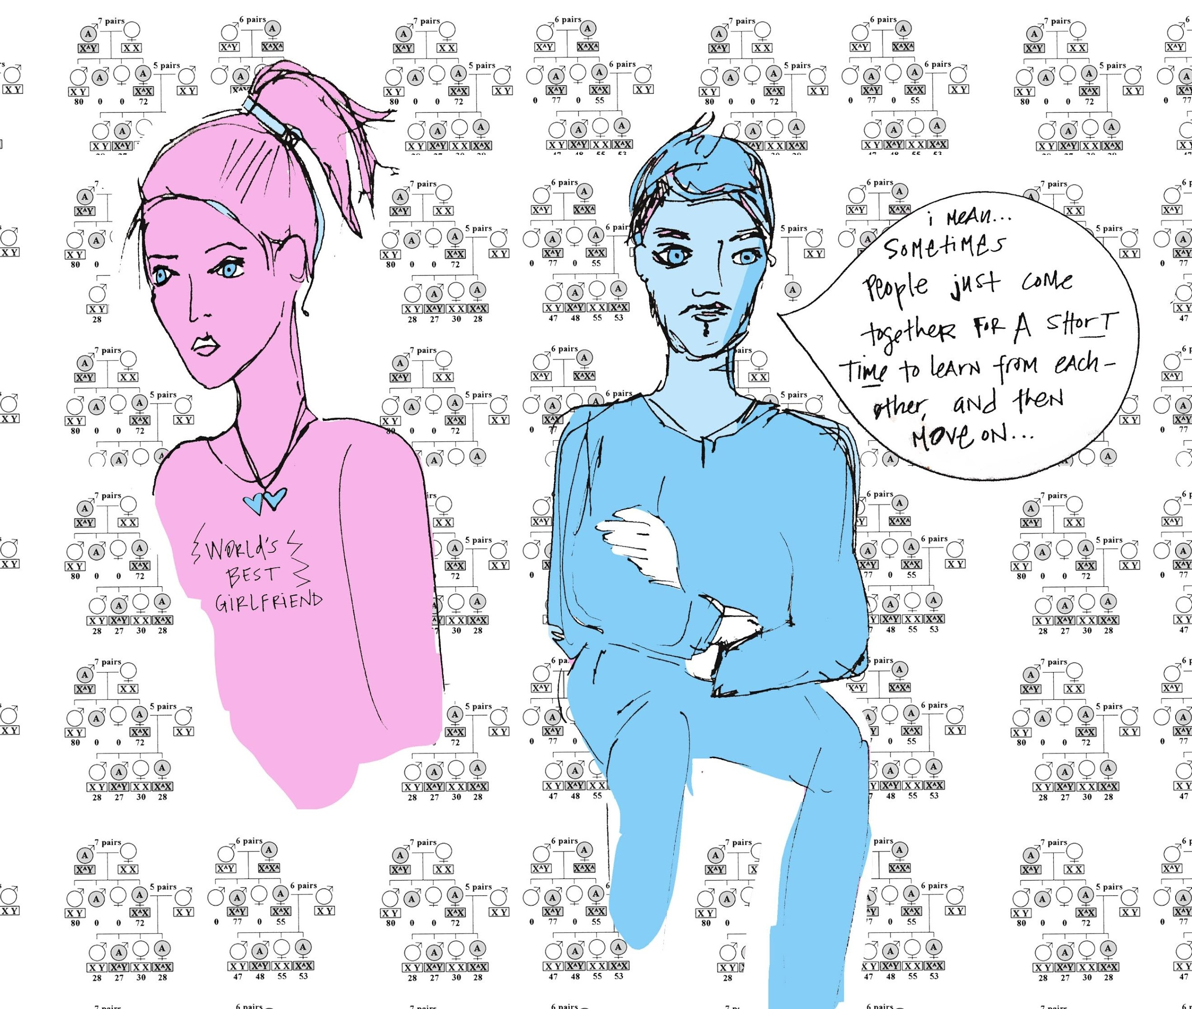

Aside from saving the XX from serial hetero heartbreak, the XY could find much advantage in fetching his energetic content back from his XX's energy drive responsibly (no more difficult than simply picking up his own socks off the bedroom floor.) He'd likely save himself the expenses of elaborate flights and environmental tourism adventures, or posh sabbaticals to secluded cabins to write his memoirs. But he is called on a XY-strengthening, testosterone-building rite of passage, something to make him feel like a man. He brushes up against her edges to prove himself enduring, to strength-train his emotional quotient, to climb the next rung of urban jungle bedpost. Once-upon-an-early-era, tribal elders sent him to the cold tips of high-altitude mountain peaks to find his manhood, risking death. Now, he merely risks "high drama" ramming his manhood between the warm, pushed together peaks of a girl he'll later brag he's "conquered" simply by emptying crumbs of his life-force all over her tits (during which she remains perfectly preoccupied, evaluating the estimated distance between her two breasts, their size, texture and density). It was completely aligned with the occidental promotion of cost-value commodification defining culture– an entire initiation for the price of a cocktail, an Uberx. While irreversible memory erasure (TMMFS) was purchased 85% of the time by women, whose XX chromosomes were far more suited for the program's benefits, some men also invested in wiping their energy drives clean post years of, for example, playing professional-level sports or when retiring from high-ranking, stressful corporate jobs. This way, they would not risk suffering deflating self-esteem, or else constantly relive their "glory-days". It was better for their golf-game to be less distracted by past trials and tribulations.

Between the third and fourth wave of feminism in the onset of the 21st century drive-erasure programs were still largely underground. Marketing had just begun to gain the attention of women, whose double X chromosome suffered more from holding memory-rich, physiologically impacting material. The earliest days of the protocol's advertisements received extraordinary media backlash. Many felt memory manipulation was not only risky, but immoral or inconceivable. Additionally, the program debuted with such an astronomical price-point, which added to its shock-value. Still, some women chose to redeem their 401K, suffering the 10% early-withdrawal IRS fee. These were women who were in deep, dire straits to be free from what had been termed as a real condition by the Diagnostic and Statistical Manual of Mental Disorders (DSM) as PTRS (Post-Traumatic Relationship Stress). Others interested in wiping their energetic external drives free of relationship memory underwent meticulous technical schooling to become service technicians for Neurostar, the first patented monopoly of the technology. These women would then receive significantly discounted services as part of the team company culture. The company, while beginning independently, was eventually absorbed by Amazon, as was Whole Foods, having received its series B funding from Jeff Bezos. Bezos loved to fund monopolistically promising enterprises and then ultimately financially funnel these initiatives toward pioneering the cosmos.¹⁰³

Before erasures were the norm, you were in Berlin, going through the end of a Bohemian-esque phase. You remember, you'd made friends with an opera-singer who'd left her small Canadian-island to pursue a career in Germany, home of the top opera houses. In a paradoxical turn of events, in one day she'd simultaneously won the lead role in a Mozart Opera she'd auditioned for and received word her fiancé decided to curtly end their engagement. You'd suggested she get a low-tier hard-drive clearing, which you'd heard about through some Californian-based friends. She was offended by your suggestion, and your friendship ceased that very night. Five years later, you knew only less than a handful of women who hadn't undergone the procedure, it had become a no-brainer. Most had purchased the complete irreversible program, as it was now significantly more affordable than when originally released on the market (however still comparable to several month's rent in lower Manhattan circa the year 2020). Some who wished to release their past intensity of hetero male or female-body encounters still went with just the temporary version, in the case they eventually wished to recall the intensity of their previous emotional and energetic exchanges, get back together with a former significant other. Even after a complete erasure, later accidental exposure to new ill-timed or non-mutual intimate experiences required a mild fixative at an established erasure center. For this, most directed their Siri to fetch web-coupons for semi-completes and complete-upkeeps. Eventually, you could go to get your brows tinted, your face filled in, and your memory kept at bay all at one corner spa in Manhattan. This became a standard weeknight date-with-self.

Ana mentioned the period of "before" to her therapist, but she didn't extrapolate. Some chose the path of deep extreme complete removal (which required pages of document signing prior to implementation, as it was considerably high-risk and even banned in parts of the European Union). Reportedly, those who'd undergone deep extreme removal erasure retained almost no recollection of people they'd previously loved or encountered. Former lovers began to adapt to the reality that when running into an ex post-erasure, especially if not given prior notice, they'd literally be met with a cold shoulder. However, these measures were typically too severe for most. To be succinct with friends, photos and family, women more commonly chose the medium-level program, which was still irreversible but less extreme. This degree of microbiota-engaging, frequency-based energy removal therapy would leave the intellectual memory of the relationship intact to a certain degree, but would undo any trauma-reactive patterns, depressive habits, deflated state of mind or ill-physiological conditions related to past intimate relationships. The procedure was successful mainly by implementing a small influx of multiple placebo components simultaneously unleashed through the gut and densely-populated areas of the microbiome. The main biome points accessed in the frequency-based radionics process were the umbilicus, the external auditory canal, the interdigital web space (between the fingers), the gluteus crease and the popliteal fossa (kneecap). The kneecap's frequency signal, (surprisingly voluminous when listened to with the right tools) were referred to medically as crepitus, coming from tiny bubbles in the synovial fluid in the knee joint. It turned out the tiny bubbles, however, were the physiological, expressive body-reaction to the most innocent, childlike part of the emotional heart. This was confirmed post 2020 when both astrology and energy medicine were reunited with their original other halves, astronomy and medical science. Somehow the knees held the song of the heart, and so focusing on frequency-resetting the microbiota populated there significantly affected the mind/body memory.

Ana, because she opted for the medium-level irreversible TMMFS (Transcranial Microbiome Magnetic Frequency Stimulation) was able to remember the name and basic information of the men she'd loved before her original frequency clearing. She could still recall "what" happened and the choices she made. If she focused her complete attention long enough (which she consciously rarely did) she could remember certain words exchanged, the shape of her lover's body, the size of his penis, the color of his eyes. She couldn't recall, however, the smell of his skin, the way it felt to be kissed by him, anything like "butterflies". She could also remember the mothers of the men she loved, despite her own preferences. She remembered them saying things to her, could see their lips still moving, but couldn't remember what they were saying. She couldn't recall if she liked them or not, or if they approved of her. She definitely couldn't remember how the mothers related to their sons, anything Oedipal or malevolent between them, and how it had impacted her at all, for better or worse.

She got her first drive erasure nearly a decade later than most of all her friends. They'd suggested many times she opt for the process, less because they wanted the best for her, but more-so because they'd tired of hearing her patterns of relationship repeat. (In general, the female attention span for listening to heartfelt woes had lowered considerably after TMMFS became more widespread, coupled with video-game apps like Candy Crush, which replaced thinking about male-body crushes with looking at emoji candy). Despite the peer pressure, Anna opposed undergoing the procedure for years. Though her work heavily involved programming and machine learning, she liked to consider her own interior technology as natural, and efficiently working. She liked to consider that she had what it took to adaptively continue to perform at a high speed of success, and by evidence of her many professional accomplishments, she appeared correct. Then the Relationship Trauma of Her Lifetime happened, entirely unexpected, as it does for most. After this, for some time, she remained engulfed in an inconceivably gross state of distress; every possible fault line in her tectonic frame broke, her face nearly froze in an open-mouthed wailing shape. Some seasons later, still in disrepair, Ana caved. She joined her friends in the rite of passage they'd successfully taken years before her. Her remaining post-traumatic axioms fired in the eventual reason, if one suffering from heart arteriosus would logically undergo the most advanced surgery available, why shouldn't she also use medical technology advantageously? Why suffer a lifetime what women with lower counts of enteric neuropeptide Y hormones had already suffered for centuries, systemically stuck, slow processing grief? Her ancestors would want this for her. So, Ana turned her preoccupation from analyzing her past failed relationships and busied herself intuitively choosing which level hard-drive sweep felt right to purchase. Intuitive consideration was easier pre-drive wipe-out, as the female gut, despite being toxically perturbed by hetero-tumult, more naturally connected to feeling-based neurological reason. After evaluating all commitments involved with purchase, the medium level irreversible track seemed the safest (and most financially intelligent) option. Her decision was not influenced by the drive-erasure manufacturing company Neurostar's advertisement, or even through a solicitous intervention of friends. It was merely one blind-date that was the catalystic turning point.

Ana had agreed to meet her friend's boyfriend's friend, who had recently moved to Manhattan from Zurich, to build a company which connected human Social Media Influencers with robot-run companies, to put a human face to their business name and culture. This pivotal date initially seemed harmless enough. Frankly, she expected a conservative-seeming man, judging by her friend's descriptors, a man who ascribed to what was called "modern chivalry". Modern chivalry had taken an askew departure from its first knighted decree, which described a noble man, highly trained to both gracefully and fiercely devote his life to defending an honorable code, body and soul. Early-era chivalrous men were immaculate with their sword and word, educated in broad fields of archery and musical arts. Modern, urban chivalry remained a public assertion, displaying a phenotypic male's unwavering commitment to holding firm to his values. However, it was now confirmed through deployed behaviors of a more subdued decree. The metro-chivalrous male might stand on the outer part of the sidewalk, might sveltely open a restaurant door with swagger, may even pay for his date, fetch and open her coat for her easy re- dressing, and perhaps even walk her (no more than) three blocks to her door. At his home, he might suggest he brave making popcorn on the stove (no microwave), putter about finding her a glass of water, opening a window, selecting a playlist. He'd check the cleanliness level of his bathroom before granting her use of his toilet. If, when parting, she showed promise of interest, he'd possibly text her under the guise of assuring she was home safely (though months or years later, he'd have no problem letting her walk the same path, in the middle of the night, alone, furious, in the rain). The modern, chivalrous man texted in the morning, just to say "hiiii" to wish her a fortunate day. While these were considerable expressions, Ana surmised, the real remaining chivalrous hetero-males were flagging construction areas mid-block, the ones singing in the morning, the superintendents of the city. They had eye twinkles and would charmingly spin their own prose on repeat for those passing. "Ladies and gentleman, good day! Please mind the pothole, we appreciate your patience with our city's construction." They merrily announced their presence even on snow-days mid-February. They wore hardhats. They were also the men in the hardware store who could assemble your endangered twist-mop-- as no one seemed to use twist-mops near the year 2020. They'd keep extra mop-heads in stock just for you. They wouldn't make fun of you if you couldn't assemble or disassemble a replaceable mophead. They understood– the mop was a modern-day jousting spear, they naturally had the know-how to put it together, and let you pick it up at 3 p.m., on your way back from wherever. These were the chivalrous men, who made muscles not for successful selfies, but for successfully carrying shelving, for loading your moving van, for catching women from falling into manholes, by the handful. Ana had read many postings by social media lifestylists enforcing that women could be both feminists and appreciators of the chivalrous man and, she identified as such. Why not have it all?

She had arrived at the cafe to meet the recent Zurich transplant, taking an extra 30 minutes to wrap up some business emails. Unfortunately, despite requesting he meet her a quarter past the hour, her date arrived early, himself, and so she shut her laptop and waved him over, recognizing him mainly from the photo her friend had shown her. This was New York, meeting strangers for a beverage was certainly more common than meeting a pre-established friend. Friends, these days, barely anyone had time to meet.

Her stranger fit her unconscious expectation. He was dressed in pinstripe suit-pants, mid-workday attire, confidently peered around the room for her. He placed his winter layers on the cafe table and gave her a short hug hello, and went to hunt down warm provisions for their table. She didn't want to wait awkwardly for him while he forged through the perilous line alone, so she joined him in battle. It was a close call, but they came out okay, having made selections. Sauntering back to their roundtable, Ana made sure to extra-carefully not spill her lemongrass tea off its wobbly saucer. She sat down and immediately practiced; she'd learned this from the lifestylists. Listen, breathe, feel, listen feel her vulva, listen, don't disassociate from her hips, breathe, listen, nod, listen, smile, get a question, breathe, distinctly reply without giving too much away, deflect. Smile, be nourishing, let her warm, freshly-clean hair circle her face. Sit back, be a conquest, keep relaxing, nearly to the point of feeling her bones release into the earth: it was a dating savasana, a yogic state... a practice of depth awareness, no forwardness, pushing nothing, surrendering. Somehow, this simple equation worked miraculously. In the days before the irreversible drive erasure, Ana wished she had learned these techniques earlier, before she'd experienced the Relationship Trauma of Her Lifetime only months before this meeting. The social media lifestylists wittingly insisted, she could attract any relationship to her by practicing this simple goddess-like vulva- centric dating protocol. If she had known this previously, if she could have more often placed her bodily curves, lovingly, in her man's wide, warm hands instead of placing the crookedness of her learning curve there, retrospectively, she might have avoided the Trauma of her lifetime. In these days before her complete drive erasure, Ana's focus was nearly always derailed, considering how she might have performed better in his eyes.

It was impossible for Ana to relax into this teatime meeting. While she was absolutely prepared to remain as cultivated in her feminine center as possible, she did not expect the chivalrous-seeming man would employ multiple tactics at once. First, he presented his sophisticated linguistic charm, which she found easy enough to admire, despite her lack of pheromones naturally triggered in response to his overarching physicality. Once he felt warmed up, he added a type of teasing facial movement to his parlance. This might seem passably respectable to most modern hetero phenotypic-female daters but Ana knew right away, he practiced no degree of distinction, he'd already begun to unlatch his chivalrous armor. By indication of his facial gesture alone, he was ready to enter her space if she'd let him, and in some ways, he was pushing against her resistance. He'd obviously been trained somewhere (likely Paris) in the skill of undressing a woman through the space between his words, a type of manipulative hypnosis, bordering on paranormal. Honestly, in the middle of the cold New York winter, only barely returned to herself after the Worst Relational Trauma of Her Lifetime, Ana would not mind pretending to be unconscious to his energetic fondling. This was a difficult case, however, because she was not purely attracted to her suitor. She felt sure, despite what some therapists had told her, that quality of biological attraction was always energetically mutual, regardless of each individual's learned preference. This meant, then, that despite the lack of actual attraction between them, her teatime date had cultivated a wider palette, or, one could say, lower standard for what he'd plainly just fuck. Evidently, the frequency of his hormonal drive was par to a jack-rabbit, and his concern for microbiological compatibility was nil. The type of sexual expression he'd present would likely reflect a largely populated gut biome filled with transplants and a low level of original strains. He survived by constantly introducing strangers into his microbiome fields, and, once pressed, was vacuous of original thoughts. Without a solid home-base of inference within himself, he'd of course maintain little endurance for long-term attraction, only surface-level chivalrous strength, and, by the third date, would certainly bore her entirely. If they'd have kissed, certainly he'd have stuck his tongue deep into her mouth, both implanting her with his sour-tasting, burnt-smelling breath excrement, and also culturing deeply into her orifices for whatever he could take. He'd attempt to float this parasitic energy ride for as many days as possible, texting her things like "Hey babe, I can still smell you." or "text me when you are free to meet this week" without providing any creative context for a date, without attempting to actually woo her depth. This was precisely the kind of man the Swiss-Francoise was sitting across from her, and she was, through her presence, allowing him to give her all he had in their 30- minute tea. This was the duration of length he could remain at his "wooing best". He'd expire, certainly, in the 31st minute. His coquettish facial movements would turn to passive-venomous twitches, he had too many conflicting strains of antibodies living in his spine plus his cells were obviously turning over at a slow rate, his Thyroid suffering. In time, this type of man, if entering an actual relationship, would certainly not have the skills to navigate through communication challenge and maintain libido. Regardless of how their time played out in these 30 minutes, it didn't really matter to him how Ana responded to their shared time, or how she'd excuse herself: He'd use their meeting as quick ejaculation fodder later, before setting his alarm for the next workday, an entrepreneur.

The teatime dynamic was a difficult case for Ana because, despite the worminess of character of her date, in the under-realities of her mind, she would not entirely say no to the idea of being a temporary sex experience for a man who was chivalrously endowed in the most traditional sense. She would not mind if a man had just fought a wild band of village intruders, come from over the mountain, smelling of earthy salt, and locked her eyes in his deep gaze, for example, at a well, filling up her wood basin of water. She would not mind his gesturing her toward, after her eyes had been long enough caught in his, if he could read her completely. She would not argue if he directly took her hand gallantly and swiftly lifted (first the water basin) and then her body in muscled agility. If she was swung, her hair falling down around her shoulders, onto the back of his horse --- if he'd maybe first nobly rescue a few others, including her family members, business colleagues or whoever else from fiery peril, and then brought her to a soft field. If the earth became their sole accommodation, their provision, she would not mind if he put his fingers through her light red hair (she would have light red hair in this instance) as the warm sun set on the gentle grass and if he said, with clear distinction "I know we are only laying on a rich plot of land, and that I am not a king, exactly." And, "I know that you have a highly worthy regal future in front of you, but--- as knight of code--- I was hoping you might let me absolutely worship you, as I am dying for this sole moment to relax your hips with my extremely large, slightly Neanderthal-esque hands that simultaneously possess savant inherence." Then he'd obviously say, "of course I know you might forget this agreement, if you choose to make it, later, because this is so much energetic information between us right now there is no way your neurological memory can sustain comprehension, but just remember this: I theoretically cherish you forever, and this moment is a single forever, and it's complete as all we'll have. Then, he'd pull off whatever kind of underwear she would be wearing in that period, and somehow he'd undo her corset and whatever else under a minute's time so that she didn't feel a slight awkwardness of wanting to help him.
Then, he'd kiss her body symmetrically in a complete line descending from her decollete (which she'd only just learned as the upper-echelon term for neck, thrown around casually in high-end NY spa scenes, where too many women cared too much about taking care of body parts ignored by men who'd forgotten how to really perform with chivalry).

Ana could not even begin to conjure such a momentary scene with the man in-front of her now, as he presented his various layers of faux-chivalry. Past his eye gesticulations, and after the intermissive moment where he displayed his character strength helping a stranger reach her jacket hung on the hook behind him, was the trickiest move of all, his third act. He pretended to not care at the least about manners or personal boundaries. His conversation entered "full abandon" and he prodded Ana in liberal, sudden quips until evoking a chatty, bold, dark-humored and dystopic part of herself she knew was nowhere near her centered, breathing, in-control "first-date" demeanor. Somehow, within only three minutes, he'd gotten her to share the grueling story of her recent relationship, until her eyes brimmed, shamefully, with tears. After this, she told him straight-away "well, we've definitely zero chance of having a future together now." To this, he asked "why?", simultaneously revealing his next faux-chivalrous get-up, concern followed with pert attention, and a factitious ability to remain present during the divulgence of emotions (this trait was learned in the very highest finishing schools of chivalry. In fact, most men had not reached this stratum of player-ship, and point-blank wrote on their dating app profiles "no drama, seeking simple and happy all-the-time" under the "a perfect date to me is..." section. Doing such was a sure-fire way to derail any man's chance of earning attention from a high-value woman. Women wanted men who could endure temperature change, welcome her varietal flavors, play in the extremes. Being positioned to appear unconditionally singly-emotive in pleasantness was completely outdated and the desire for such expressed nothing more than a man with stunted maturity, who was, in fact, frightened by his own spasmodically volatile potential; literally scared of his own shadow.) Despite her supreme conditioning and typical ability to refrain from an overshare, Ana opened to him in err before properly filtering herself. She'd intended only to show up to play the part of mysterious, gentle, loving and unavailable woman; to make up for the destroyed, agonizing, betrayal and rejection she'd received in the months before during the Biggest Trauma of Her Lifetime. The ensuing conversation was the pivotal moment after-which she knew she must undergo a full drive erasure, in order to keep herself from losing the remnants of her best-learned haute social etiquette.

He prompted her... through various verbal interrogatives until, before long, she asserted, "I will never try to change a man again!"
To which he said,
"Did you do that a lot in your past?" To which Ana said,
"I guess, yes. I saw their potential; I loved them but insisted they must learn to use a napkin, or cut their nose hair, or exercise, or not eat spaghetti regularly at midnight; requests I thought were basic but proved to be critically demanding."
To which he said,
"I know how to take care of myself well." To which she said,
"because you are divorced and, obviously, the best thing about you is effectually your ex-wife's dedicated schooling."
To which he said,
"No, no. I chose on my own to get laser." To which she said,
"What?" Thinking she could not hear properly over the Union Square cafe's jazz.
To which he said, smiling smugly,
"Yes, I laser my butthole." To which she said,
"Wait--- did you just tell me in the first 30 minutes we've met that you get laser hair removal on your butthole?" to which he said, amplifying his Swiss-French accent,
"Yes-- and it's delicious."

Ana actually remains in his company for the next half hour, somehow she nearly becomes charmed, likely because, as were many hetero women near the year 2020 in lower Manhattan when you could still physically walk through the city, she is under-touched. Still, she makes sure to let him know he is a creep, and also that she's only just learned that eating ass was a culturally common, even desired, sexual act.

Perusing through the aforementioned dating app world she paused on a mysteriously attractive-seeming man, hiding in the shadows of a single solitary dark-lit photo. Underneath neurosurgeon, his professional title, he'd filled out his about me section. Ana prepared for the usual "love to travel, drink vintage reds" or "amicably divorced" or the popular "loves witty banter" (it seemed half of the men whose profiles she'd read would settle for nothing less than a relationship filled with witty banter.) The neurosurgeon, however, had opted for the most impressionable one-liner, listing "while skilled in operating within the nether-regions of the brain, my real talent is the dark art of eating ass." Ana literally had to ask Siri what this meant. Evidently still processing the ass-eater's profile some days later, mid-toenail trim on E. 25th, she conversed with a woman de-callousing in the adjacent chair. Within the first 2 minutes of their one-and-only encounter, the woman confirmed ass-eating as a definite thing– in fact, she asserted, it was basically relationally mandatory in Manhattan circa the year 2020. Also, she insisted, mid-deciding between bold red or deep-burgundy for her manicure, Ana certainly must try having her ass eaten as soon as possible. The woman (who'd selected the bold red after asking for Ana's final vote) ran PR for a SoHo spa, and offered to give Ana significant discount for laser hair removal around the ass-hole. Evidently, shaving her armpits was no longer culturally imperative by the standards of Vogue, but to have any soft hair (or coarse, for that matter) around one's back exit-door was unacceptable.¹⁰³ This brought up a concern she'd not yet felt to consider. How much soft hair there was tolerable? Should the area look a certain way, otherwise? Was there a preference in size or dimension of the rear portal? She couldn't believe she actually had to objectify a new part of her body in consideration for male assessment. A single date with the Swiss-Francoise had launched a downward spiral of sabotaging considerations. Like all women, Ana had better creative ideas to consider than these self-limiting neuroses. It was only after she realized how dangerously impressionable she'd become post The Most Traumatic Event of Her Lifetime she decided she could endure it no longer: she must wipe her drives completely and irreversibly, and let her body and mind heal from such perturbing life-long inputs.

It's difficult to sleep the week of the disk swipe. Procedural centers include a "preparing for your erasure" manual, and you've read it multiple times, careful to not have skipped any stage of the protocol. As advised, you've fasted from heavy fats, synthetic and fruit sugars, carbohydrates excluding sweet potatoes, spices, salt and any western medication, even one week longer than the 5-day recommendation, just to be absolutely safe. You've consulted your ND, your RN, your primary MD, your somatic psychologist; your friends and family. You've asked Siri and Alexa, and have read every published account of the small percentage of clients who've suffered abnormal consequences post-process. One girl in Utah forgot her father after a heavy irreversible erasure, but strangely still remembered her ex- boyfriend. A helicopter-parent in Kansas, worried about her child's extreme affinity for his classmate, gave the drive erasure to her kindergartner-age child who resultantly acquired delayed hand-eye coordination. Federal regulations thereafter enforced an 18+ age limit for all potential program users.

The hardest part preparing the week before isn't the narrow food list, you've limited your spectral consumptive intake to far fewer items in your earlier diet-influenced teen years. The challenge isn't even allotting yourself the required week off of work following the erasure, necessary for resting and returning amino-acids, tryptophan, dopamine, serotonin, and GABA levels to a normal level. You aren't too mussed over possibly suffering the typical short-term side effects: insomnia, headache, dilated pupils. Even the potential long-term effects; obscure color perception, malabsorption, or skin irritation seem not an enormous price to pay in exchange for the relief. What evokes your anxiety around the hour of 9 p.m. as you curl onto your side, status quo, with eyes covered by black velvet patches to block out the city lights, is the emotion of love. You still love him. An 86-year old colorful poet you encountered upstate who rode his bicycle through the quaint Woodstock town center read you his poem, you were with him-- the man you'll soon erase from your collected memoirs. You stood in line for a morning coffee, your boyfriend couldn't function for long in the morning before a double shot cappuccino, and you'd order a decaf latte in camaraderie. Joining the line behind you, the poet spoke to you when you smiled, he said "can I read you a poem I just wrote this morning?" You were zestful-- as per usual-- in the morning, happily replied, "please, yes!" You can't remember how the poem started, but it was about a Sarah or a Kristen or Rachel, his preferred lover who'd abandoned him some years ago. It ended with a sentiment about how some "painfully exquisite love festers". You remember the poet, gaunt aside from the flicker of inspiration in his eyes, fueled, purposed by his narrative pain, reciting how this gnarled love would "continue to grow, ceaselessly on its own, both more vile and verdant as years progressed." It sounded like a terrible condition to you. Your charisma retreated, and, guarded, you briefly muttered "sorry" to him, as you would respond to a Union Square street person begging for change. The old poet left you alone after this, but evidently his microbiome infected through foreshowing language. Not only did your mood for the day dampen, in fact, later on your drive home on the Garden State Parkway you'd fight with your ex. He was upset because he felt you were ungrateful for something or another. Now, in the week before your removal, you recall the poem, feel both the verdant and vile love burning your insides like cast iron. Soon you'd not viscerally remember his thinning curls, how many pairs of glasses he owned. Where you kept the eyeglass cleaner. How you'd spray clean his frames in the morning, adding the gesture to your own morning care habits. You'd no longer neural-fire critical conjurations; how his nose ran in the winter, sometimes dripped. How it sounded when he'd lead you to the apartment door, find his keys, the smart shape of his hand swiftly unlocking the entrance.

You'd forget how he checked the mail every time he left the building, how you called every single company who'd send him useless catalogues, unsubscribe, try to conserve paper, conserve something: do something right. Soon, Coney Island would not be a place where you goofily danced to the Chipmunks Christmas Album on Christmas day, with the whole tacky strip nearly to yourselves. You'd forget the vows you wrote in the sand with sticks, all of your intentions. You'd forget how he weirdly twisted your nipples like little dials on an old radio, like no man ever had, how he barely touched the rest of your breast. His eruptive anger, his poor stress management, his belly when you lifted his shirt, the gross number of white tee-shirts he collected. You'd forget how nearly odorless his armpits were. Better, you'd never again reflect on one moment, in the middle of everything, when you wanted to fight for love, when you'd chosen with what you called your heart-and-soul to make it work. You'd not recall the trace of divulging smile, reminiscent of a gaseous baby’s, he let slip via rem state gesticulate stretch, while you lay awake, studying his body. You'd no longer remember how you knew somehow, when you saw that mid-slumber smile, he would tell you the next day he'd fucked someone else while you were gone, while you were planning your shared future, while he was agreeing to build it with you. You'd forget the agony of the months you'd waited for him to acknowledge the value of your connection, or the complexity of the situation. How he left you homeless, how he tried to pay you off. You'd forget that he suggested you'd manipulated him into the commitment in the first place, how he could only recall the challenging times. You'd forget the name of his sister, what she did to him: what happened to her. His mother, father, his cousins, all of his torment. You'd never remember how he emotionally ate ice-cream, how you had to ask him to sympathize with any sorrow you felt. How you starved yourself when you were together, how you controlled what you consumed because you had no other space to yourself. How he complained when you shared your needs, his mixed messages. You'd never again see the receipt of the money he sent you as a spontaneous gift weeks before he disappeared, writing For My Ana, so she might buy something special she likes. You'd still own the lace underwear he bought you in Cambridge, but you'd forget the icy day you bought it, jumping over a mound of snow, first playfully exploring a sex toy shop, wondering if he was serious when he wanted to buy a leash, a whip, a black lacy one-piece that wouldn't support your breasts well. You'll forget how on that same block he awarded you the privilege of lunching with his closest Harvard colleague, a beloved writer who had given him plentiful advice during the year. You'd no longer care that he took advice from accomplished colleagues but ignored yours, or never credited you. You'd no longer recall that he ridiculed you after his friend said goodbye, for talking too much, for quoting other women and citing the (female) lifestylists. "Have your own thoughts," he insisted. Elegance, you'd forget it was his word--- a word he described as a quality you lacked... in your first weeks together. You weren't elegant like the families of his rich friends. You'd forget he sought out rich friends and made it a point to feel both attracted by and critical of their wealth. He kept them like bonds, waiting for the moment to ripen the possibilities, he encouraged you to think this way. Opportunistically. You'd forget the moments you were surely terrible. How he bought you things. How he'd make "maybe" suggestions about outfitting you and you'd take him up on his offer, remind him of his offers. "Did you say that you really wanted to buy me a winter jacket?" You'd no longer feel shame constantly that you said one unforgivably mean thing to him on a mountain icy walkway, warning him that you were readying to sputter angry exaggerations. You'd forget that after he forked over the money to visit your family in the cold winter high altitude, you were angry that he wasn't ravenously making love to you, asserting his undying love all over you. You told him that his penis was too small, which was a lie, his penis almost always felt absolutely right. You'd no longer remember this nor the comment. You'd not recall shaving the back of his neck, helping him pick what outfit he should wear, how you'd been closer to him than any other. It would all be gone.

Most people let their former significant other know. In fact, there were downloadable standard form letters available on the Neurostar website, created to support effective client–ex communication pre- procedure.

The form letter read:

Hello ______,

This is a form letter. It has been fashioned by the company Neurostar. Neurostar is a rocking innovation that supports the physiological health and betterment of its approximately 86% female phenotypic and 10% male phenotypic and 6% other phenotypic clientele. Our successful clients no longer suffer from repetitive limitations of memory floods recalling relationships such as the one you and ______ (our client) had for approximately _____ long.

Our client has been encouraged to use this form letter to safely let you know that, although she felt your relationship was (please check all that apply)
  - educational
  - riveting
  - the one relationship of her life that should have lasted forever
  - a rite of maturity
  - uniquely special
  - filled with powerful moments

It was also (please select from the following)
  - violent
  - disturbing
  - terribly timed
  - shocking
  - heart-wrenching
  - sick
  - exhausting
  - self-limiting
  - a bunch of shit

enough so that s/he/they finds it mandatory to risk the (less than .03% chance) side effects potentially including night tremors, restless foot syndrome, color blindness, or nodular melanomas to undergo the top-tier, cutting edge, exclusive technology of Neurostar's powerful TMMFS (Transcranial Microbiome Magnetic Frequency Stimulation).

This letter is to notify you that our client, _______ , has carefully chosen to undergo the medium level erasure program, and will be erasing all traumatic imprint of your shared relationship from his/her/their internal and external neocortex drives and enteric microbial nervous system channel using the Franklin Institute awarded Clean Sweep™ frequency method. As a result, in the very near future, s/he/they may either not recognize you when/if you meet again or else will remember you with the sort of vague recognition one may have for their local postal carrier. Neostar withholds the right to casually generalize the previous statement based off of the Nielson Consumer Behavioral Data report, which states that 86% of the U.S.A. public have no established connection with their postal person and would hardly recognize her/him if encountering the aforementioned postal worker ununiformed and outside of a 20-foot circumference from their mailbox.

We advise you to please respect the new orientation of your former partner/lover/spouse when/if you encounter her/him/them in the future. In the case that you confront him/her/them and attempt to emotionally evoke him/her/them with memoirs from your former relationship, including photos and/or other recorded media, s/he/they will likely not respond with much vigor, as her/his/their microbiome and neural pathways have been heavily informed by specific frequencies which now repel the specific type of energy s/he/they felt previously called to within the container of your distinct former connection.

The client will undergo this procedure in an estimated 2-4 week time period. By receiving this letter, you are now fully informed that our client wishes to be left to her/his/their proactive choice of the erasure protocol, undisturbed. If you feel against this choice, you are asked to contact her/him/them through legal measures only, as s/he/they wishes to not be reached directly by you at this time. Additionally, please do not contact her/his/their friends or family regarding this letter. If you fail to comply with the above requested abstinence of all forms of communication, in the most severe cases, you will be warranted a restraining order.

Meanwhile, we wish you future successes in all of your intimate relations, and remember, you are always welcome to contact Neurostar regarding receiving your own Drive Erasure Protocol. Mention this letter and get up to 35% discount on treatments as well as a free initial consultation to see if the program is right for you.

You don't send him a letter. You just can't lick the envelope (amazingly, near the year of 2020, your office envelopes are still the licking kind, made of gum arabic, tree sap). You don't send him the form letter because you can't bear days wondering if he still lives at that address, just 7 blocks north of you, or if he's home to get his mail. You decide that, if he sees you, somehow, in the future, he probably won't even realize you've changed. He already thinks no longer knowing someone you knew every day, every night, who washed your armpits in the shower, whose back teeth you sophomorically examined to speculate whether there was, in fact, a cavity there or if, after-all it was just gum sensitivity, is completely normal. He already thinks that having been involved with you for years was synonymous with having been unhealthily entangled together, "codependent" or any other suffocated-like phrase he picked up in the handful of therapy sessions you coerced him to attend together with you so that he might know himself, emote, engage, care. He was practically born with a perpetual delete-delete-delete command. Little sticks to him outside of his work-life, outside of caring if he is quoted properly, or if he might be selected as a Macarthur Genius, because then he could maybe love himself, or maybe then his parents would be able to intellectually digest his achievements. And you loved every pore-less inch of his calcified avoidant epidermis, because you were fed the fodder to do so from television, etc., and because two psychics confirmed that you should keep surmounting the summit, that there you two would glean a loving reward in togetherness.

While transpersonal therapists tout vulnerability as key to resilience, post the year 2020, the largest probiotic company, MegaSpore, releases well-researched information that changes the field of integrative medicine and, specifically, proactive health-food communities worldwide. As it turns out, exposing our gut bacteria to a gross amount of intrusive, foul and dirty things, if done correctly, strengthens our physiological resiliency, and, most specifically, our emotional rebound. Going to the disco, drinking down a half-dozen fizzies, bringing one (or two) stragglers home to long-overdue-to-be-changed bed linens and eating whatever sugared processed food substance found in the refrigerator off of each-other's dance-sweat soiled body parts until 4 a.m., followed by a morning of Bloody Mary's, a Meat-Packing District carb-rich brunch, and a cigarette-to-boot strengthens one's immunological armor. It turns out that certain cancer treatments, which were less than 25% effective, become 90+% effective after resistance-training rats' guts with the treatment of the typical hard-edge lifestyle of the irreverent youth. While previously publicly unsupportive of animal testing, National Geographic, post the year 2020, sends top photographers to photo-document Brown University's rat-microbiome testing lab. There, little rats wear sideways-placed large-brimmed NYC hats, microwave their own buttered popcorn at free-will, drive around intentionally polluted air shaft spaces in convertible mouse-sized heavy emission-releasing cars, and sleep no more than 2-4 hours nightly, exclusively in stinky rat beds piled on top of each other after spinning their mouse-wheels to Eazy-E remixed as EDM, sipping gin and juice out of dripper feeds, thriving.

Meanwhile, you spend your night after night in the yoga studio, controlling your breath through alternate-nostril practices, cool air in, excess fire out. You spend your last waking hours of each evening seeping in Epsom salt baths, while feeling guilty that you have exclusive access to a tub with jets. Before carefully tucking yourself in, you rub lavender-chamomile essential oil on your freshly laundered, ironed sheets, fluff pillows. When you climb into the crispness of bed alone, with your freshly washed mouth-guard, you listen to a custom-made subliminal hypnosis recording to both ward off bad dreams and remind you that "You are Loveable". You clutch a citrine stone in your hand to support your second chakra releasing the past and fall asleep after a final adjustment: one thin pillow between your folded legs, another, made of memory foam, precisely supporting your cranium.

On Tuesday, after one irritated New Yorker says "watch where the fuck you're going" while you text-walk and message your acupuncturist to let her know you'll be (max) 5 minutes tardy, it takes you until Wednesday night to rebalance your liver chi. While your energy may be wide and vast, while you feel certain you can sometimes touch the light of god, the variety of bacteria in your gut, particularly near the year 2020, is exclusive, completely lacking diversity. It's more minutely exclusive than a bunch of Y chromosome's remaining genetic content, meeting in a member's only socially elite club in SOHO. However, regardless of the sensitive and undiversified state of the 100 trillion bacterial cells in your microbiome, post-erasure procedure they will travel inside of a newly minted enteric nervous system, flowing like a first-class Euro super-rail. Programmed mostly with the vibrational equivalent of the phrase "I love, I love, I love" on repeat, little will disarm you or trigger you superficially, for your long-held, deeply rooted fundamental physiology of anxious sorrow caused by the Relationship Trauma of your Life will be nullified, quitted.

The morning of, your friend who underwent the same medium-level irreversible drive erasure accompanies you. While you won't undergo traditional anesthetic, the effective state-of-mind shift is strong enough that Neurostar legally insists clients are allowed release from premises post-procedure only when escorted safely home by a family-member, friend or hired service. You arrive at the center; it feels nearly like a yoga studio. You chose the elite, exquisite space as it was the top-rated, and with the reputation of excellent customer service. You are separated from your friend and given a preliminary salt-based foot bath to encourage a state of relaxation, and for its anti-inflammatory and detoxifying effects. After, you are directed in plush slippers to a treatment room, designed much like a private massage space. First, a single attendant enters the space for a cordial intake, asking basic questions: height, weight, date of event inspiring the energetic drive erasure, medical issues of family, etc. She also gives a brief overview of the history of developmental physics involved in Transcranial Magnetic Microbiome Frequency Stimulation, paying special dues to Donna Strickland, whose refinement of ultra-short optical pulses were modified to support Clean Sweep™ and Neurostar's product. Strickland, herself an early-stage TMMFS client, accredits her hyper-focus in part to the efficacy of the drive-erasure, which allowed her to no longer overly-dote on her husband and son. In 2018, she received the Nobel Prize in Physics, becoming one of sole three women among a century-worth of the remaining 109 male awardees.¹⁰⁴ The attendant verifies that you commit to taking a week off of work to recoup post the procedure, and acquires her first inpatient signature. She then administers a crucial hydrogen-based breath-test to diagnose the condition of bacteria in your enteric nervous system. She tells you what you already know: the immediate test results will be put through a spectrometer, which will produce comprehensive data in rapid turn-around, meticulously revealing your unique metabolic signature, highlighting specifically where impact from relational trauma has resulted in lifestyle impairment. The complex technology, through frequency notation, magnetics and a Neurostar trademarked diagnostic tool involving a mineral-induced state of hyper-gravity, diagnostically isolates which specific bacteria entered from outside past partnerships. Working as an antibiotic, this part of the drive erasure process will retrain these bacteria within the clients' systems through directly triggering the HPA axis of the endocrine system. (This part of the process will, post-procedurally, often stimulate an effect similar to that of food poisoning. The expulsion of bacteria no longer able to sustain within the digestive tract of the patient creates a need to immediately release the bowels. This phenomenon is most common for patients who've been in contact with their ex-significant others in the weeks before the procedure.) During the protocol clients are preliminarily informed to expect frequencies and magnetics to be pumped into their systems through a combination of visuals, binaural frequencies and administered inhalants. The inhalants, mixed in a base of fermented oregano leaf are the most crucial part of the clean sweep. Soon after the client respires while inhaling the mix, the theta state of the brain will enter what feels like a long, yet timeless and relaxed period where thoughts seem to suspend, a natural induction of the similar-anesthetic state administered prior to invasive medical surgeries. However, in the disk erasure process, incisive surgery is never required. Instead, a frequency-driven, highly patented combination of minerals and natural compounds work together to efficiently recalibrate and restore the most optimum microbial state of each client's unique physiological system. The attendant then goes over the intention of the procedure. She reminds you that post-erasure for 3-5 years, it is important to safely have a few play-by-play sexual fantasies lined up during masturbation. This is because (as you know from your thorough review of disk-erasure studies) that it is possible for the mind to resurface a previously nullified ex-boyfriend trauma when the clitoral nerve-endings are stimulated. This is because the non-myelinated c-fiber clitoral nerve-endings neurologically inform the entire body¹⁰⁵. Also, scientific studies on the nerve function within the clitoris (even near the year 2020) were historically less accessible relative to the advanced findings within the well-funded field of neurology. Science affirmed this, as Neurostar forewarned: it was quite difficult to program or control the potential sensations evocating from the vagina with absoluteness. The intake attendant hands you a thin book published by Neurostar and Clean Sweep. Here, she relays, Pleasurable Sex Fantasies for Women [age 30-45, demographic: USA upper-middle class, urban, never-before-married]. She reminds you what you obviously know, that after the medium-level drive erasure your memories of former intimate relational traumas will be extremely nullified as an effect of the procedural modification. You nod when she articulates a line she's memorized as a waiter has memorized the day's specials or when a company service provider asks if her communication has been effective and clear. (Amazingly, post the year 2020, it turns out, technology does not replace customer service reps, in fact, more humans than ever take the position of being available for incoming technical calls; it becomes a nearly socialized and very popular Millennial and Generation-Z inspired company culture move to have real people working phone lines, in alignment with the "slow food" movement.) For you, these are your final moments: you've already begun to put the past behind you, you wouldn't dare recall the Trauma of Your Life now, as the attendant asks for you to sign a screen with your finger to confirm that she has read you what is, comparably, your affidavit.

The moment after you sign, two certified Neurostar and Clean Sweep administrators enter the space, bringing with them a calming air of professionalism. This is what you've paid the big bucks for. One of the administrators turns on pleasant music at a gentle volume, projected in surround sound. The first attendant who performed your initial intake, now begins to massage your temples in counter-clockwise circles. The certified Neurostar technician introduces himself, then the one who turned the music on introduces herself, she is the Clean Sweep administer. The intake attendant tells you that, while the erasure procedure may feel like 5 or more hours, it is less than one hour in total. She asks if you familiarized yourself with some of the verbal directions you'll be given and when you say, she moderately dims the clinic room lights and triggers salt-rock lighting that comes up through a thermal heated floor. You are prepared for the awkwardness of the first stage, as the Neurostar clinician asks you politely to bring the pointer and middle finger of your dominant hand onto the surface of your clitoris. You read through the process numerous times both in the client material provided for you in the pre-procedure prep kit and also in the many personal recounts available virtually. Clitoral contact is necessary as part of the erasure protocol to best support the specific 8,000 nerve endings which remain most resistant to the program efficacy, as these cavernous nerves stimulate memory stored in the postganglionic parasympathetic fibers. Through the Pudendal nerve of the pelvic floor, the clitoris is part of the Vagus nerve stream¹⁰⁶, a part of the nervous system which received as many post likes on social media near the year 2020 as did Princess Meghan Markle of England, when popularized science linked stress with this branch of the human nervous system. It turns out, when female clients arrive on-site for their disk erasure in a high-state of anxiety, the procedure is significantly less effective. Near the year 2020, the Placebo Effect was taken one step further to realize that all medicine, allopathic and homeopathic both, are nearly twice as effective if consumed in a state of pleasure. This altered sexologists late proclamations, that the female clitoris was solely purposed to pleasure the female in an erotic sense. Pleasure, it became broadly accepted, was actively useful (as was imagination) beyond the bedroom alone. People universally practiced "turn-on" maintenance openly by the middle of the century, once time-space had nearly been completely obliterated, when nearly anyone still actually walked through the city of Manhattan. At this time, virtual pleasure- recharge centers (similar to USB device-charging stations now found in urban airports) became part of the left-side of the world's daily hygienic rituals. However, because pleasure had not been technically accessed successfully through the clitoral reserve near the year 2020, many females still remained in a Dorsal Nerve-triggered state of shock. Out of this stress-response, the clitoral nerves we apt to later trigger effluvium-like vague and offsetting memories throughout the neuro-vasculature system, especially when sexually aroused and engorged or when the neural brain entered the R.E.M. state. Effectually, many phenotypic females post-protocol still suffered the occasional bad dream of an ex-boyfriend, though--- upon waking, would hardly recall enough details to restore logistical information about their past. Despite the best laboratory efforts, science had many decades of catch-up to play regarding understanding the functional intricacies of the entire clitoral nerve network, as medical texts until near the middle of the 20th century had greatly omitted information about the female anatomy, or had misappropriated and downsized its shape and impact significantly.

When Ana underwent the protocol, though nearly a decade later than many of her contemporaries, the program's efficacy for female clients remained approximately 13% lower than the male rate-of-success. This was largely due to the intelligent design of the cavernous clitoral nerves, which are numerally double in amount of penile nerves, comparatively. Aside from clitoral anatomic complexities, the lower rate of success for women was medically justified by the American Medical Association (AMA) by the biological happenstance that the phenotypic woman has 10X the amount of white matter in her brain as does the phenotypic male. The AMA reiterated that it is the integrity of the white matter which is most relevant to the efficiency of one's memory.¹⁰⁷ Thus, to take all greatest efforts toward achieving program success, the most-touted erasure administration centers began their procedure encouraging women to induce their clitoral pleasure through combined white-matter stimulating frequencies and touch engagement.

Though Ana was not naked, but clothed in thin leggings and a long-sleeved tee-shirt, she remembers feeling surprised, touching herself in front of three clinicians. Somehow, the music makes it infectiously easy for her. The Clean Sweep technician comes over and hands her eyewear that look like pillow- covered glasses. The fabric is filled with buckwheat, which serves as a vibrational protective sheath to secure the magnetic resonance and frequencies to be administered through the enteric nervous system through the shaft of the eyes. Ana puts the eyewear and is now in the dark. She receives instruction verbally from the clinicians, they tell her to keep listening to the music, which directs her to maintain clitoral contact and regulate her breathing to the beat of a tribal-sounding drum coming through the speakers. The Neurostar clinician tells Ana that in the next 3-5 minutes, she will be supplied with a personal headset, and the musical experience will continue, designed specifically for her erasure process as determined by her previous microbial metabolic results. When the headphones are adjusted over her eyewear, she is directed to then place her hands by her sides, palms facing upwards. Ana knows from reading Neurostar's published materials that she'll be listening to the sound of 210.42 Hz, the binaural sidereal frequency of the moon's orbit. In combination, she'll receive 4 Hz, 221.23 Hz, and 10.81 Hz, frequencies comparable to the vibration of telepathy, the planet Venus and the state of heightened alertness and arousal. Remember, the technology of drive erasure was largely accepted near the year 2020 when fields of astrology and energy medicine began to reunite with their original other halves, astronomy and medical science. There is no way in hell, just 35 years earlier somewhere in the mid-80's when shows like Silver Spoons were the most quoted on television and some people considered Nancy Reagan's initiatives as too progressive, that a procedure zeroing in on relieving relationship trauma using bacteria- moderating magnetics, moon frequencies and borrowed equations from the field of osmotic science would be considered legit. After-all, only about 250-ish years before, women were burned at the stake for basically just ditching Sunday sermon at church a mere few hours from Manhattan's Holland Tunnel.

Ana's eyes and ears are covered. Her outer senses abated, she is surprisingly comfortable. The weight of the buckwheat cushioned glasses slightly press on her retinas, producing a gentle light show of phosphenes, fractal-like patterns in synch with the frequency blend playing in her ears. Ana feels already nearly entranced. She is sensitive more than most, or else incredibly eager to give herself entirely to the procedure, always an overachiever. The Neurostar Technician's warm voice evokes a wave of pleasure through her body, he notifies her of the inhaler being placed over her mouth. The intake attendant brings spacers around Anna's neck, so that she does not tense her in-breath or lift her shoulders to her ears, it is important there remains ample length in the entire spinal column, particularly in the cervical spinal area. Then the intake attendant, having received Ana's permission prior to the procedure, places her hands onto Ana's ribs. The sensation is utterly satisfying, Ana feels somehow held in complete support. The Clean Sweep clinician directs Ana to guide her respiration from her lower body, as though she is breathing into a floatation device around her lower abdomen, relaxing the muscles around her mid and low back. This allows the base of the spine to also fully release. Then, the nebulized mix of minerals and alkaloid- derivatives can enter her system. Beyond its base of fermented-oregano extract, the mix includes (but is not limited to) the medical herbs first used vaporously in the 15th century, Black Henbane, Castor Plant, Bayberry, plus a few bronchodilators courtesy of modern chemistry, to keep the lungs receptive.

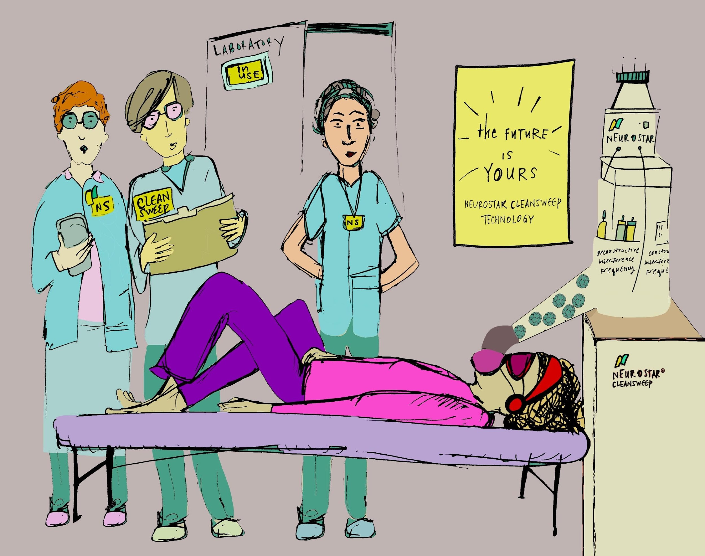

Ana feels as though she is watching a screen, she almost forgets that she is not. The phosphorous images produced by her retinas, in combination with the music, allow her to immerse herself in a contemplative process best described as the feeling of receiving the equivalent of years of talk therapy combined with of "fresh, just-brushed feeling", but one extending far beyond the orifice of the mouth alone. Her eye-gaze, though covered with buckwheat, is led right, left, right, left. A combination of the music frequency and the lit images she continues to see on the dark, screen-like space of her inner eye have produced a type of "follow along" call and response. She feels moved to bring her eyes upward, to the side, diagonally. She is mapping out the signature of microbial strands, and, through what appears similar to ancient paleography, scripting shapes which somehow unsubscribe her from, unravel and undo whatever systemic disruption she previously felt. Whatever pathological malady that led her to spend nearly half of her entire savings, risk having night tremors, long-term dizziness and dry mouth makes an exodus from her system through a motion that feels non-violent, easeful and nearly like an aboriginal death ceremony, a gentle rite of passage encouraging what's been done and gone to truly go.

*This is only ½ a Novel, if there is a “next” part written there will be a part about quarks; whereAna solves Einstein's last problem using a sound-color connection.

